 | Report Title | Case Management / Employment Exchange | Description | Report Module Name
1 | Advance Employer Query Report | Employment Exchange | This report works in conjunction with the Employer Query screen allowing printouts of the queried information. | uw_aqr.rdf
2 | Appointment Notification Letter | Both | An Appointment notice which is sent or given to the seeker to notify them of up coming appointments | uw_appointment_notification.rdf
3 | Assessment Summary | Case management | Print out of the Assessment information which is collected when a seeker is assessed for needs and training. | uw_assessment_print.rdf
4 | Authorization/Payment Voucher | Case management | Prints a list of Authorizations(Financial Payment Authorization) | uw_auth_rep.rdf
5 | Business Management Report (Counselor) | Both | Counselor Detail of Business Management Report | uw_bs_agent_detail.rdf
6 | Business Management Report (Statewide) | Both | Statewide Detail of Business Management Report | uw_bs_state_counts.rdf
7 | Business Management Report (Office) | Both | Team Detail of Business Management Report | uw_bs_office_team_detail.rdf
8 | Call-In Card | Employment Exchange | Job Notification. The seeker is sent a letter to notify them of a job that matches their information. This Card gives instructions about how they can get information to apply for this job. | uw_callin_card.rdf
9 | Case Management Query | Case management | This report works in conjunction with the Case Management Query screen and prints a report of the queried information. | uw_case_manage_seeker_list.rdf
10 | Claims Payment History | NA | This report prints a copy of the Claims Payments from the Unemployment System | uw_claims_payment_history.rdf
11 | Correspondence Template | Both | This report works as a basic template for the information which is populated with in the Correspondence screens. The correspondence screens allow counselors to send standard letters with customized information populated. | uw_correspondence.rdf
12 | Daily Job Order List | Employment Exchange | Prints a list of the Job Orders that were entered the past day (1 day ago) | uw_daily_job_order.rdf
13 | Daily Schedule | Both | Counselor Task and Appointment List | uw_task_appt.rdf
14 | Daily Team Calendar | Both | Appointment Calendar for the Team | uw_daily_team_cal.rdf
15 | Edit Detail | Both | This report gives a print out of the completed Edit with the score. | uw_edits_yna.rdf
16 | Edit Result | Both | Quality Assurance Edits allow the department to define a set of quality points, which they can evaluate how well staff are performing. This report gives the scoring output for the edit | uw_edits_results.rdf
17 | Employer Contact Summary (Counselor) | Employment Exchange | Reports on the Contact (notes), which was made with an employer. Counselor Detail | uw_emp_summary_agent.rdf
18 | Employer Contact Summary (Office) | Employment Exchange | Reports on the Contact (notes), which was made with an employer. Office Detail | uw_emp_summary_office.rdf
19 | Employer Contact Summary (Region) | Employment Exchange | Reports on the Contact (notes), which was made with an employer. Region Detail | uw_emp_summary_region.rdf
20 | Employer Contact Summary (Team) | Employment Exchange | Reports on the Contact (notes), which was made with an employer. Team Detail | uw_emp_summary_team.rdf
21 | Employer Letters | Employment Exchange | Template for Letters that get sent to Employers. | uw_employer_letter.rdf
22 | Employer Letters Sent | Employment Exchange | Summary Report of the Employer letters that were sent | uw_emp_letter_sent_list.rdf
23 | Employer New Hire List | Employment Exchange | This report lists seekers Hired by the Employer and shows brief information about the seekers | uw_emp_new_hire_list.rdf
24 | Employer Survey | Employment Exchange | This report is a Survey which is sent to the employer to enable the employer to report on quality assurance issues and general feedback on recent listing of Job order with DWS | uw_emp_survey_watt.rdf
25 | Employer Survey w/o Attachment | Employment Exchange | This report is a Survey, which is sent to the employer to enable the employer to report on quality assurance issues and general feedback on recent listing of Job order with DWS. This version does not have the attachment included (Hand stuff Survey). | uw_emp_survey_woatt.rdf
26 | Employer Transcript | Employment Exchange | Detailed report of Employer information. Demographics, contacts and general information pertaining to the employer | uw_emp_transcript.rdf
27 | Employment Plan | Case management | Employment Plan print out. Outlines all Objectives, Services and Tasks related to the seeker plan to become employed. | uw_emp_plan_print.rdf
28 | Employment Plan Closure Reports | Case management | Reports that show the reason why a Plan was Closed and include a Resource list. | uw_closure_report_add.rdf
29 | Employment Plan/Training Plan Agreement | Case management | Training Agreement printout. This agreement is signed by the customer and allows them to receive training funds to accomplish their training plan. | uw_train_authorize.rdf
30 | EO Notice Letter |  | Seekers that are being Case Managed must receive an Equal Opportunity Notice. Only need this notice sent to them once. This gives them information about services and programs. | uw_eo_notice.rdf
31 | Funding Query (Customer Detail) | Case management | This report is used to print Funding information about case managed seekers (Shows Authorizations and Obligations) | uw_cust_det.rdf
32 | Funding Query (Customer Summary) | Case management | This report is used to print Funding information about case managed seekers (Shows Obligations) | uw_cust_sum.rdf
33 | Funding Query (Authorization) | Case management | This report is used to print Funding information about case managed seekers (Shows Authorizations)
34 | Funding Level Report | Case management | This report gives the Accounting Staff information about the amount of money available by funding source. It lists the amount Obligation, Authorized, Paid and Available. | uw_fund_levels.rdf
35 | Information Card | Employment Exchange | Information Cards are mailers sent out to groups of seekers to inform them of seminars, job fairs, or general information. They are similar to call-in cards but are not associated directly with a job order. | uw_info_card_display.rdf
36 | Initial Interview | Case management | This report prints information collected during an initial needs assessment. The counselor uses the initial interview tool to direct the seeker to other sources for assistance. Also lists any up coming appointments. | uw_resources_activities.rdf
37 | Job Board Display Card | Employment Exchange | Job Board Display Card is used for office job boards | uw_jo_card.rdf
38 | Job Order Query Report | Employment Exchange | This report works in conjunction with the Job Order Query screen and prints a report of the queried information. | uw_jo_query_list.rdf
39 | Job Order Scratch Pad List | Employment Exchange | This report gives a list of seekers, which were place on Scratch Pad list on the job order. | uw_jo_scratch_pad_list.rdf
40 | Job Order Transcript | Employment Exchange | This report is a complete Transcript of the all information pertaining to Job Order requirements | uw_jo_transcript.rdf
41 | Job Order Verification Letter | Employment Exchange | Letter, which goes to the employer, shows the people who have been referred and asks for feedback on seekers they have hired. | uw_jo_verif_let.rdf
42 | List of Staff | Both | This report gives a listing of detailed information about the Counselor setup and configuration of the agent / agent hat relationship in the Uworks system | uw_employee.rdf
43 | Notes Query Report | Both | This report works in conjunction with the Note History screen. Prints a report of the queried information | uw_notes.rdf
44 | Obligation Plan | Case management | Printout which gives the seeker information about money which has been Obligated(set aside) for training and employment plan objectives and tasks | uw_obligations.rdf
45 | Payment Authorization | Case management | Payment Authorization which authorizes the provider to bill DWS for funds which were authorized | uw_pay_authorize.rdf
46 | Petition List | Both | List of petitions (NAFTA,TAA,TA2002,etc), which are currently active in the Uworks system. | uw_petitions.rdf
47 | Petition Clients | Both | List of Seeker associated with a Petition | uw_petition_clients.rdf
48 | Pre FINET Report | NA | Transfer Payment information to the FINET system (Accounting). A report that show the information before the transfer. | uw_pre_finet.rdf
49 | Post FINET Report | NA | Transfer Payment information to the FINET system (Accounting). A report that show the information after the transfer. | uw_post_finet.rdf
50 | Rapid Response List | Employment Exchange | Report, which shows employer/seeker information, which are associated with a Rapid Response. | uw_rapid_response.rdf
51 | Referral Letter | Employment Exchange | Referral Letter is given to the seeker, which they can show to the employer to show DWS screened them | uw_referral_letter.rdf
52 | Registers | Both | Report gives a listing of seekers and employers associated with registers | uw_registers_report.rdf
53 | Resume (Job Seeker) | Employment Exchange | Client Resume - Formatted | uw_resume_print.rdf
54 | Resume Scanable Version | Employment Exchange | Client Resume - Different version which could be scanned and OCR'ed | uw_resume_scan.rdf
55 | Schedule Query Report | Both | This report works in conjunction with the Schedule Query screen and prints a report of the queried information. | uw_schedule_query.rdf
56 | Security Report | NA | This report shows a breakdown of the Security Roles and Staff connected to the role. | uw_security_title.rdf
57 | Seeker History Report | Both | This report works in conjunction with the Seeker History screen which report the history of appointment, correspondence, tasks, services, workshop notices and worksite learning referrals | uw_hist_rep.rdf
58 | Seeker Information Card List | Employment Exchange | Information Cards are mailers sent to groups of seekers, which notify them of seminars, job fairs, or general information. This report lists the seekers that have received the information card | uw_info_card_seeker_list.rdf
59 | Seeker New Hire List | NA | This report shows all of the New Hire jobs that a job seeker has been reported as hired. | uw_new_hire_list.rdf
60 | Seeker Referral | Both | Seeker Referral is a letter which is given to the seeker that gives proof of referral to an employer | uw_client_referrals.rdf
61 | Seeker Search Results | Employment Exchange | This report gives a list output from the seeker matching screens. | uw_seeker_search_rslt.rdf
62 | Seeker Services | Both | Reports the services which were provided to seeker | uw_seeker_service.rdf
63 | Seeker Transcript | Both | This report is a complete Transcript of the all information pertaining to a seeker. Demographics, Education History, Employment History, Licenses, test scores etc. | uw_client_transcript.rdf
64 | Service Referral | Both | Referral letter, which is given to the seeker when they are referred to service provider. (Votech,JobCorp) | uw_referral_serv.rdf
65 | Service Request | NA | This is a change request to the Uworks software. | uw_service_request.rdf
66 | Service Request List | NA | Details of a single Change Request selected from the query screen | uw_service_requests.rdf
67 | Test Certificate | Employment Exchange | Hard copy of results which were entered pertaining to the test which was recorded in the Uworks system | uw_test_certificate.rdf
68 | Training Waiver | Case management | Training Waiver Print out. | uw_train_waiver.rdf
69 | Veteran Client Report | Case management | Veteran Extract information for Seeker Federal reporting | uw_vet_client.rdf
70 | Veteran Job order Report | Case management | Veteran Extract information for Job Order Federal reporting | uw_vet_job_order.rdf
71 | Wage Data List | NA | Wage Data - History of quarterly wages reported by employer | uw_wage_data_list.rdf
72 | Weekly Colander | Both | Counselor Weekly Colander Printout | uw_weekly_cal.rdf
73 | Workload Activity | Both | Workload Activity Report (Summary) | uw_workload_activity.rdf
74 | Workload Activity Detail | Both | Workload Activity Report (Detail) | uw_workload_activity_detail.rdf
75 | Workshop List | Both | Workshop List of Attendees | uw_workshops_list.rdf
76 | Workshop Notice | Both | Workshop Notice sent to seeker to notify of enrollment in Workshop | uw_workshop_notice.rdf
77 | Worksite Learning Referral | Both | Worksite learning Referral letter. This is used for OJT, and apprentice referrals. | uw_wsl_referral.rdf
 | AdHoc
1 | Dormant Employer Report (Adhoc) | Employment Exchange | List the employers which have been dormant ( listing no job orders) for a period of time | uw_dormant_employer_list.rdf

Advance Employer Query

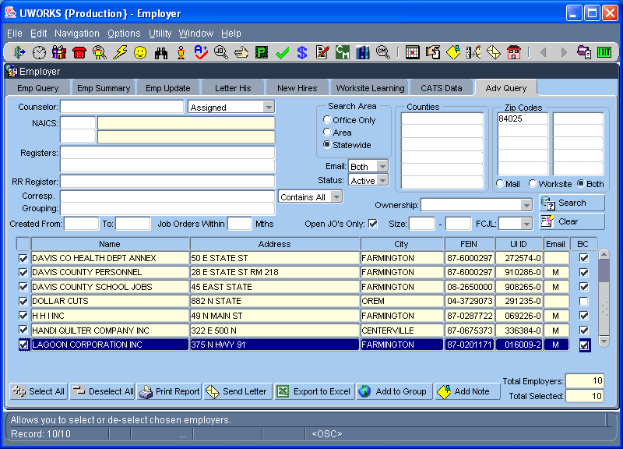
The Employer Adv Query is a tool used to query employers records based on query criteria entered.
Click Employer speed button to access Employer.

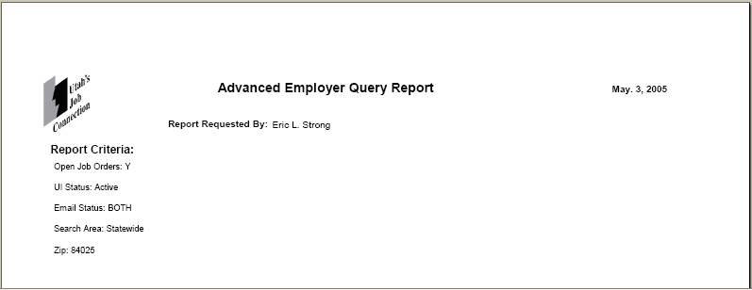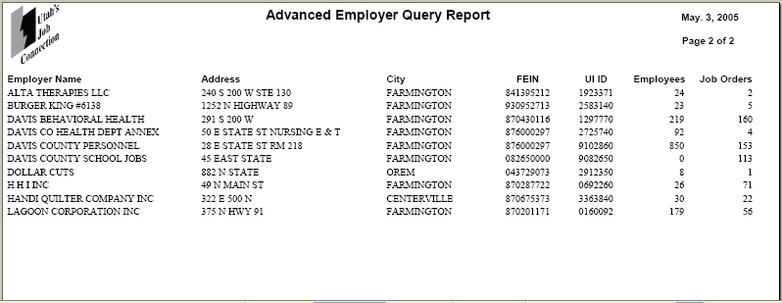
The first page of the Advanced Employer Query Report lists the elements that you selected on the query screen. These elements are listed as “Report Criteria”.
The Advanced Employer Query Report lists information from employer records that meet the criteria you selected from the Advanced Query screen.

Appointment Notification

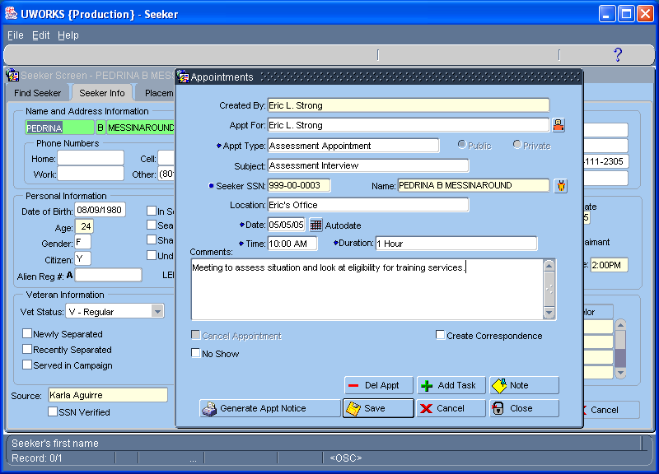
After entering the appointment information select the
button to create the notice.
Click Appointment speed button to access Appointments.

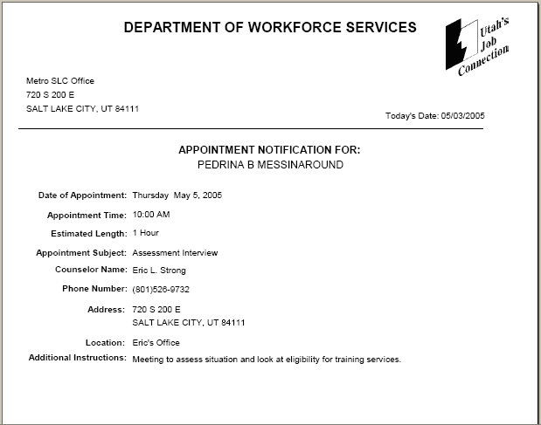
The Appointment Notice is given to the customer to show them their appointment date, time, duration, subject and information about the worker they will be meeting.
Assessment Summary
Select then to access Assessment Summary Report. You must be on an Assessment screen to access this report.
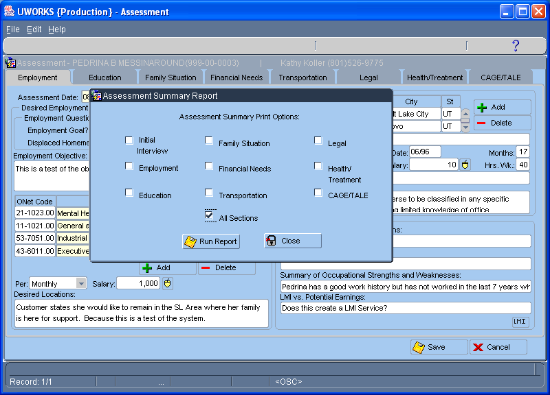
The Assessment Summary Print Options pop-up allows you to display some or all of the Assessment on the printout.

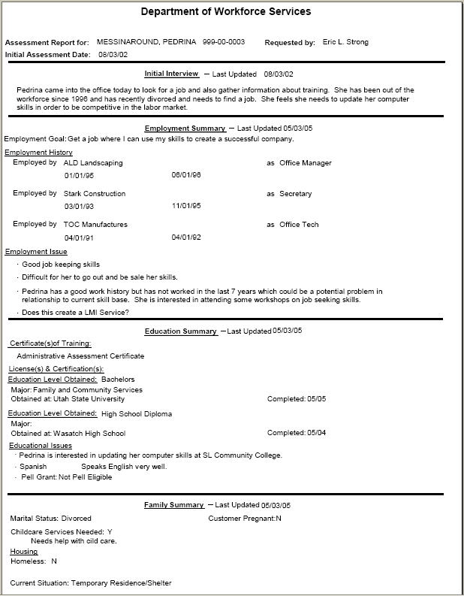
The Assessment Report is divided into sections. Only the sections that were selected on the previous page, “Assessment Summary Print Options” pop-up will be added to the report. This example shows the first four sections.
Authorization/Payment Voucher

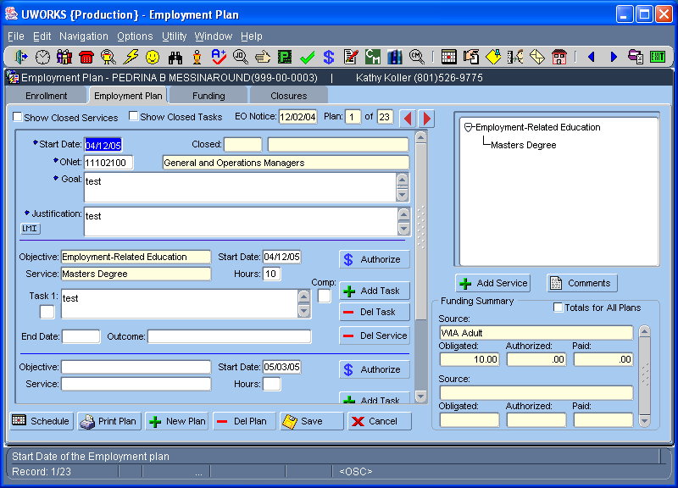
Select the button of the Service that you want to authorize money.
Click Employment Plan speed button to access Employment Plan.

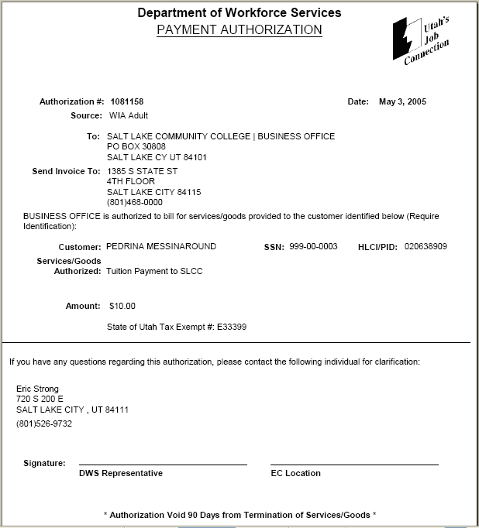
When you create an Authorization there will be an option to print the Payment Authorization voucher. The seeker can take the voucher to the provider specified and that provider can bill the Department for the services listed on the voucher.
Business Management Report (Counselor Detail)

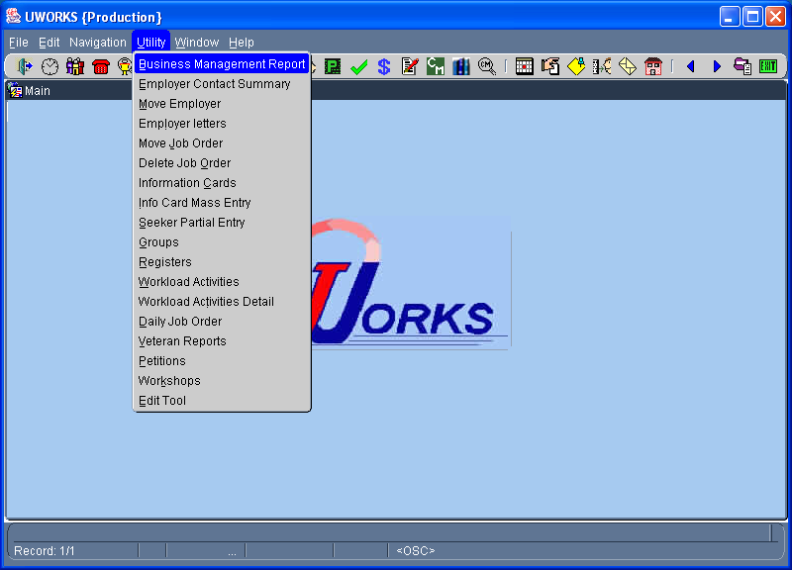
Select then to access the Business Management Report.

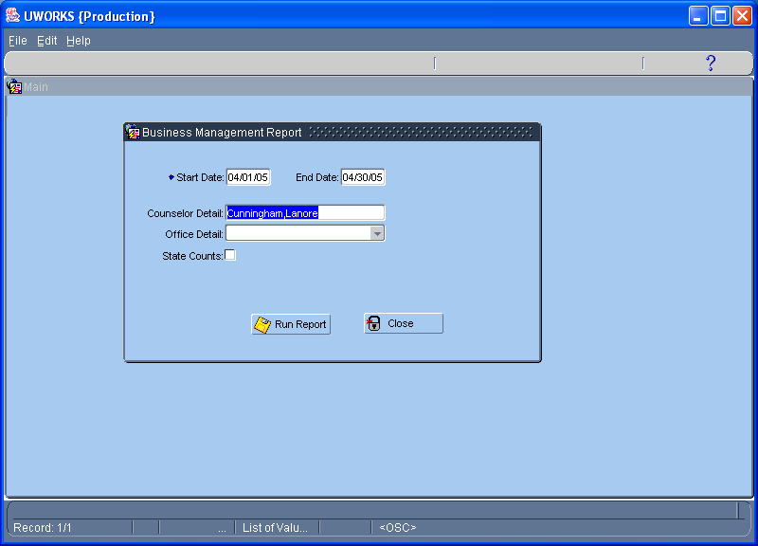
Enter the date range for the desired period. To see the details for a specific worker enter the counselor name in the Counselor Detail box.
Business Management Report (Counselor Detail)/Con’t

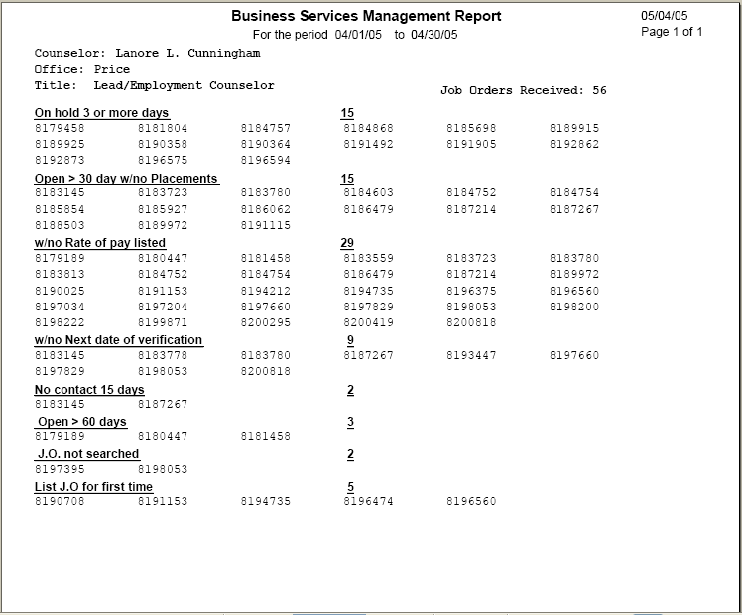
The Counselor Detail report lists information about job orders that are assigned to the worker. This can be used by the worker to check their workload or by management to find possible problems with job orders assigned to counselors.

Business Management Report (Office Detail)

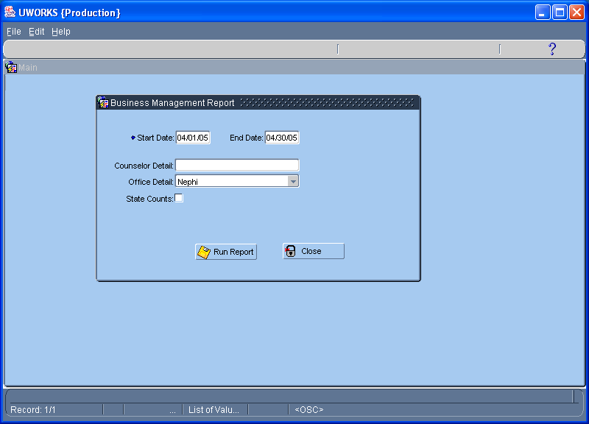
Enter the date range for the desired period. To see the details for a specific office select the office name in the Office Detail dropdown.

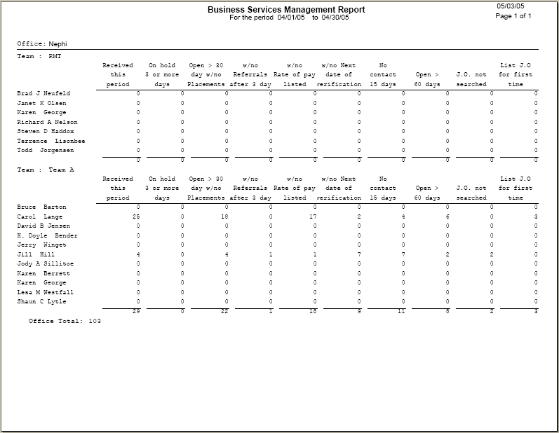
The Office Detail report displays the same general information as the counselor report without listing the specific job order numbers. All workers in the office are listed to show summary information of job orders assigned to them.
Business Management Report (State Detail)

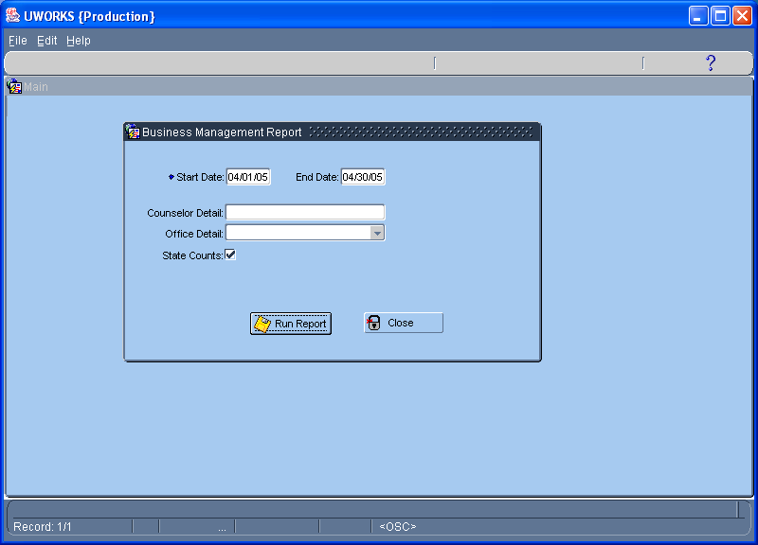
Enter the date range for the desired period. To see the details for the entire state check the State Counts box.

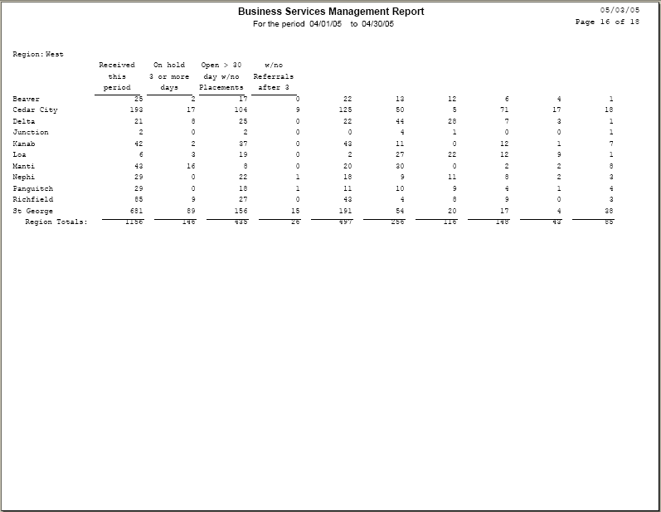
The State Counts report displays the same general information as the other reports. The information is listed by region and office. This provides a summary of how regions and offices are doing compared to the other regions and offices.
Call-In Card

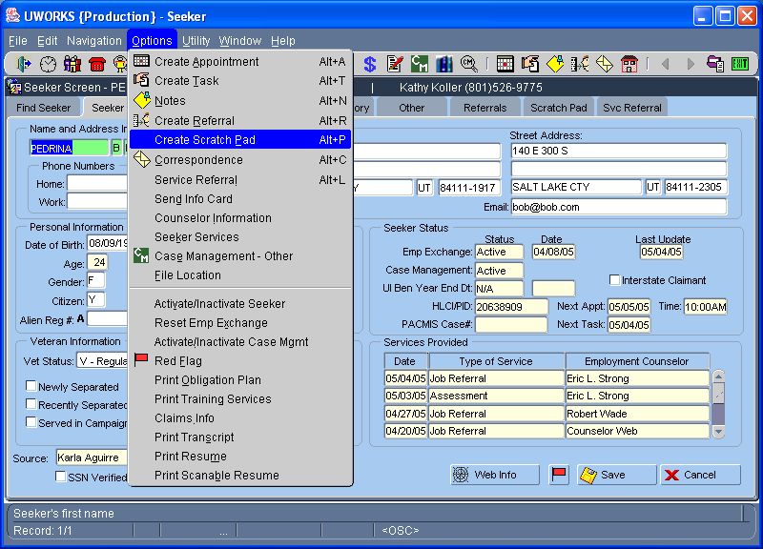
There are a couple of ways to create Call-In Cards. To create a single call-in card select from a Seeker record then . This will open the Create Scratch Pad pop-up below.

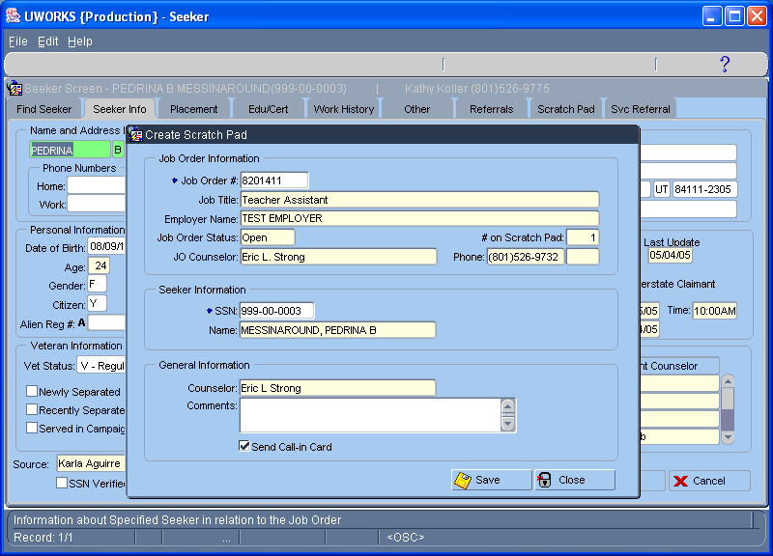
You must have a job order number and seeker social security number entered to create a Scratch Pad/Call-In Card. Make sure that the Send Call-In Card box is checked before selecting save.
Call-In Card/Con’t

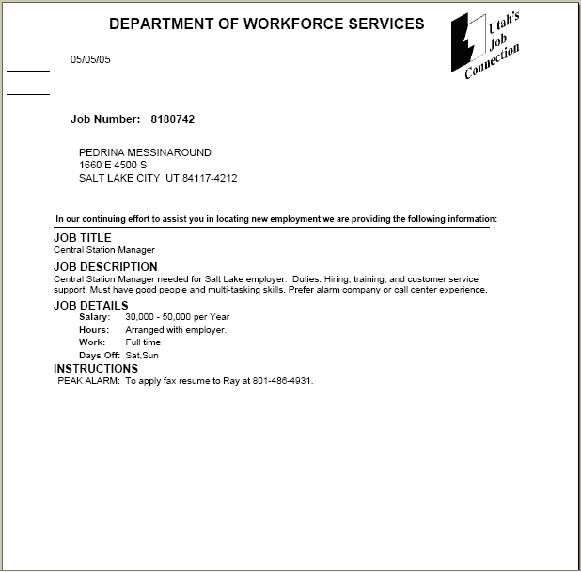
“Call-In Cards” are sent through the mail. They are used to notify qualified job seekers of jobs that they may be interested in. Job information is limited but the instructions give details about how to get additional information if the job seeker is interested.

Case Management Query
Click Case Management Search speed button to access.
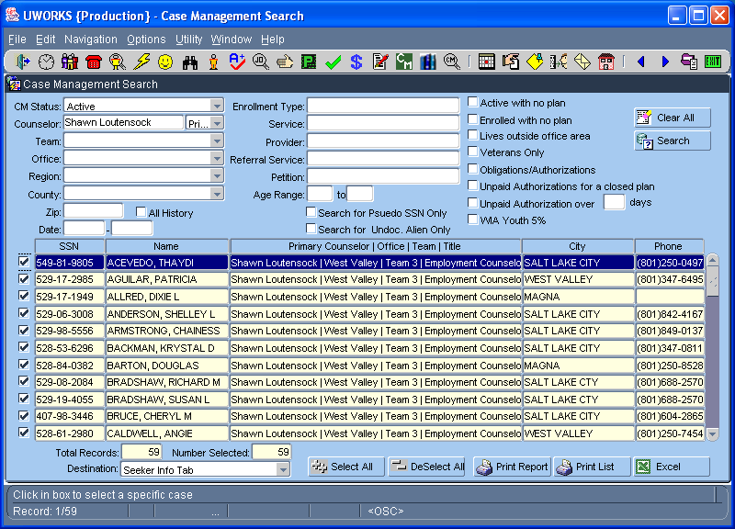
Case Management Search is a query screen that allows workers to query by many different methods to get data about case managed seekers. The example on this page shows all seekers that are “Active” case managed and assigned to the “Primary Counselor” listed.

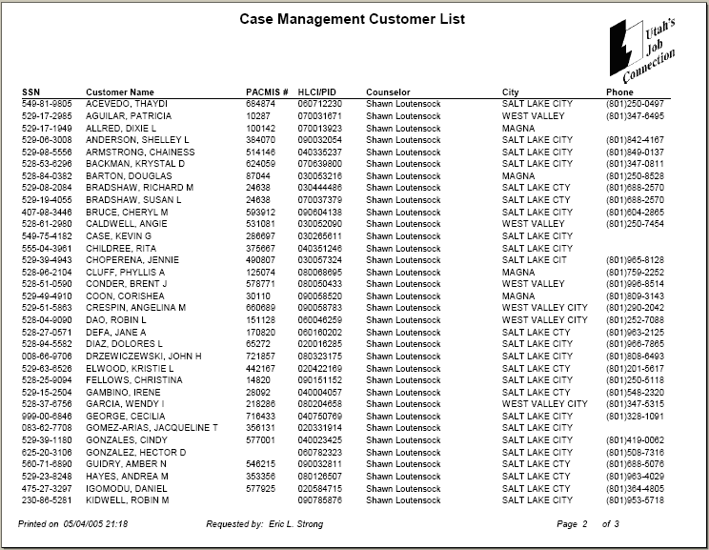
Selecting the button from the Case Management Search screen bring up a list of all the seekers found from the query. It displays general information about each person.

Case Management Query/Con’t

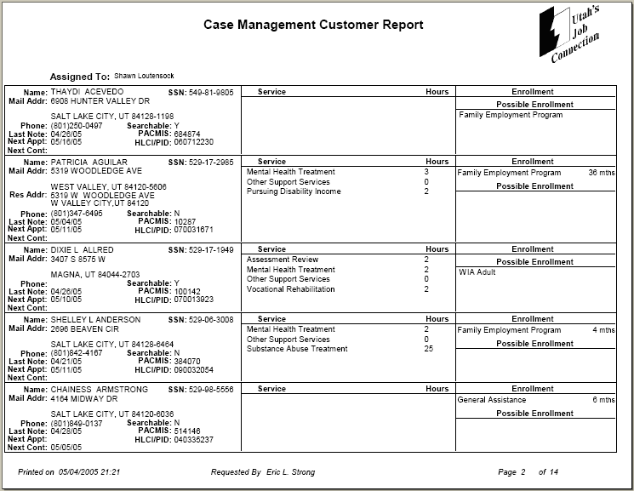
Selecting the button from the Case Management Search screen brings up detailed information about each person found in the query. The information is specific to their employment plan. Workers use this report to make sure that they are working with their customers and following up on their progress.

(As you can see, this example only shows 2 pages of the 14-page report.)

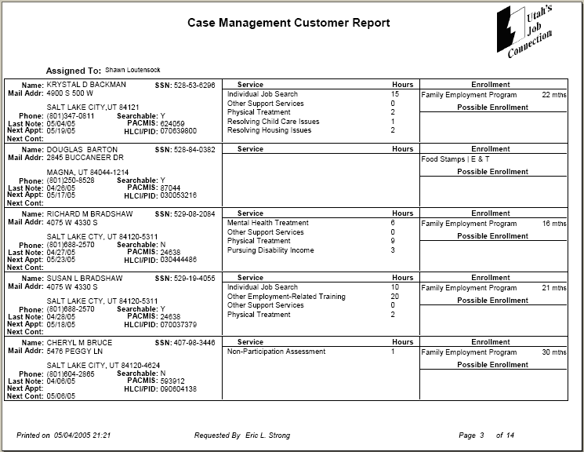
Claims Payment History

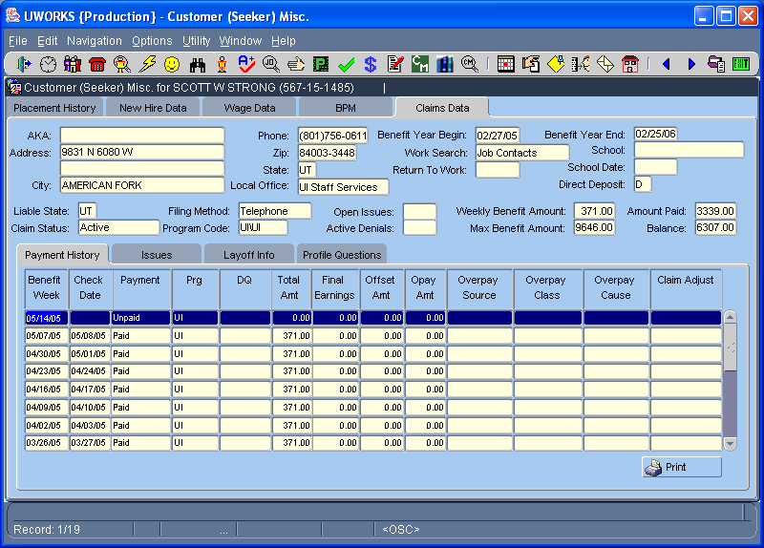
The Claims Data screen provides extensive data about unemployment benefits if the seeker has an unemployment benefits history.
Click Customer Misc. speed button to access Customer Misc screens.

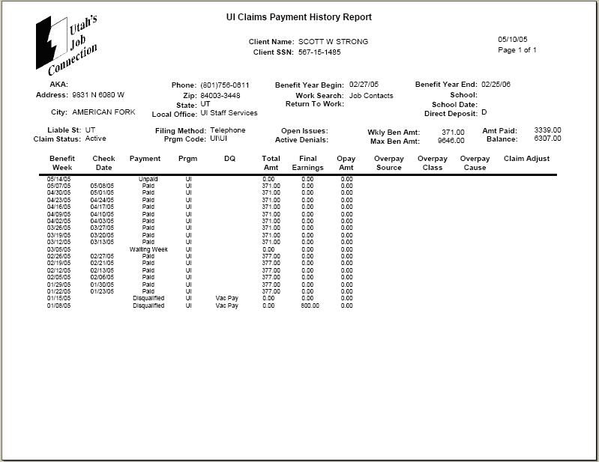
The UI Claims Payment History Report provides information about the unemployment payments that a seeker is receiving or has received.

Correspondence Template

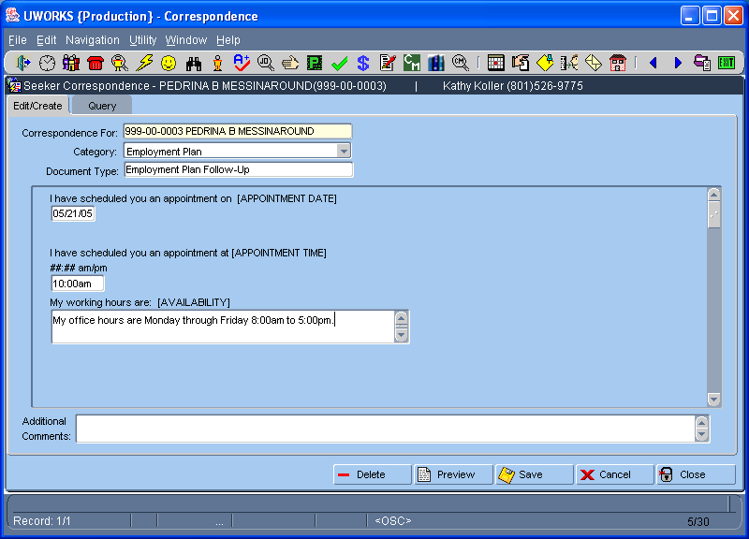
A Correspondence Template is used to select letters from a list. Use the template to enter listed information related to the letter you are sending.
Click Seeker Correspondence speed button to access Correspondence.

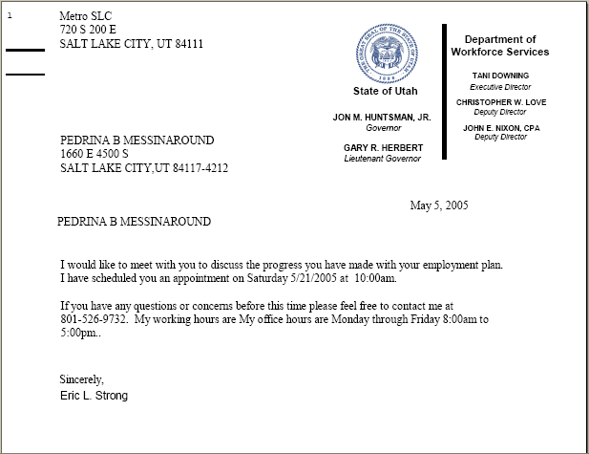
The information entered on the template is used to create a letter. The letters are generally set up for case managed customers. This letter is an example of a customer that is being scheduled to come into the office and meet with their worker and discuss progress on their employment plan.
Daily Job Order List

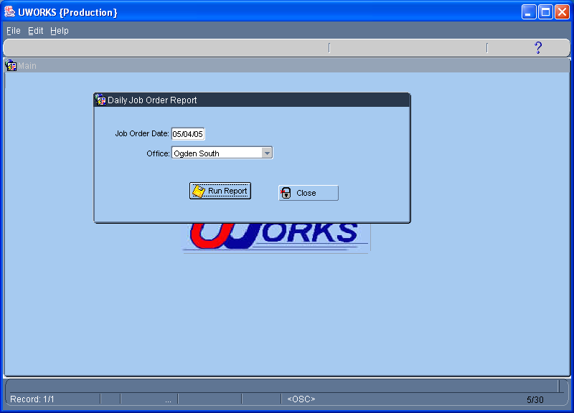
Use the Daily Job Order Report to see a list of all the job orders that were received by an office on a given day. Select date, office and .
Click then to access the Daily Job Order Report.

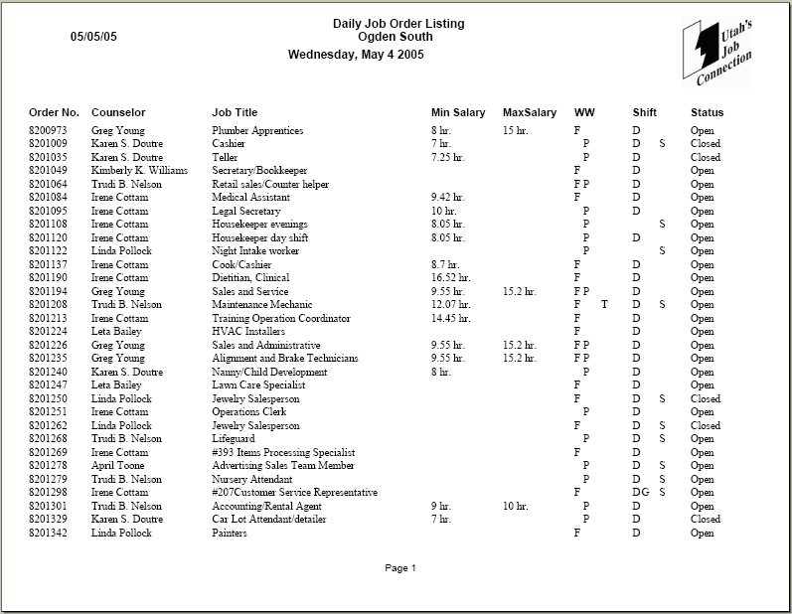
This Daily Job Order Listing shows all the job orders taken by the Ogden office on May 4, 2005. Some limited information about the job orders are also listed.
Daily Schedule

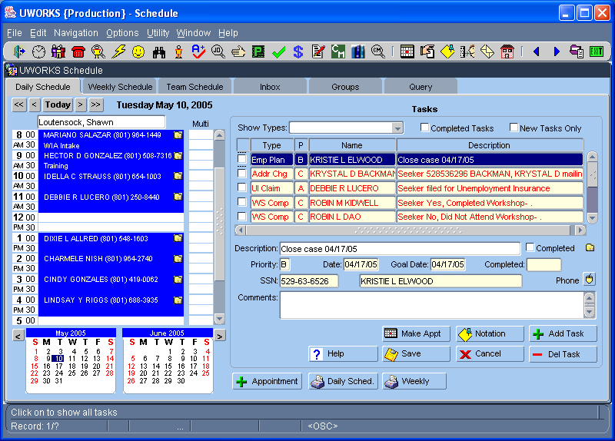
The Daily Schedule screen lists appointments and tasks for the day selected.
Click Daily Schedule speed button to access Scheduling.

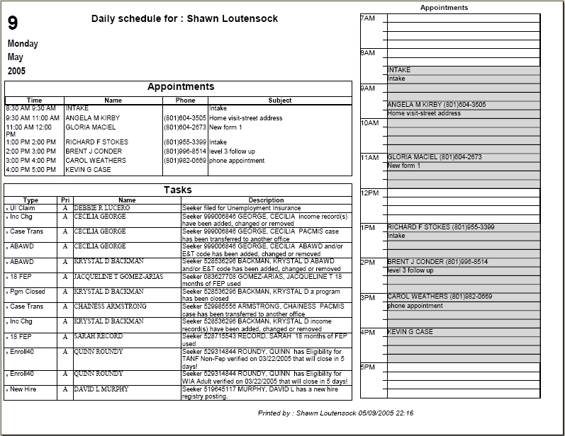
Workers can view or print their Daily Schedule to see the appointments and tasks that they have for the day.
Daily Team Calendar

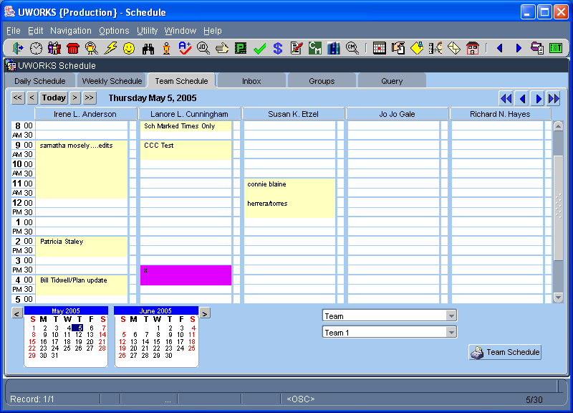
Click Daily Schedule speed button to access Scheduling.
The Daily Team Calendar shows the schedule for the whole team for the day selected.

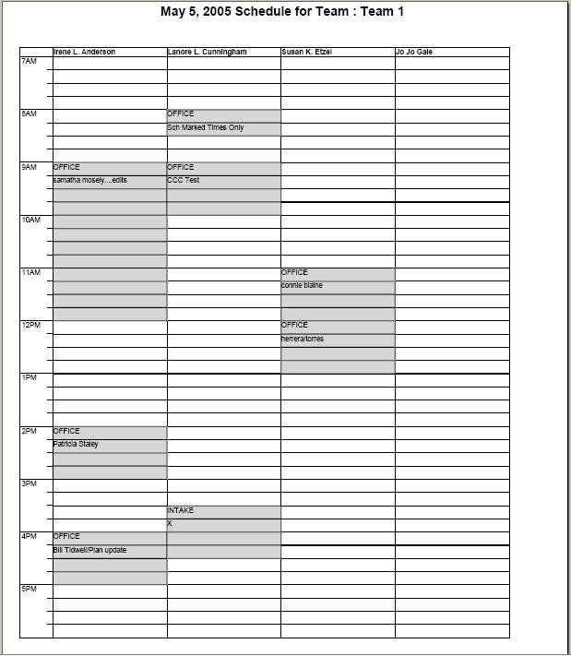
The Team Schedule report is an easy way to see the daily schedule for the whole team.
Edit Results

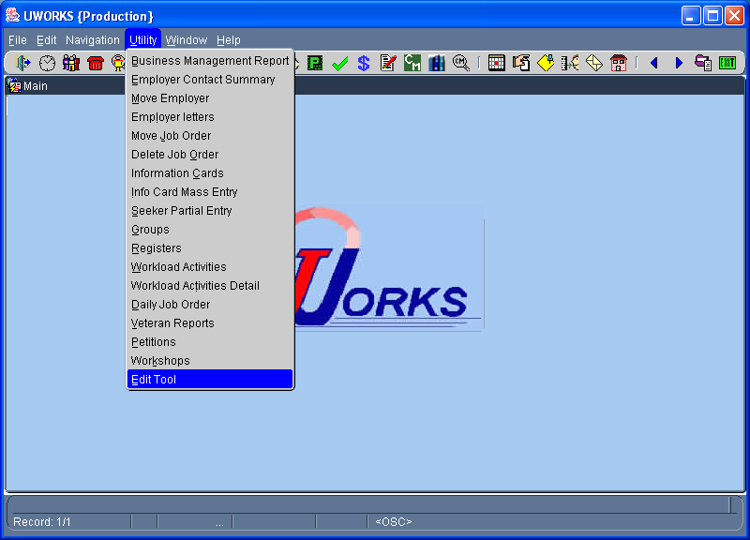
Access the Edit Tool by clicking then .
The Edit Tool is used to complete and review edits that have been done on a case management case or a job order.

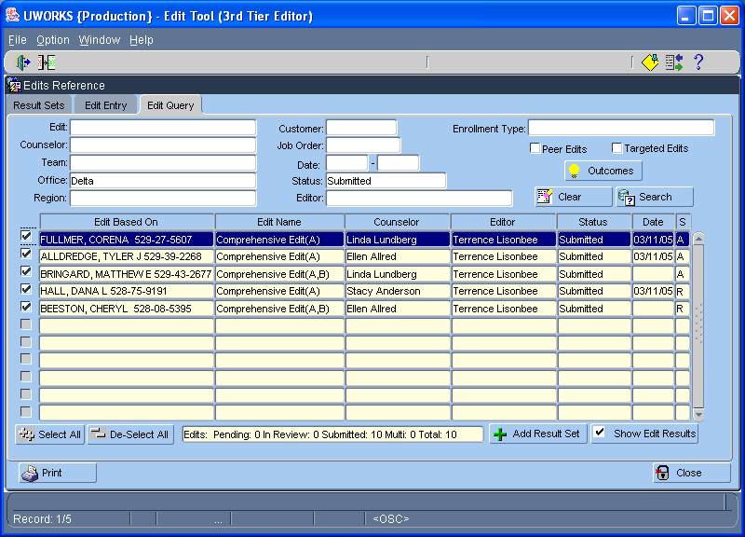
Select the Edit Query tab and then enter your search criteria to find the edit information you are looking for. This example lists edits for the Delta office that have been submitted. Select the button to print the report.
Edit Results/Con’t

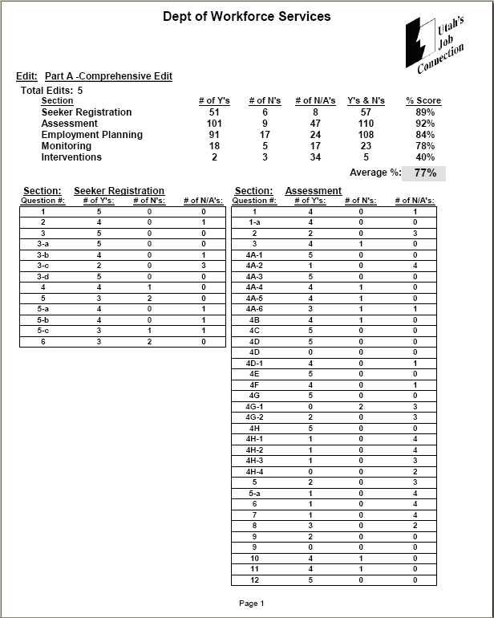
The Edit report shows the basic information from the edit result set. This example shows summary information and the answers for each question. This only shows the first page of the report.

Edit Detail

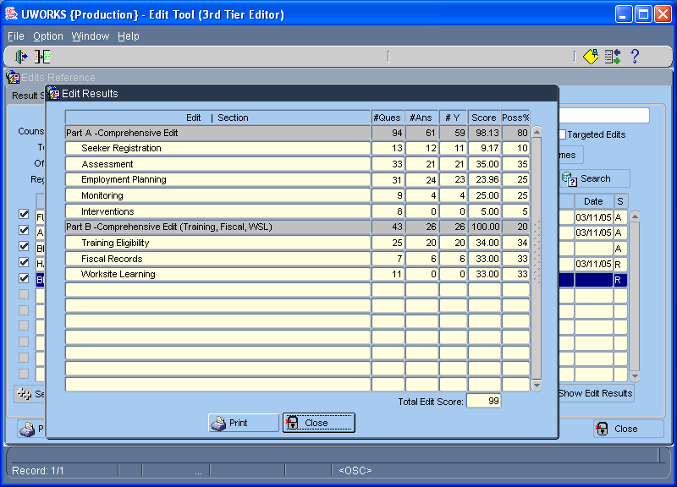
To see the Edit Detail Results click the button. This will bring up the Edit Results pop-up and you can select to print the detail report.

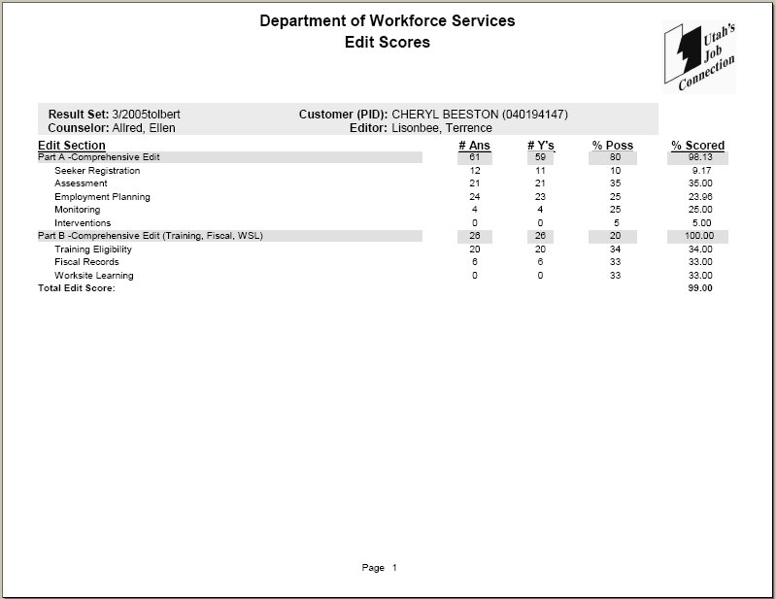
The first page lists the counselor being edited and the customer case that was used for the edit. A summary for each section is listed to show the number of questions answered, how many were answered “yes”, % possible and the % scored.
Edit Detail/Con’t

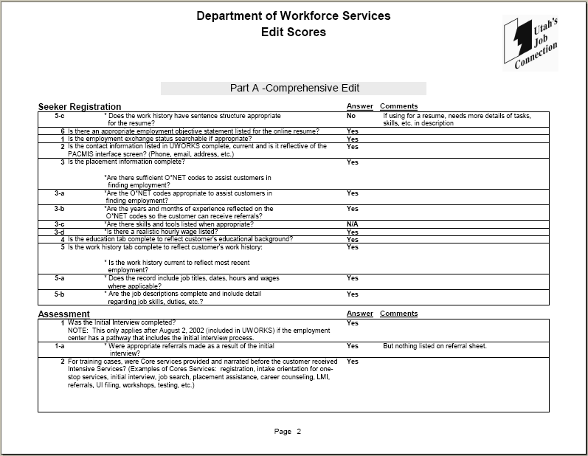
The remainder of the report goes through each Part of the edit and shows the answer to each question and any comments next to the answer. This example only shows 2 pages but the report is several pages long.
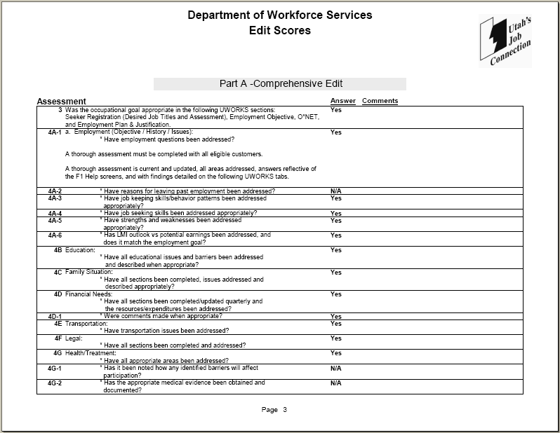
Employer Contact Summary (Counselor)

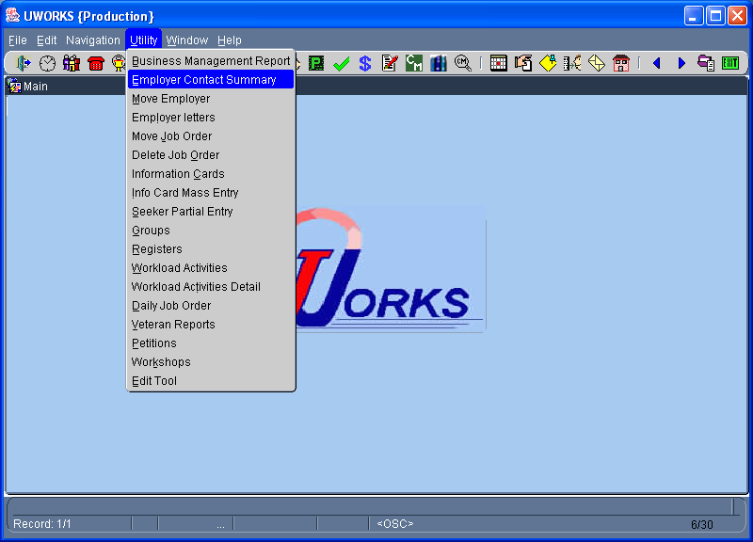
Access the Employer Contact Summary report by clicking then

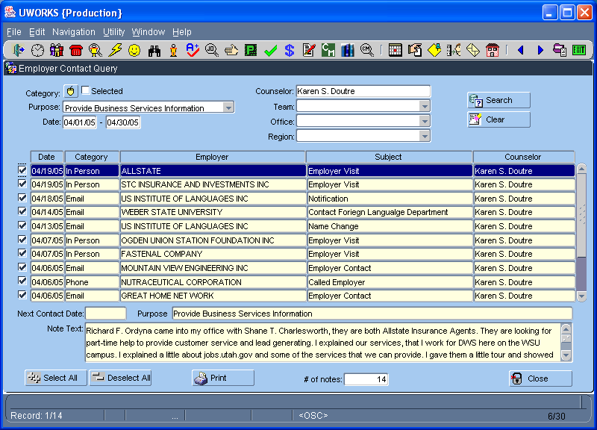
From the Employer Contact Query screen you select the query items you are looking for. In this example we selected Purpose, Date Range, and a Counselor. Select to populate the results then to print the report.
Employer Contact Summary/Con’t (Counselor)

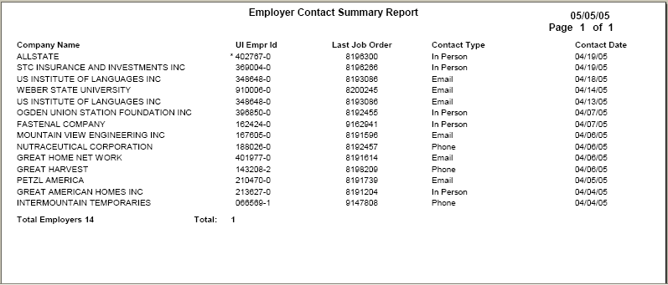
This Counselor report is an example of a report queried by counselor. The report shows the employers that the counselor contacted and the method used to contact them.

Employer Contact Summary/Con’t (Team)

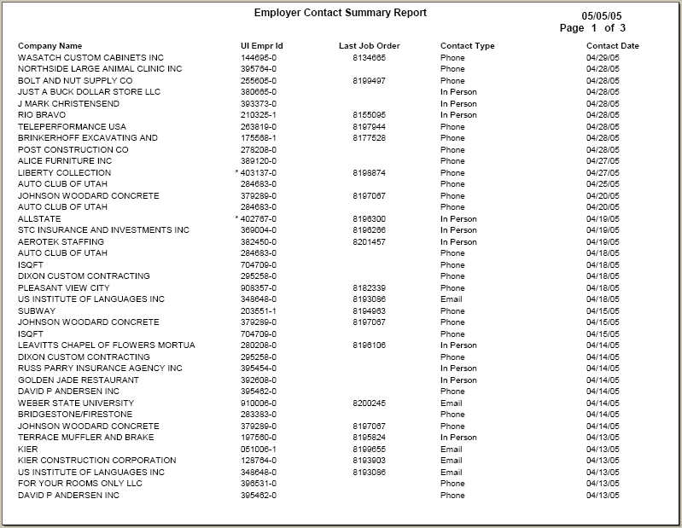
This Team report is an example of a report queried by team. The report shows the employers that the team contacted and the method used to contact them.

Employer Contact Summary/Con’t (Office)

This Office report is an example of a report queried by office. The report shows the employers that the office contacted and the method used to contact them.

Employer Contact Summary/Con’t (Region)

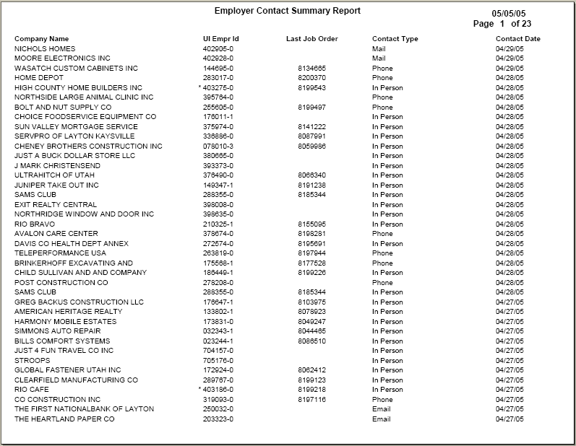
This Region report is an example of a report queried by region. The report shows the employers that the region contacted and the method used to contact them.
Employer Letters

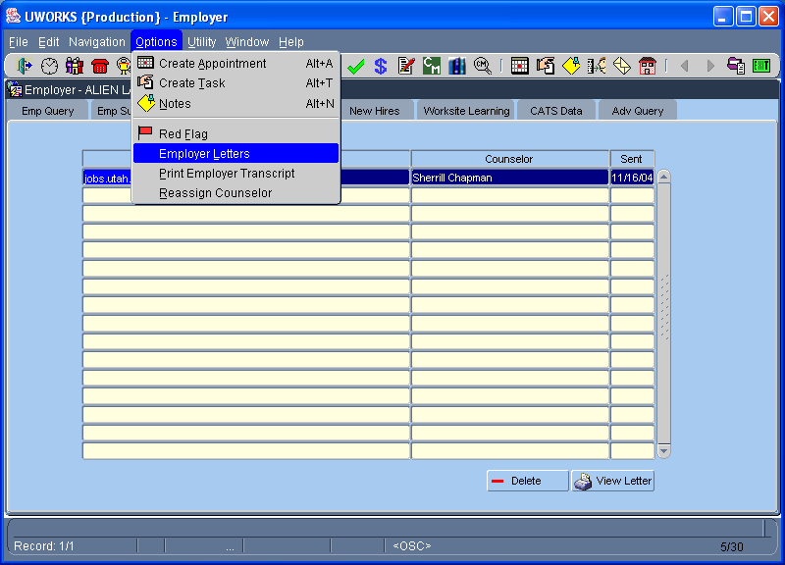
Access the Employer Letters report by clicking then from the Employer screens.

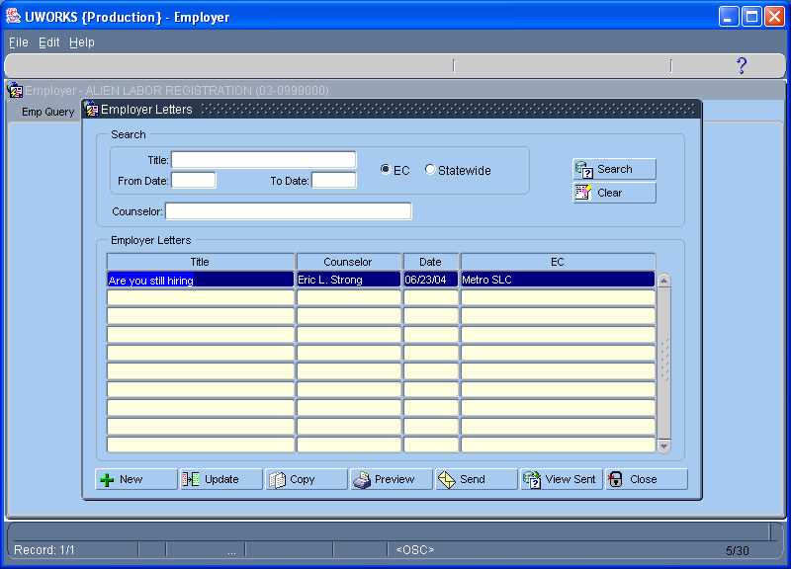
The Employer Letters screen allows you to search for letters. You can find letter you have used in the past, copy other letters or create a new letters. You can update existing letters, preview letters and view sent letters. To send a letter select the one you want from the list and select .
Employer Letters/Con’t

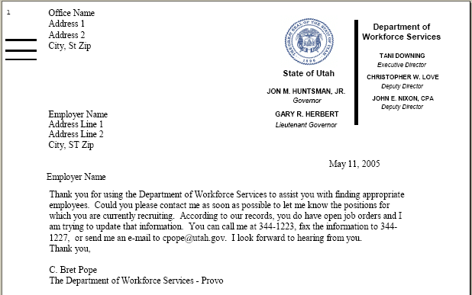
This page is an example of a letter that can be sent to an employer. The actual letter will have the employer name and address listed at the top.

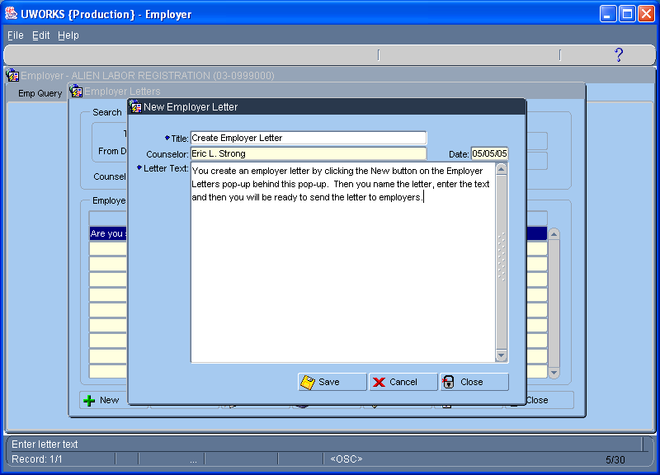
This page is an example of how to create a letter. You enter the Title and the letter text and then save the letter.
Employer Letters Sent

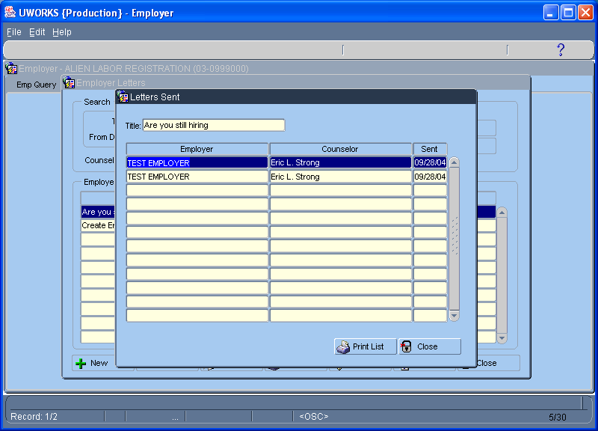
This page is an example of how to see letters. You can select to print a listing of the letters you have sent.

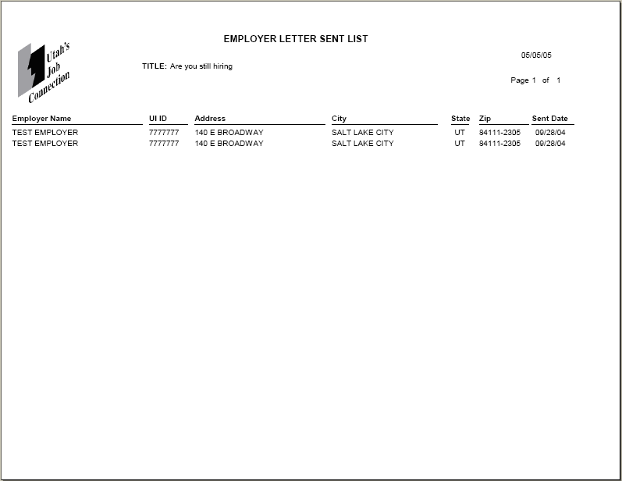
This report lists all of the letters that you have sent. Some summary information about the employers that received the letters is listed on this report.

Employer New Hire List

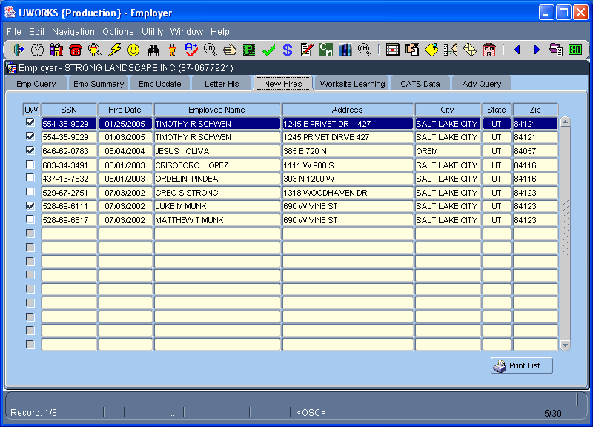
Click Employer speed button to access Employer.
The Employer New Hire tab lists all of the job seekers that the employer has reported as hires. To get a printout of the information on the screen select

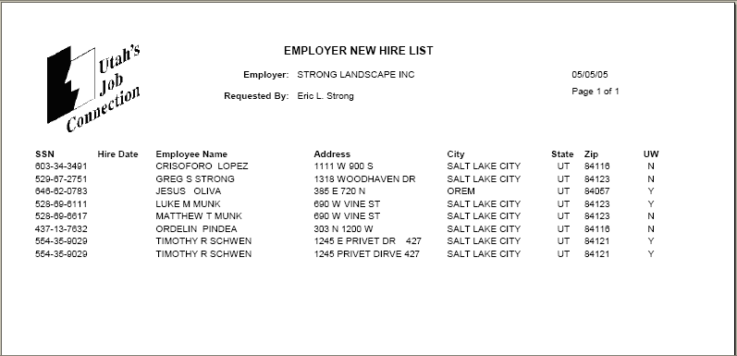
The Employer New Hire List shows the employer name and then lists the job seekers that the employer has reported as hiring. The “UW” column lists if the seeker is registered in the system or not.

Employer Survey

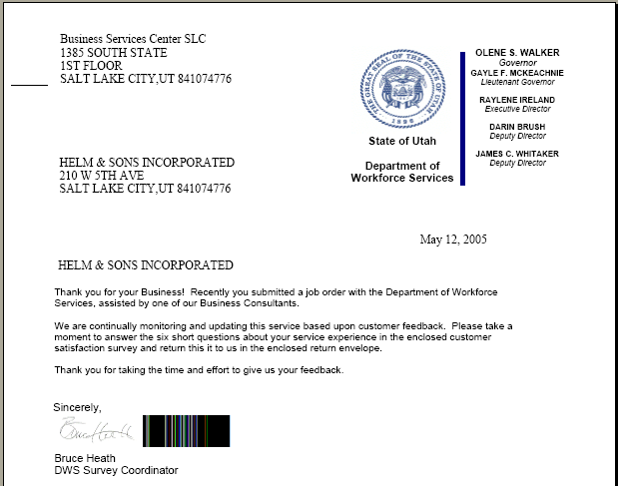
The Employer Survey has a cover letter (see example on this page) with an attached survey. To create the survey you run a job that randomly selects employers that have not received a survey in the past 6 months and has posted job orders in the system. The job will create the cover letter and the survey so they can be sorted and mailed.

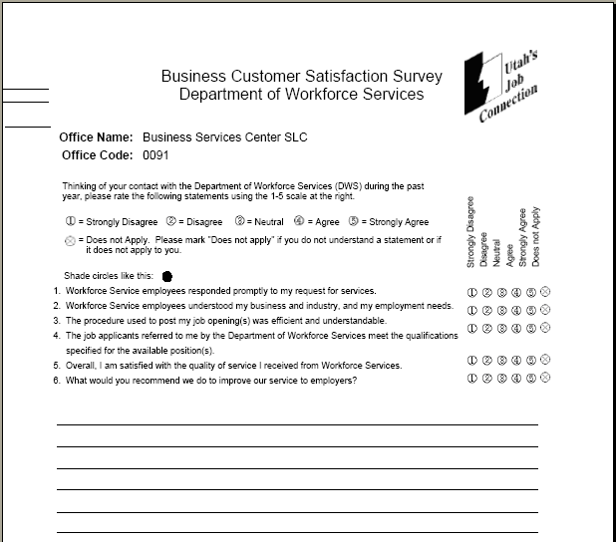
The Survey is attached to the cover letter and mailed out to the employer with a return envelop for them to mail the survey back. This page shows an example of the survey.
Employer Survey W/O Attachment

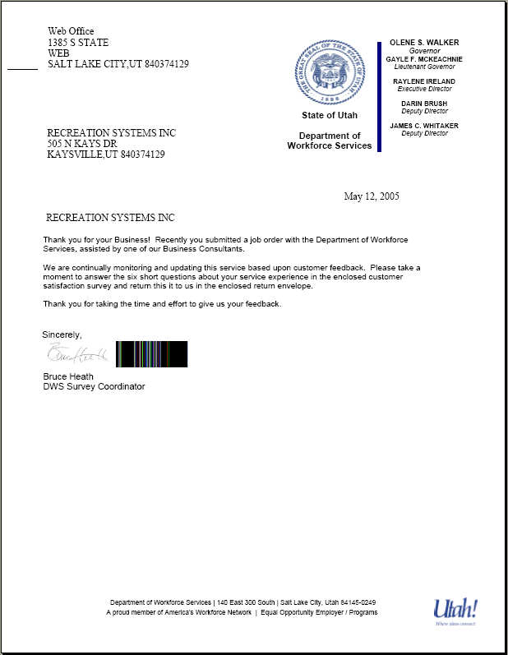
You can run the job to create Employer Surveys without including the attachment (survey page). Running the job this way will create the employer cover letters only. This gives you the option to add the survey and stuff the envelopes by hand. This page shows an example of the employer survey cover letter.

Employer Transcript

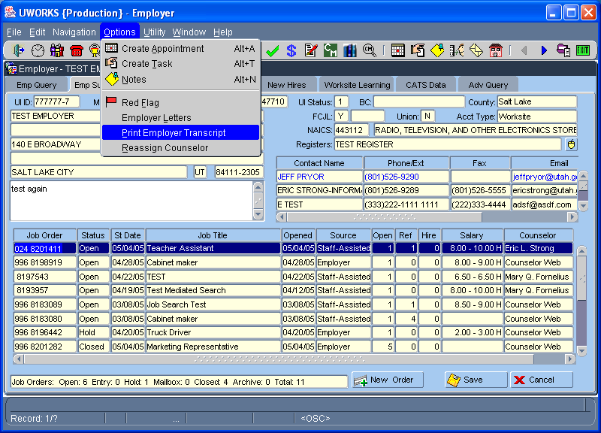
Access Employer Transcript by clicking then from the Employer screens.
The Employer Transcript lists information about the employer. It includes address information, assigned business consultant, and some other details about the employer.
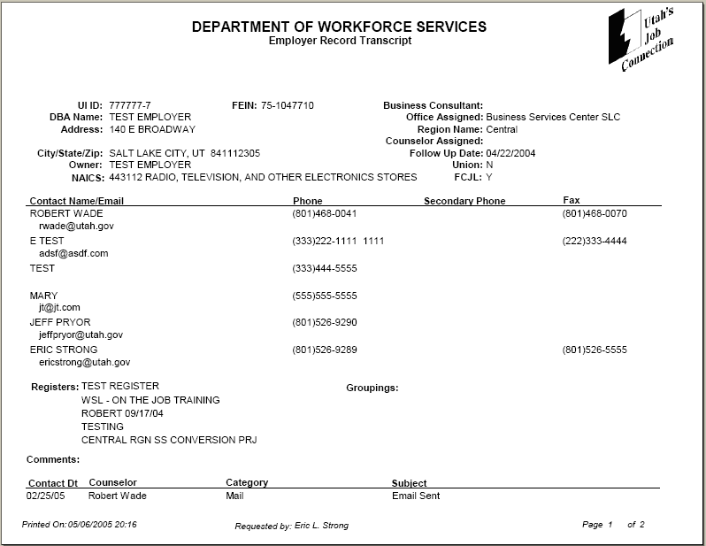
All Employer Contacts are listed along with their email, phone, and fax information.
Registers and Groupings are also listed on this page.
Employer Transcript/Con’t

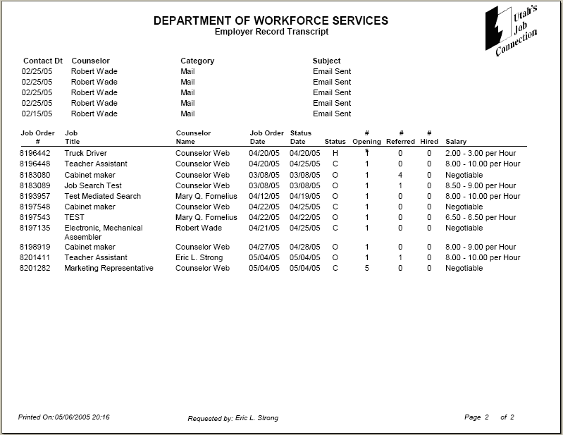
A history of Employment Counselor Contacts is listed. It shows the date of the contact, the counselor, and the type of contact made.
The final section of the report lists the Job Orders that the employer has had in the system. It displays some basic information about the job orders.

Employment Plan

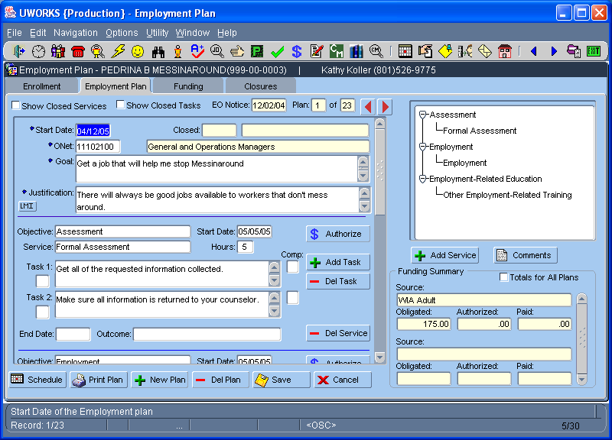
Click Employment Plan speed button to access Employment Plan.
The Employment Plan screen is used to create an Employment plan for a customer to help them become self-sufficient. The plan is created on this screen and can be printed by selecting .
Employment Plan/Con’t

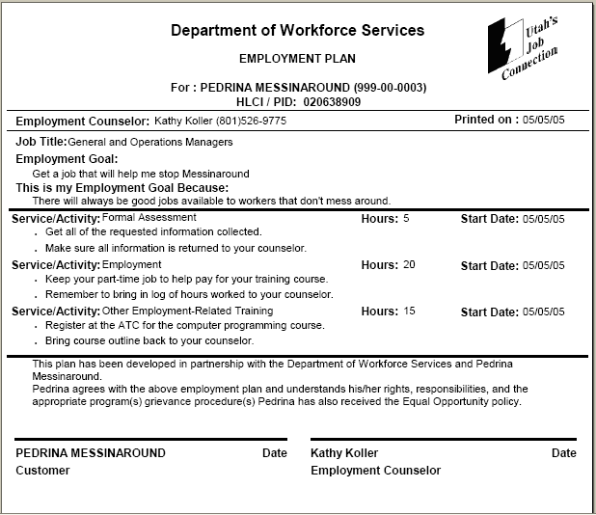
Generally an Employment Plan is developed with the counselor and customer working together to create the best plan possible for the success of the customer. The plan is an agreement between the counselor and customer and should be signed by both. Each should retain a copy of the plan.

Employment Plan Closure Report (FEP Non-Participation Closure)
Send a FEP Non-Participation Closure letter by clicking on the Correspondence speed button.
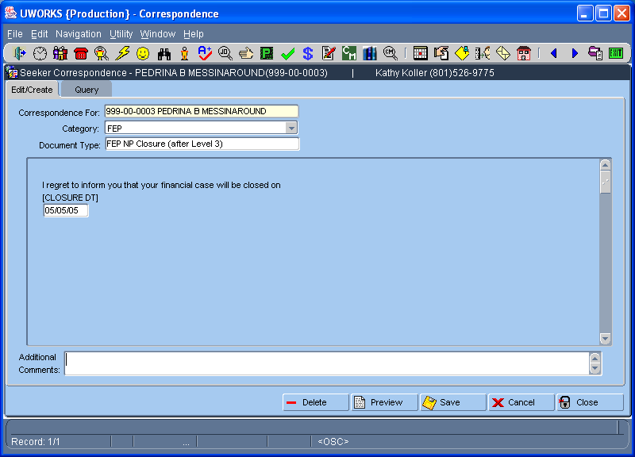
Select Customer, Category - FEP, and Document Type FEP NP Closure. The template requires the date that the FEP case will close and any other comments. Click to send the letter.
Employment Plan Closure Report/Con’t (FEP Non-Participation Closure)

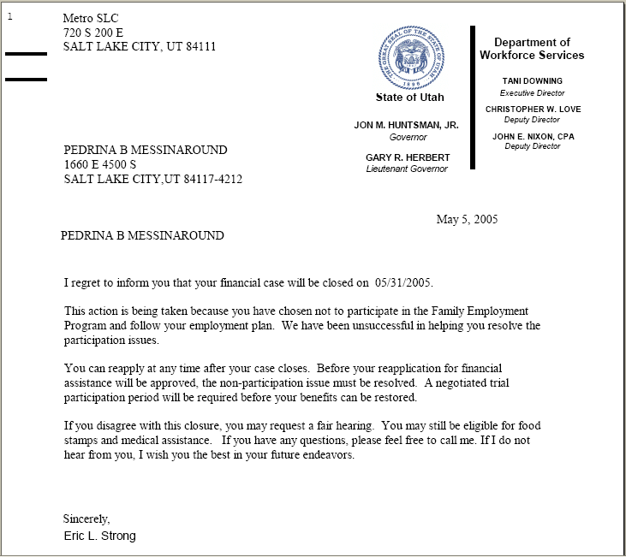
The Closure Letter lets the customer know when their case will be closed and why. It also let’s them know their rights to reapply or file for a hearing.

Employment Plan Closure Report/Con’t (Resource Letter/Pg. 1)

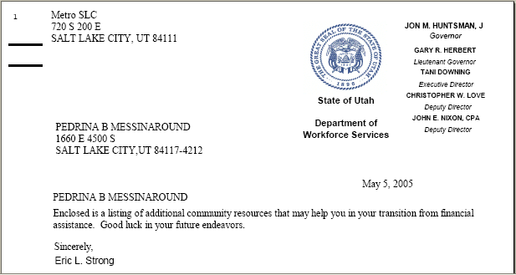
The customer will no longer be getting financial assistance. Pg. 1 of this Resource Attachment Letter lets them know that resource information is enclosed in this letter.

Employment Plan Closure Report/Con’t (Resource Letter/Pg. 2)

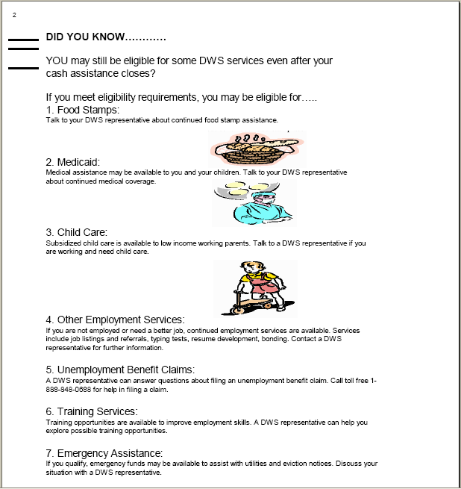
Pg. 2 of the Resource Letter gives the customer information about other Department programs that they may be eligible to receive.

Employment Plan Closure Report/Con’t (Resource Letter/Pg. 3)

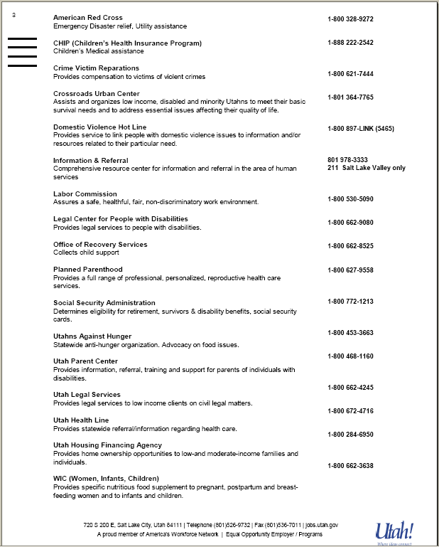
Pg. 3 of the Resource letter gives the customer information about programs and services available from other agencies and community resources.

Employment Plan Closure Report (FEP Time-Limit Closure)
To send a FEP Time-Limit Closure letter go to Correspondence by selecting the Correspondence speed button.
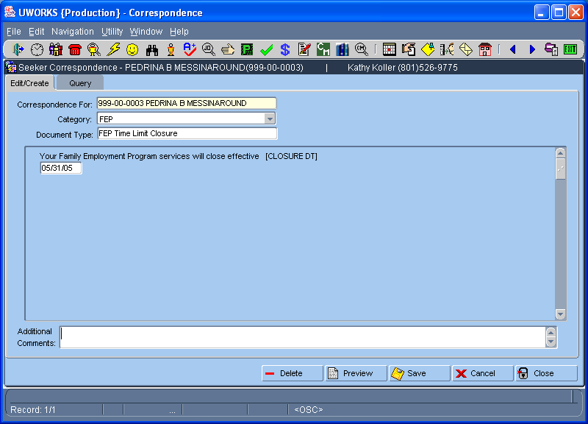
Select Customer, Category - FEP, and Document Type FEP Time Limit Closure. The template requires the date that the FEP case will close and any other comments. Click to send the letter.

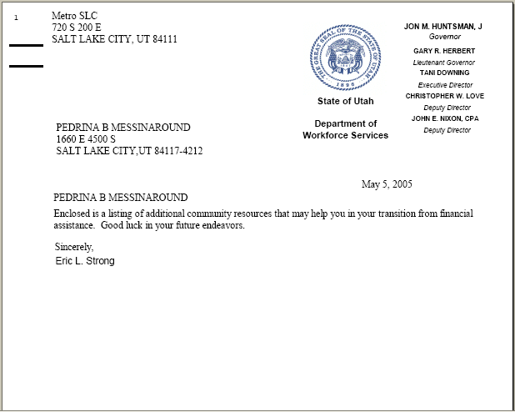
The customer will no longer be getting financial assistance. This letter let’s the customer know that resource information is enclosed. The resource information is the same as Page 2 and 3 of the FEP Non-Participation Closure letter
Employment Plan Closure Report/Con’t (Additional Services Letter)

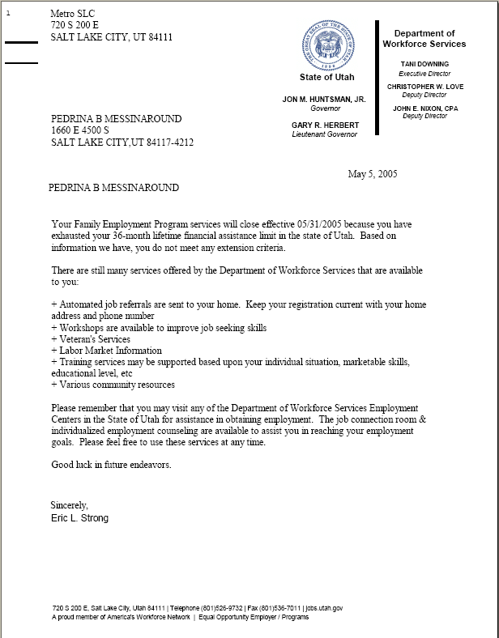
This letter is also sent with FEP Time Limit Closures. It includes information about other Department programs related to job searching and employment activities.

Employment Plan/Training Plan Agreement
Access Employment Plan Training Services Plan by clicking then from Employment Plan. The first time you print an Employment Plan after training funds have been obligated the Training Services Plan will also print. After that use the above to access.
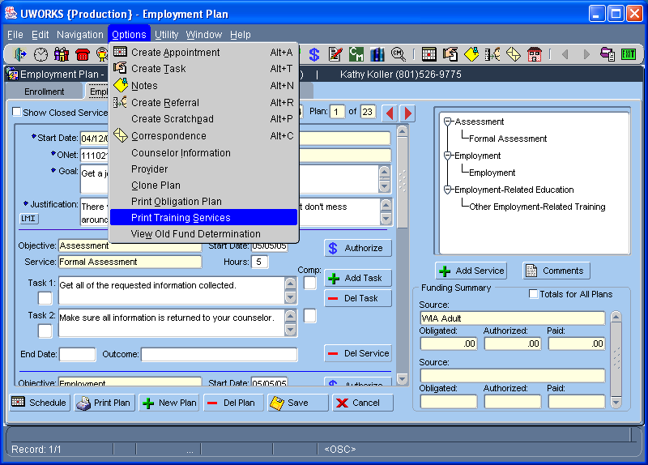

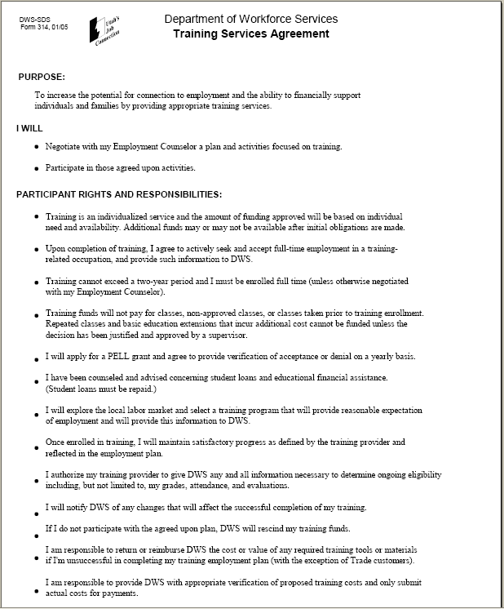
The Employment Plan Training Agreement is part of the Employment Plan report. It only prints out when you have an employment plan with training programs attached. This usually occurs when you obligate training money. The Training Services Plan is an agreement between the counselor and customer and should be signed by both.
Employment Plan/Training Plan Agreement/Con’t

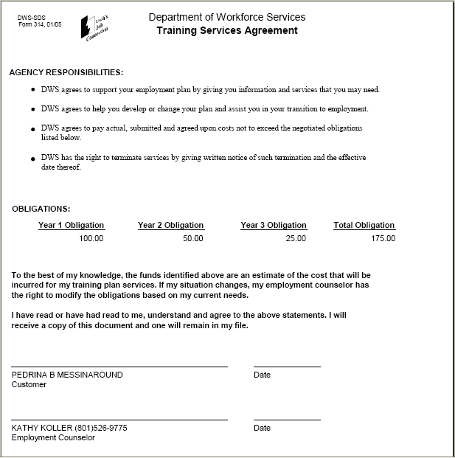
The second page of the plan includes an Obligation Plan showing the amount of money committed per year towards the customers training services. The counselor and customer must each sign the agreement. Both should also have a copy of the training plan.

EO Notice
The Equal Opportunity Letter is required to be sent to each customer that is provided intensive employment services. The system automatically sends the letter when an employment plan is created. There is an EO Notice field at the top of the employment plan that shows the date the letter was sent.
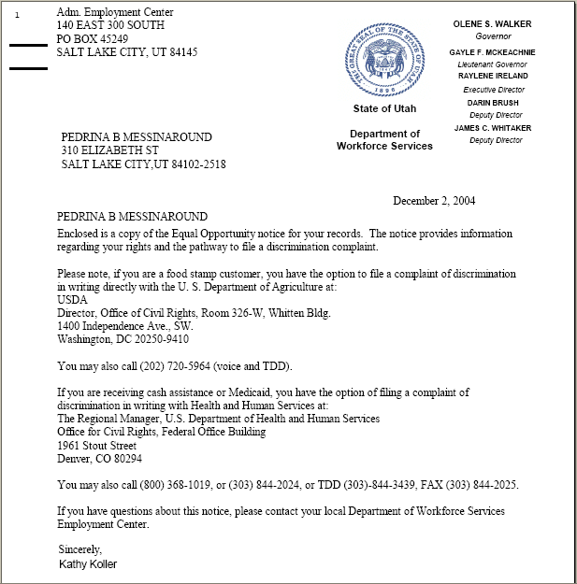
EO Notice/Con’t

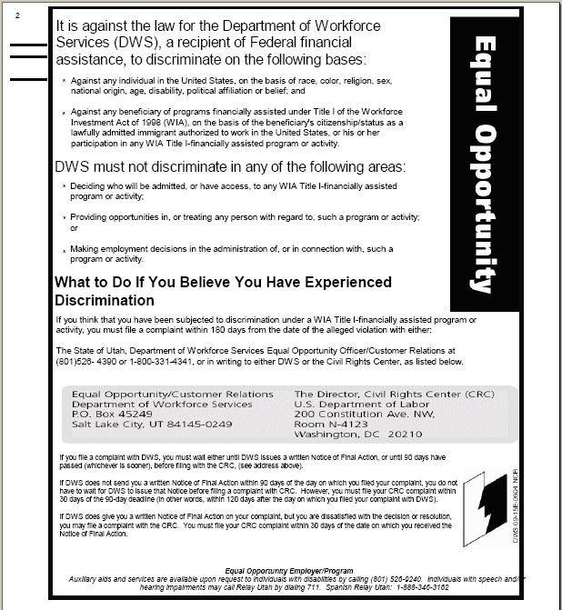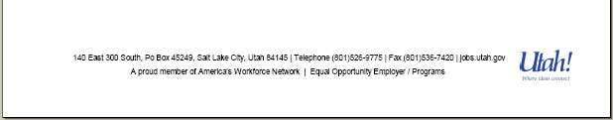
This is a copy of the Equal Opportunity Letter that is sent to all customers that receive intensive services. The letter gives the customer the information about equal opportunity laws. To see a copy of the letter that was sent to the customer click on the Seeker History speed button.

Funding Reports Query (Customer Detail)
Access Funding Reports Query by clicking then from the Menu Bar. Only Accountants have security access to Funding screens.
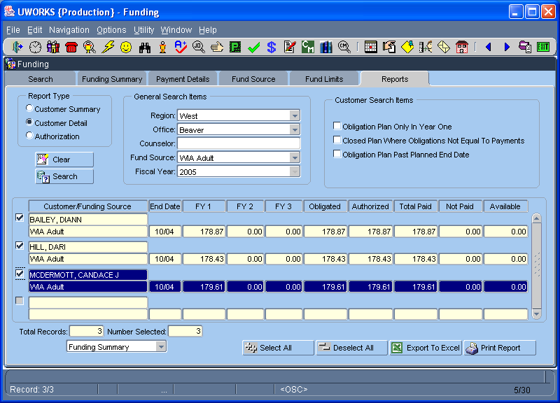
From the Reports tab select the Customer Detail report type. Also select any general search items and any customer search items desired. Click to return results.

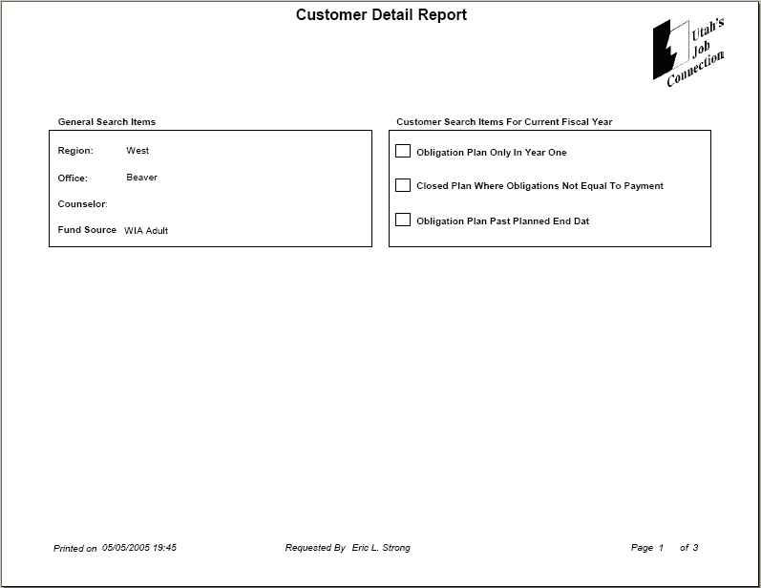
Select to print the report. The first page of the report lists the items you selected from the query page. This example shows that the report includes information about the WIA Adult program in the Beaver office.
Funding Reports Query/Con’t (Customer Detail/Pg. 2 & 3)

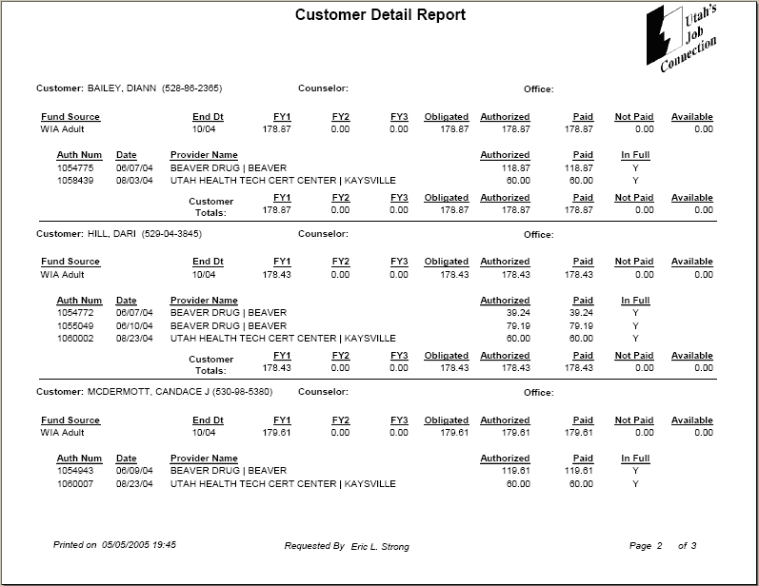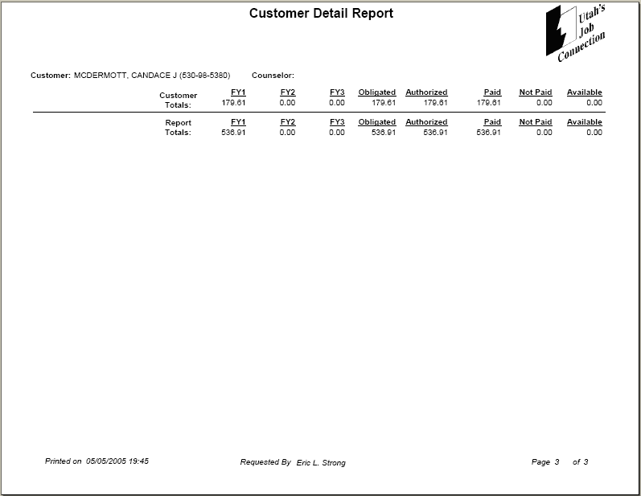
Information on the report includes customer name, fund source (WIA), the amount obligated, amount authorized, amount paid and the amount still available. It also lists each authorization number, date, provider name, the amount they authorized and paid. Each customer has a total amount line.

At the end of the report the totals for all customers included on the report are given for each column.
Funding Reports Query (Customer Summary)
Access Funding Reports Query by clicking then from the Menu Bar. Only Accountants have security access to Funding screens.
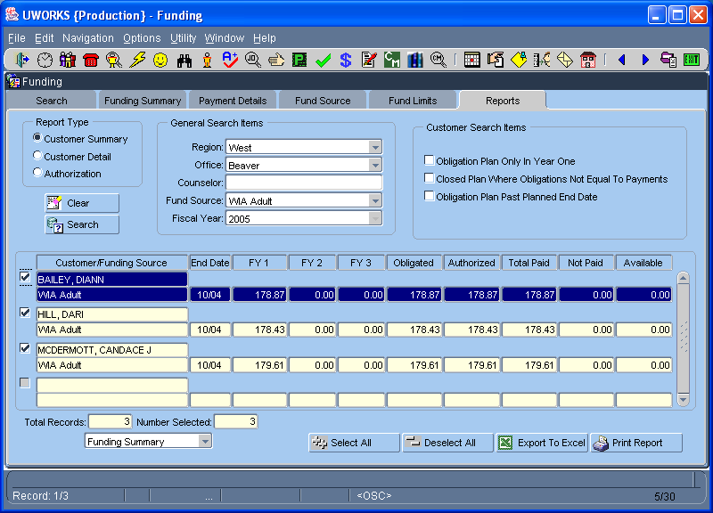
From the Reports tab select the Customer Summary report type. Also select the general search items and any customer search items desired. Click to return results.

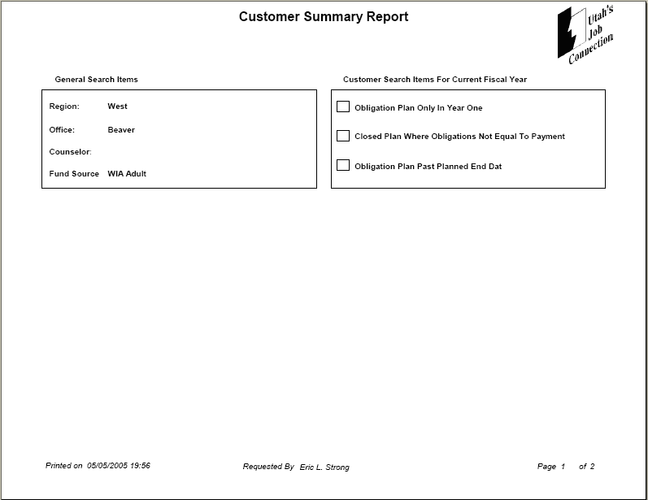
Select to print the report. The first page of the report lists the items you selected from the query page. This example shows that the report includes information about the WIA Adult program in the Beaver office.
Funding Reports Query/Con’t (Customer Summary Pg. 2)

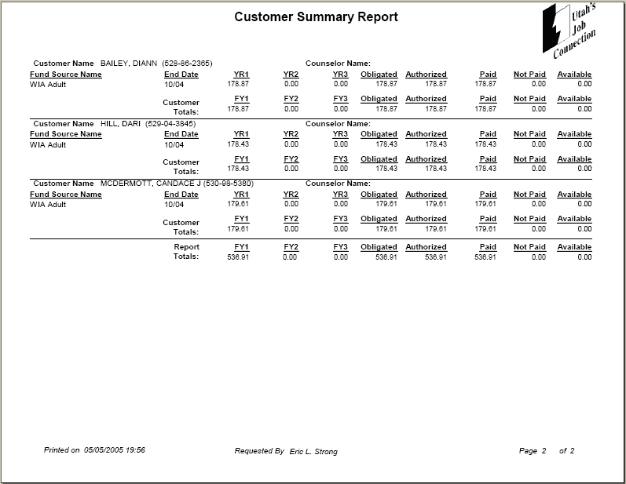
Information on the report includes customer name, fund source (WIA), the amount obligated, amount authorized, amount paid and the amount still available. Each customer has a total amount line.

At the end of the report the totals for all customers included on the report are given for each column.

Funding Reports Query (Authorizations)
Access Funding Reports Query by clicking then from the Menu Bar. Only Accountants have security access to Funding screens.
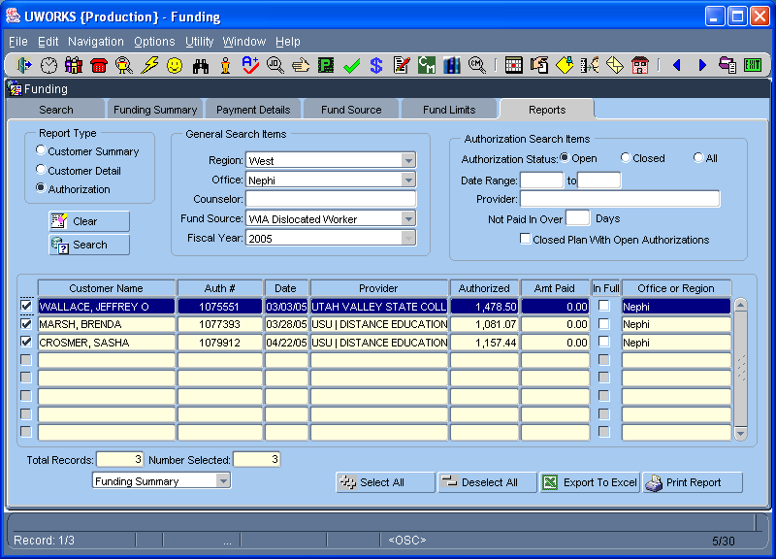
From the Reports tab select the Authorization report type. Also select the general search items and any authorization search items desired. Click to return results.
Funding Reports Query/Con’t (Authorizations/Pg. 1 & 2)

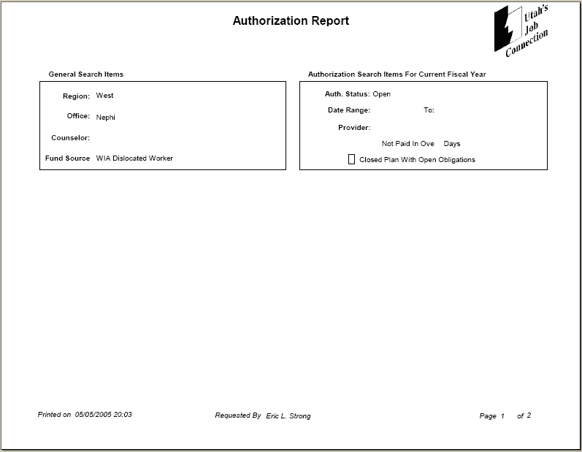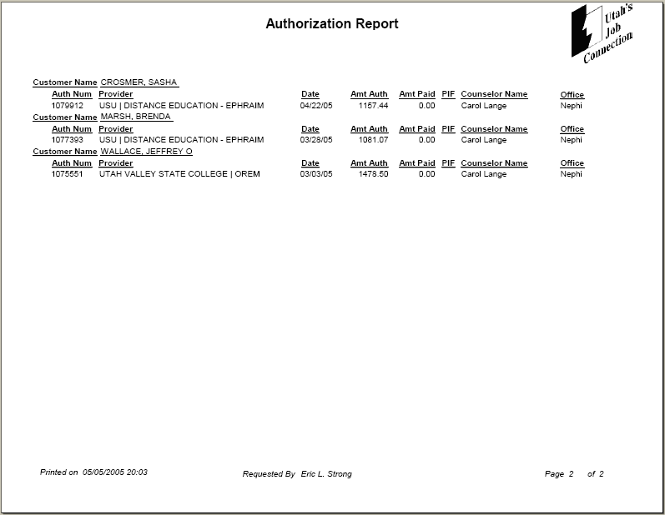
Select from the Funding Reports screen to print the report. The first page of the report lists the items you selected from the query page. This example shows that the report includes information about the WIA Dislocated Worker program in the Nephi office.
Information on the report includes customer name, authorization number, provider name, date, amount authorized, amount paid, the counselor name and the office.
Funding Level Report

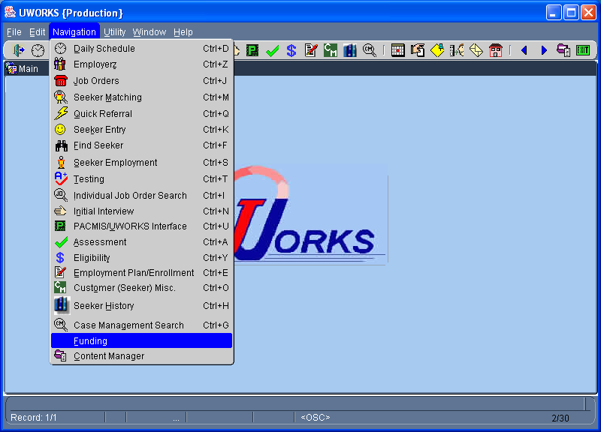
Access Funding Level Report by clicking then from the Menu Bar. Only Accountants have security access to Funding screens.

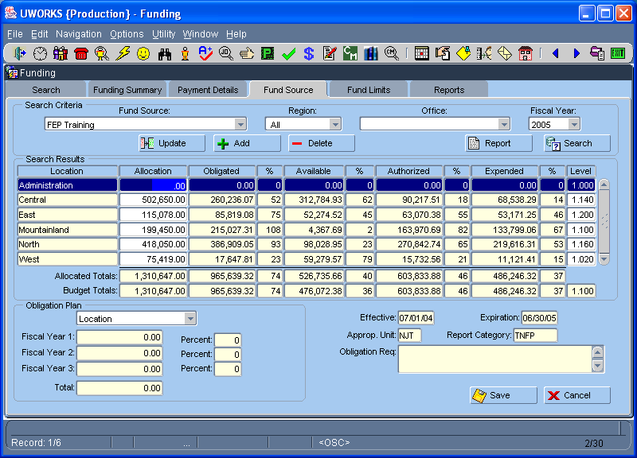
Access the Funding Level report from the Fund Source tab. You must select a Fund Source and a Region. Click to return results. Select to go to the Fund Source Report Criteria pop-up.
Funding Level Report/Con’t

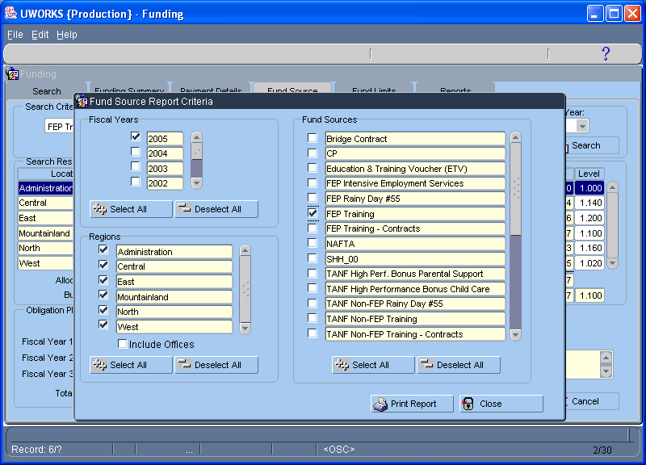
Use the Fund Source Report Criteria screen to create your report. In this example we have selected the year 2005, all regions in the state and the FEP Training fund source. You could include offices by clicking the Include Offices check box. Select to print the report.

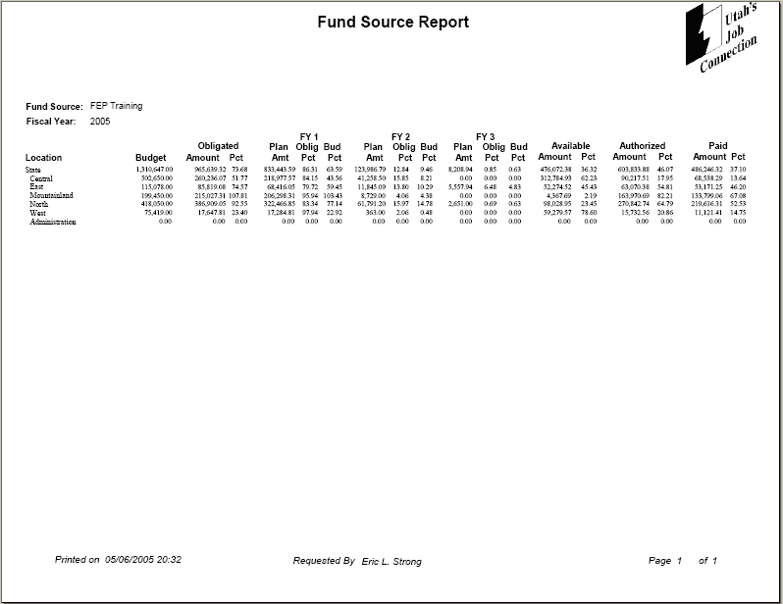
The report lists the FEP Training fund source and each Region as selected on the Fund Source Report Criteria screen. The budget amount is listed, total obligations, obligations by plan years 1-3, the amount available, amount authorized and the amount paid.
Information Card/Create

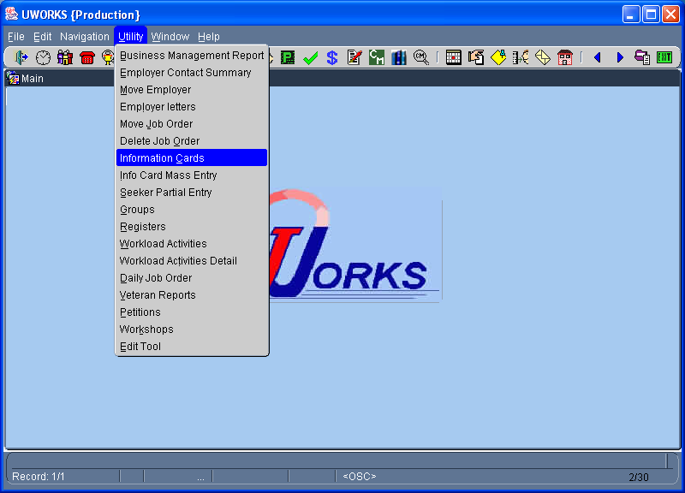
Click then to access Information Cards.

There are several
different ways to access and use Information Cards. This is an example of creating a New Card.

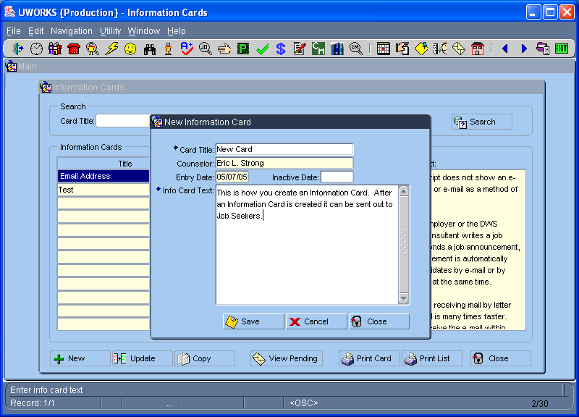
From the Information Card screen you can select to create a new information card. When you click on the button the New Information Card screen pops up.
Information Card (One Seeker)

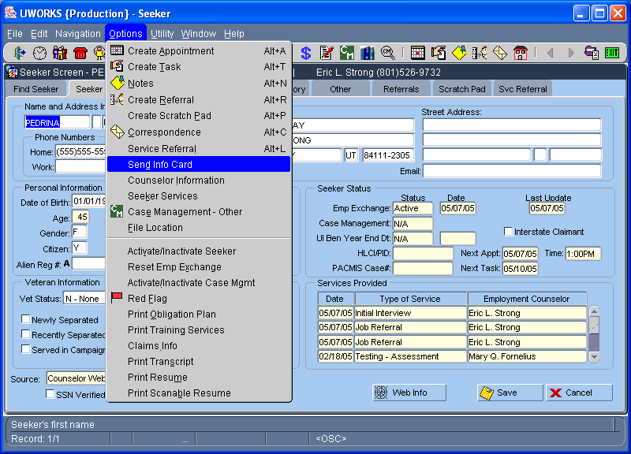
Click then to access Send Information Cards.

There are several
different ways to access and use Information Cards. This is an example of how to send a Single Information Card.

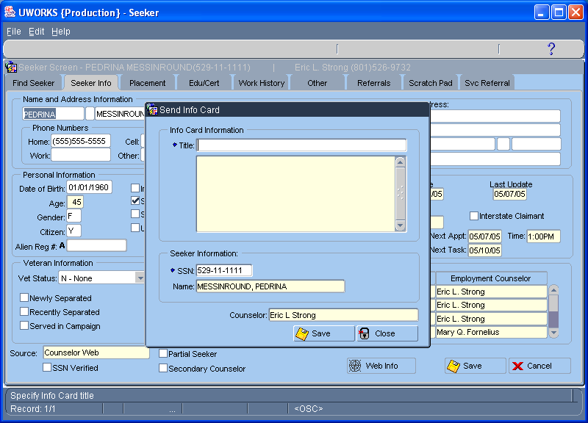
When you select the Send Info Card screen pops up. See example on this page. To send a card you must select the card you want to send. This is done by double clicking the “Title” field. This opens the Information Cards screen where you can select your card. See next page.
Information Cards (One Seeker)/Con’t

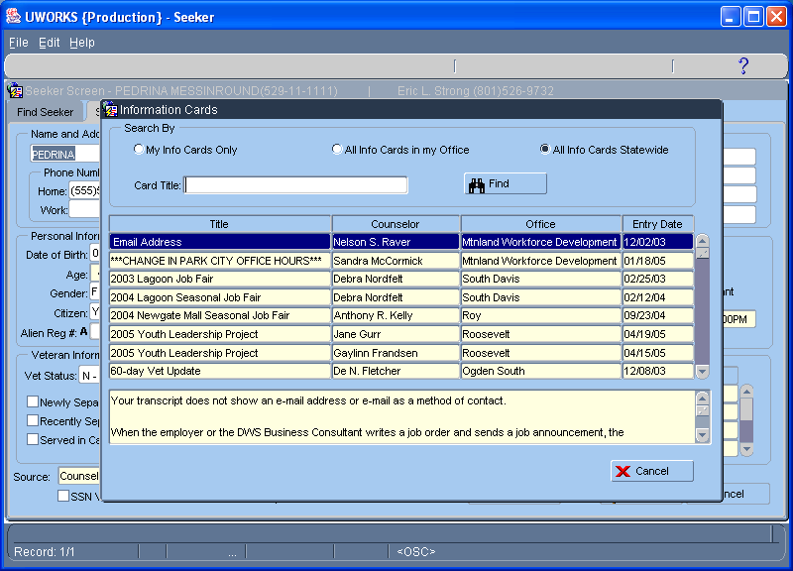
The Information Cards screen is a search screen that you can use to find the card you want to send. When you find your card double click on it to select it. This will take you back to the previous screen (Send Info Card).

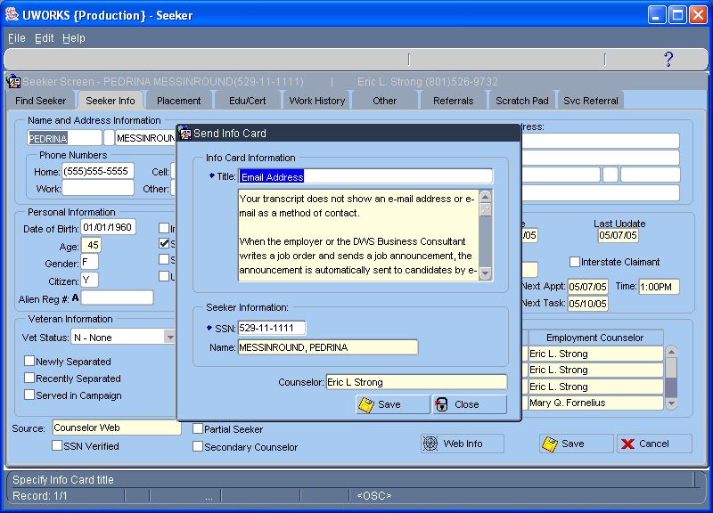
Now the Send Info Card screen has the card you selected in the Title field and the contents of the letter below in the box. To send this card click on .
Information Cards (Many Seekers)

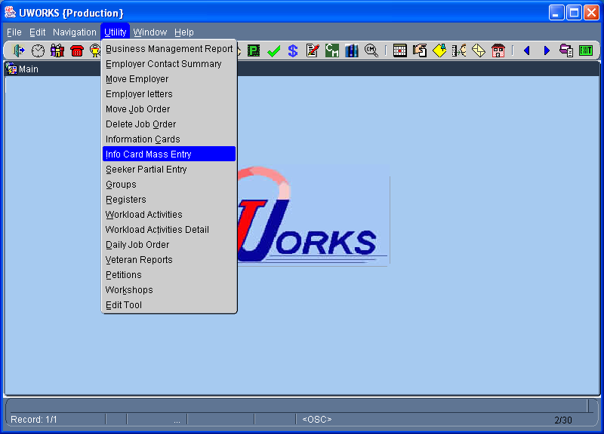
Click then to access Info Card Mass Entry.

There are several
different ways to access and use Information Cards. This is an example of how to send many information cards.

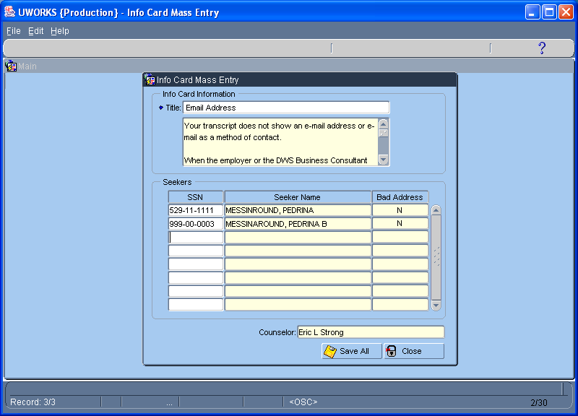
Like the Send Info Card screen when you get to the Info Card Mass Entry screen the Title field will be blank. Double click in the Title field to bring up the Information Cards screen (see next page). When you have your information card selected you can enter SSN’s in the first column to add the seekers you want to send the Information Card. Click to send the cards.
Information Cards (Many Seekers)/Con’t

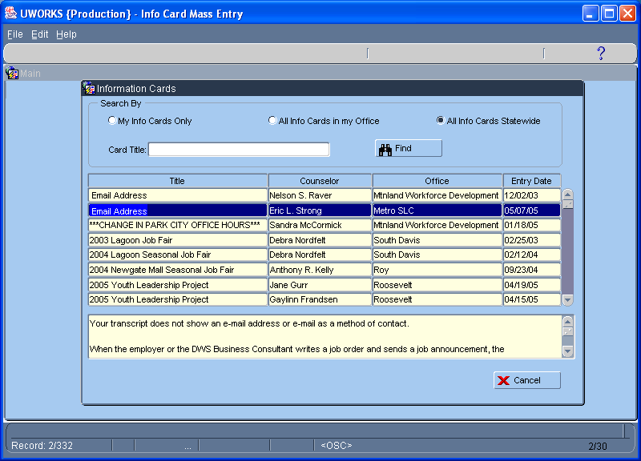
Select your Information Card from the list on this screen by Double Clicking on the card you want. This will close this screen and populate the card title on the Info Card Mass Entry screen (see previous page).

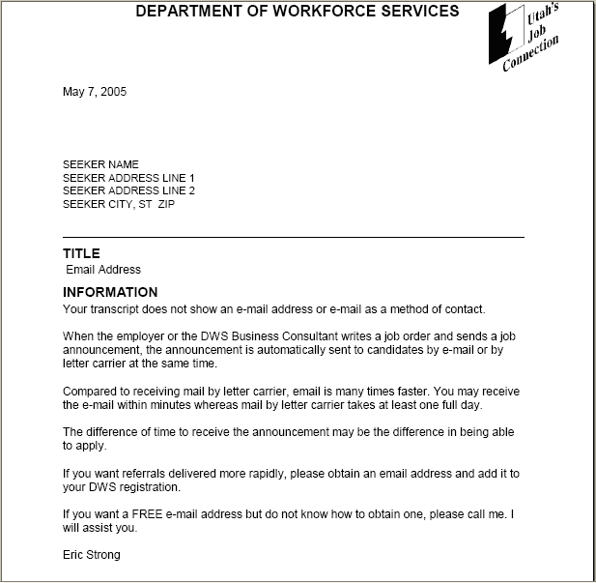
This page is an example of an Information Card. An actual card would list the Job Seeker name and address at the top of the letter.
Initial Interview
Click Initial Interview speed button to access Initial Interview.
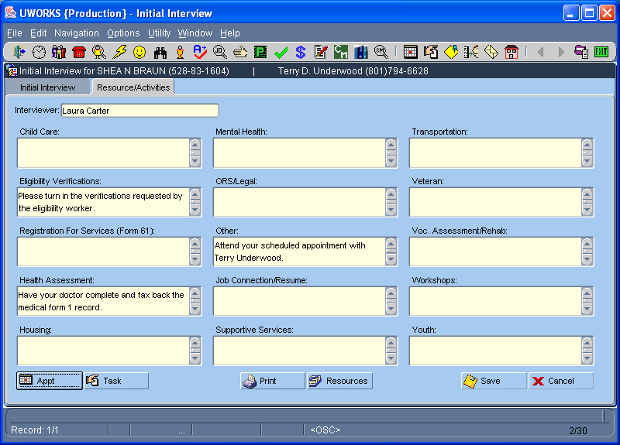
The Initial Interview screens are used when a customer comes in for services the first time. The worker assesses the situation, provides resource information and makes recommendations.

Select to print a Resource Activities printout.
The Resource Activities printout details resource and activity information that will help the customer start improving their situation. The Printout is given to the customer. This example shows that the customer needs return eligibility verifications, see their doctor, work with Voc Reh, apply for social security and their appointment date and time is listed.
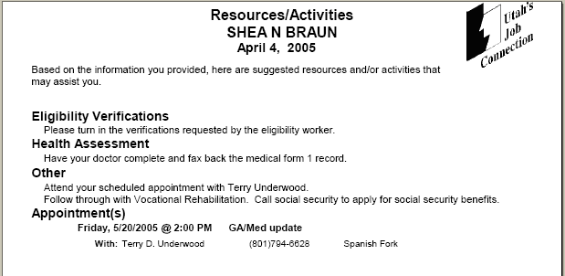

Job Board Display Card

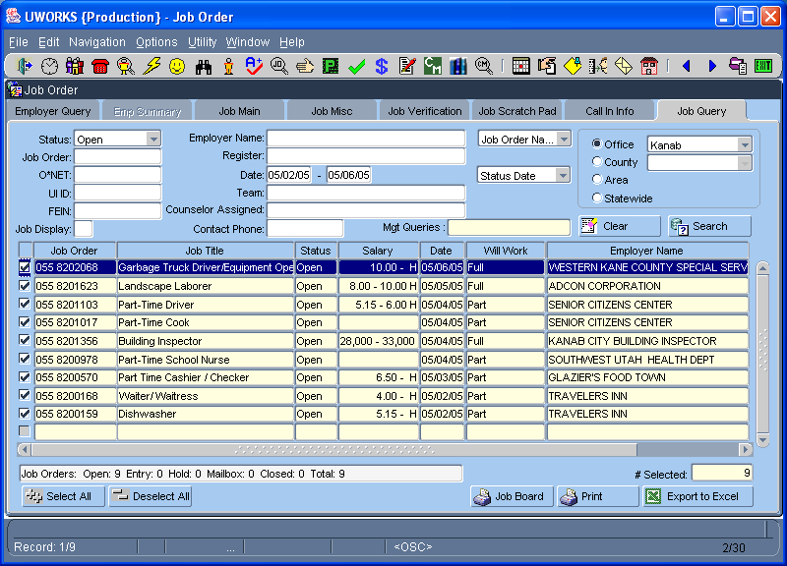
Click Job Order speed button to access Job Order.
From the Job Query tab enter the Office and date range for the job orders you want to display. Select to populate the job orders in the grid. To print the Job Board Cards select .

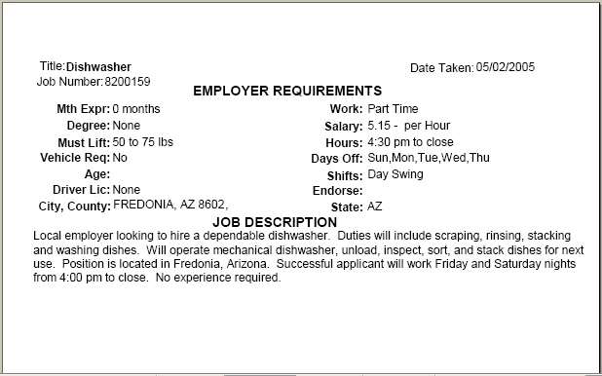
This is an example of a Job Board Display Card. Usually someone creates these cards every day and places the new job cards on job boards in the office.

Job Order Query Report

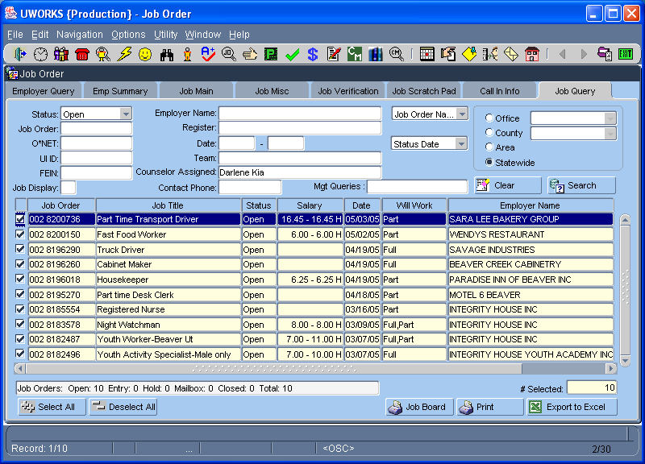
Click Job Order speed button to access Job Order.
The Job Query screen is used to search for job orders in the system. There are many options available to find the job order(s) you are looking for. Enter the criteria and select to populate the grid with job orders.

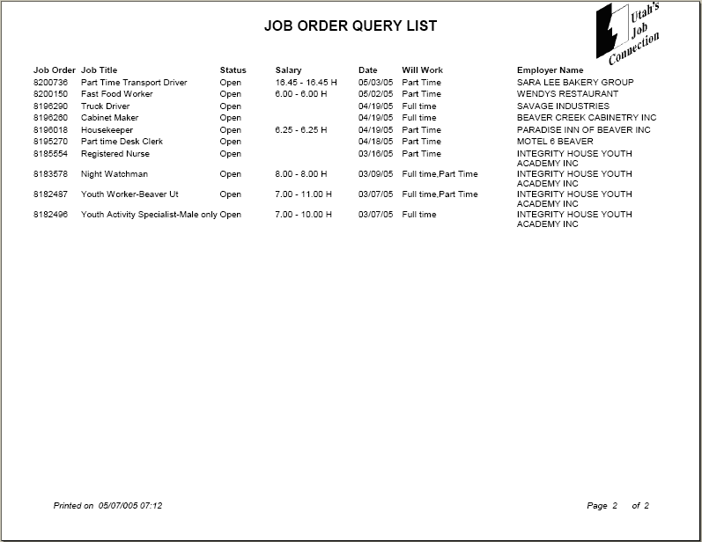
Check the job orders you want on your report. Click to print the Job Order Query List. The list displays some details about each job order.
Job Order Scratch Pad List

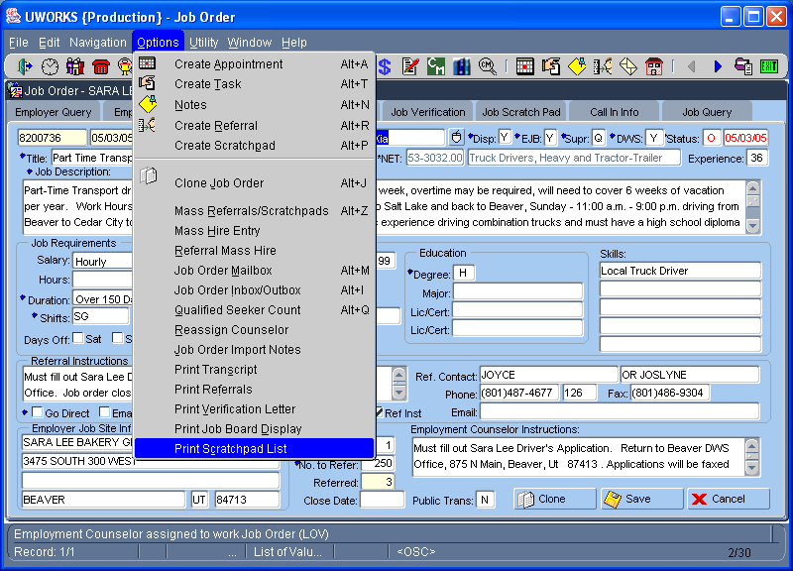
Click then to access Scratchpad List.

You must have a specific job order selected before you select this option.

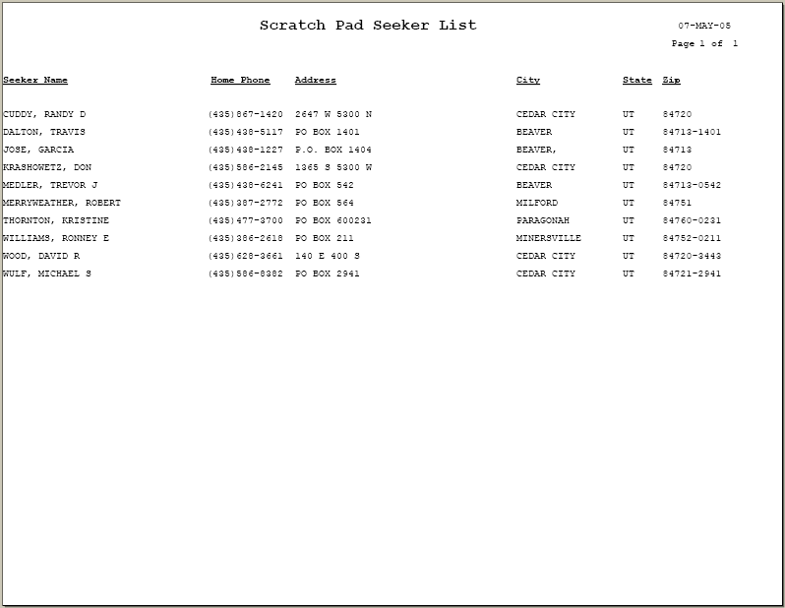
The Scratch Pad Seeker List is a report of all of the job seekers that are on this job order scratch pad tab.
Job Order Transcript

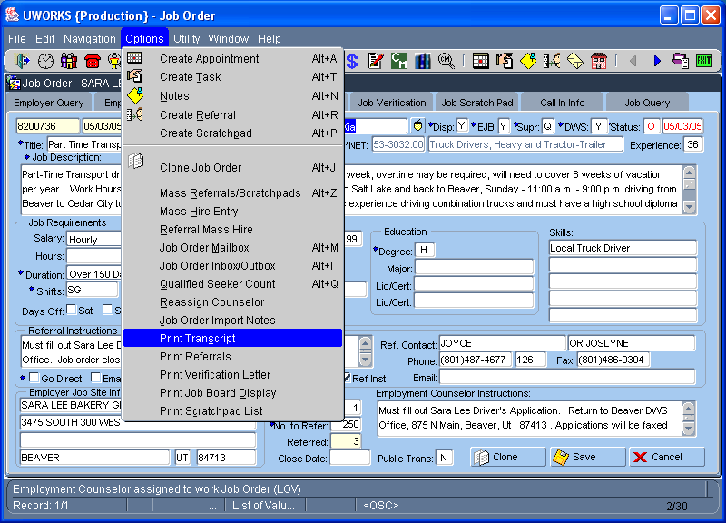
Click then to print Job Order Transcript.

You must have a specific job order selected before you select this option.

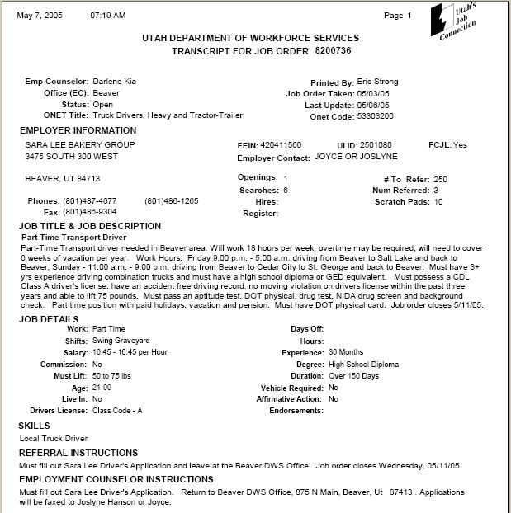
The Job Order Transcript is a detailed printout of a job order. It lists the employer information and all of the job order requirements.
Job Order Verification Letter

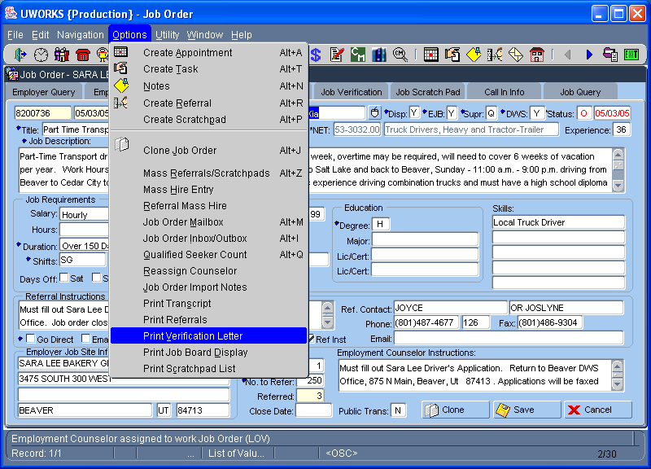
Click then to print a Job Order Verification Letter.

You must have a specific job order selected before you select this option.

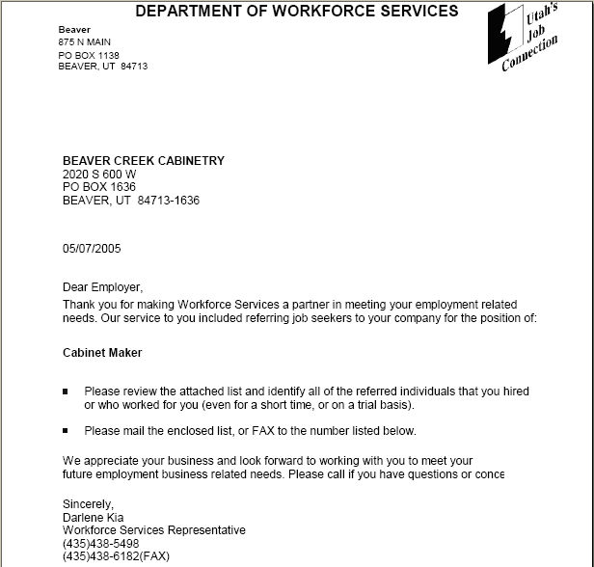
The Job Order Verification Letter is a 2-page letter sent to the employer. The first page of the letter we ask the employer to let us know whom they hired for the job listed.
Job Order Verification Letter/Con’t

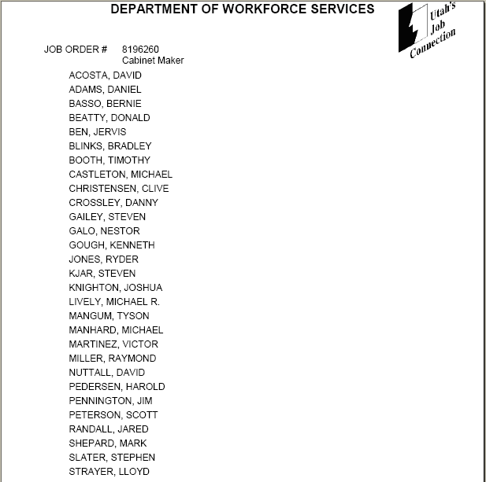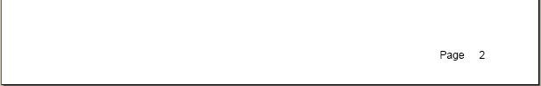
The second page of the Job Order Verification Letter lists all of the job seekers that were referred to the job. This letter is used to collect hire information from employer when they have not provided any hire information for a job we posted for them.

List Of Staff

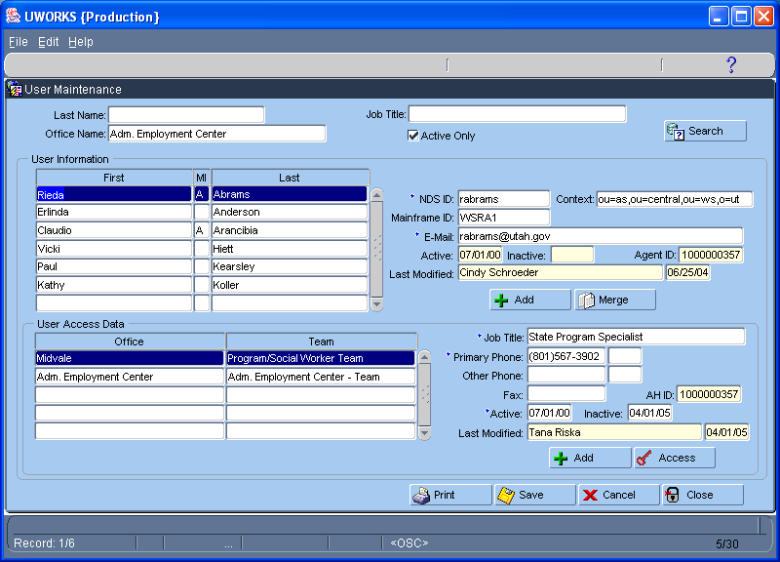
Click , then to access the User Maintenance screen. This screen is used to add, delete and edit system user information.

Access to this screen has limited security so most workers will not have access.

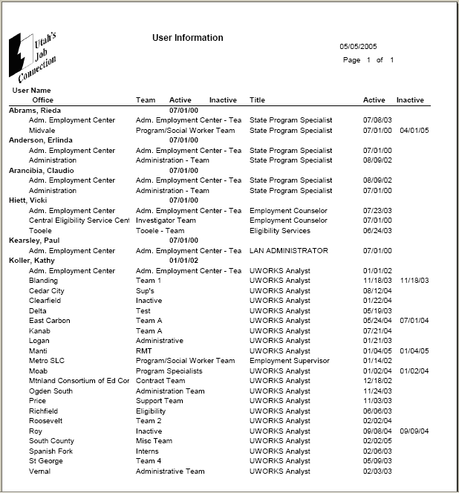
The User Information list is a report that lists the users in the system. It displays their name, office, team, active and/or inactive date(s) and their title.
Notes Query Report

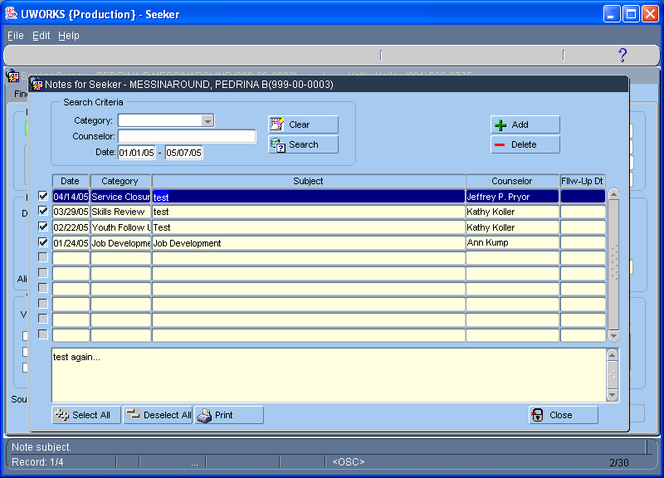
Click the Notes speed button to access Seeker or Employer Notes.
The Notes screen has a query option to help you search for specific types of notes. In this example we are searching for notes entered between January and May. Click to display the notes in the grid.

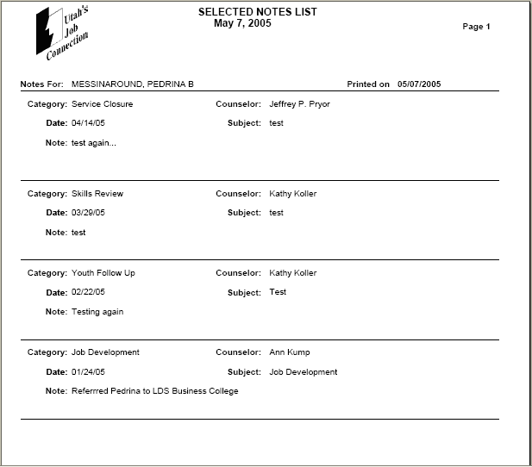
Click to print the Notes Report. This report will list each note and the detail information of the note.
Obligation Plan

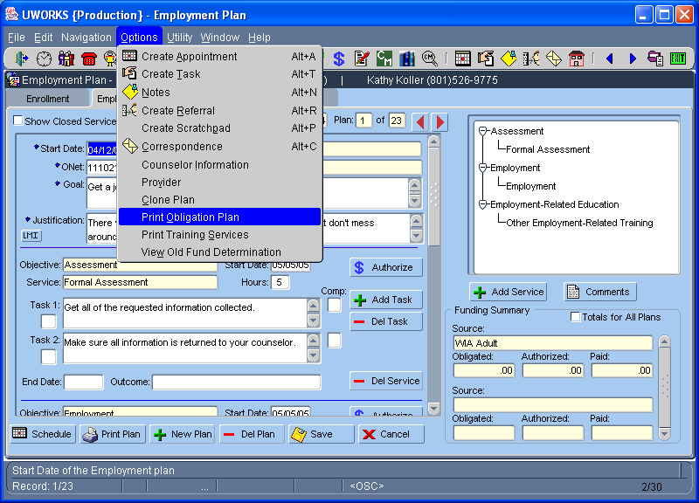
Click then to print the Obligation Plan.

You must be on the Employment Plan screen before you select this option.

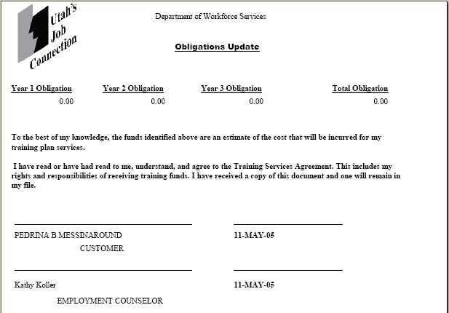
The Obligation Plan displays the money that has been dedicated to this seeker’s training plan over a three-year period.
Petition List

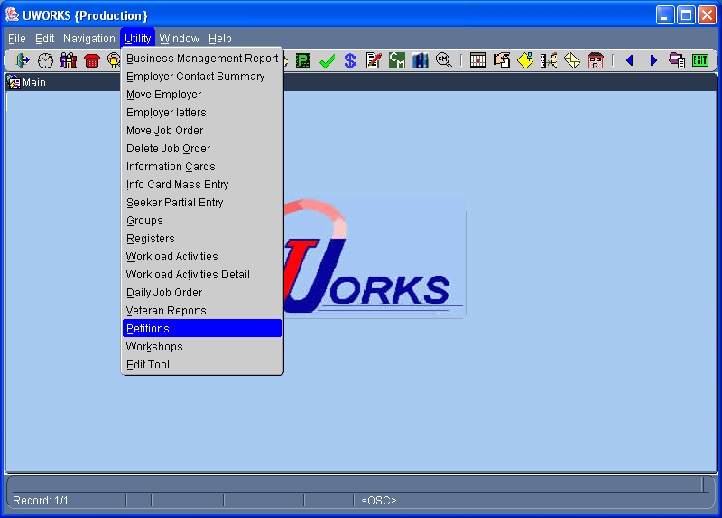
Click then to open the Petitions screen.

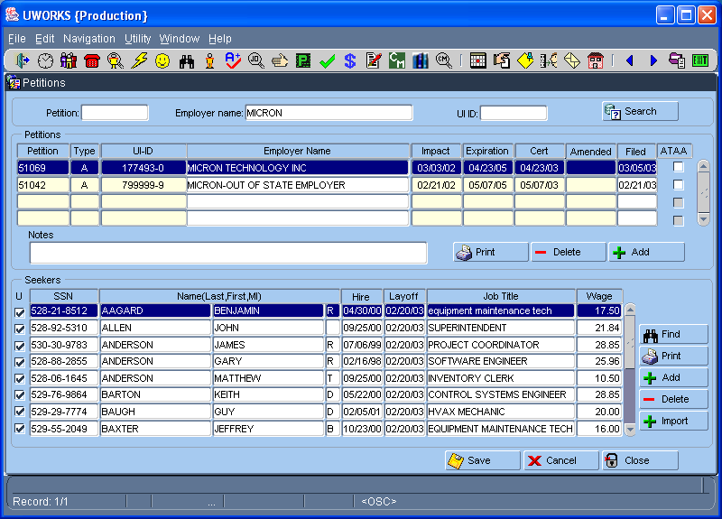
Enter the Petition number, Employer name or UI-ID number and select to see the petition information. Highlight your petition and click to print the Employer Petition List.

Click by the seeker grid to print the Seeker Petition List.
Petition List/Con’t (Employer List)

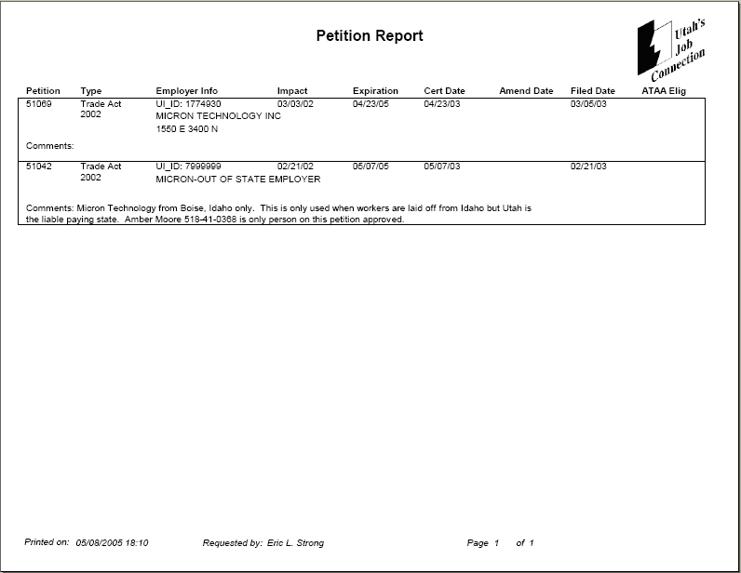
The Employer Petition List shows the different petitions for this employer. Information about each petition is listed.

Petition List/Con’t (Job Seeker List)

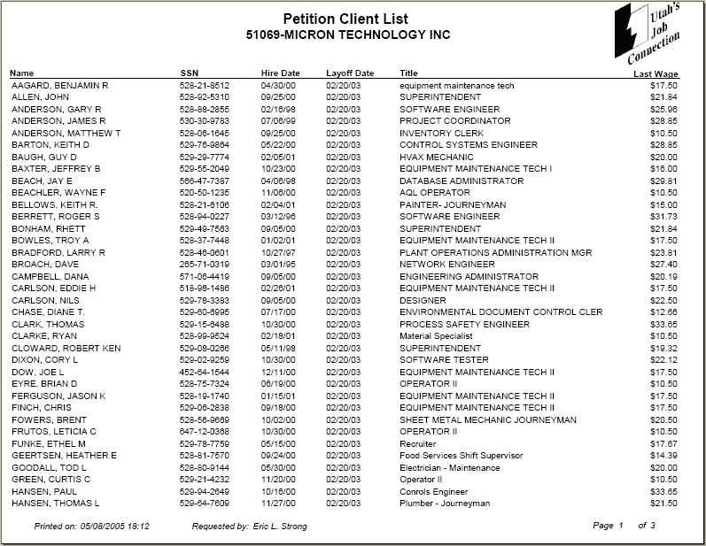
The Seeker Petition List shows the seekers that are affected by this petition. Some information about each seeker is listed.
Pre & Post FINET Reports

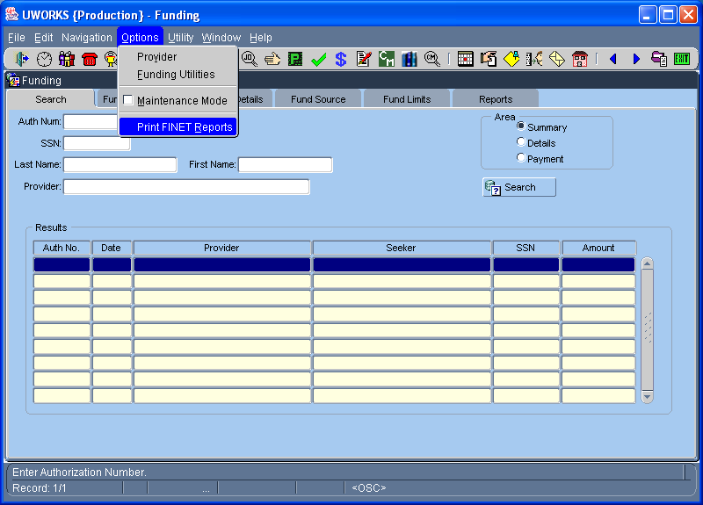
From the Funding Screens click then to print the Pre or Post Finet Reports.

You must have Accountant Security access to get into the Funding screens.

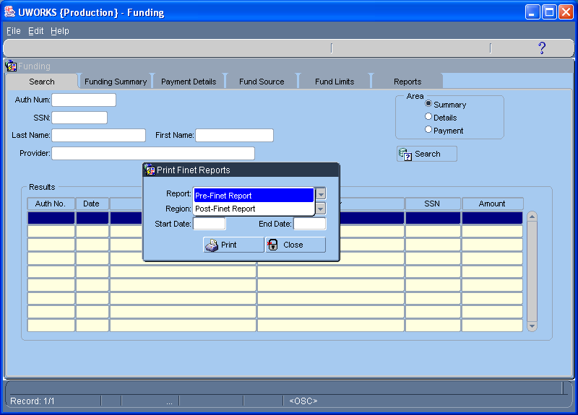
The Print Finet Report pop-up is used to select between the Pre or Post Finet report. Enter the information on the pop-up and select to print the report.
Pre & Post FINET Reports/Con’t

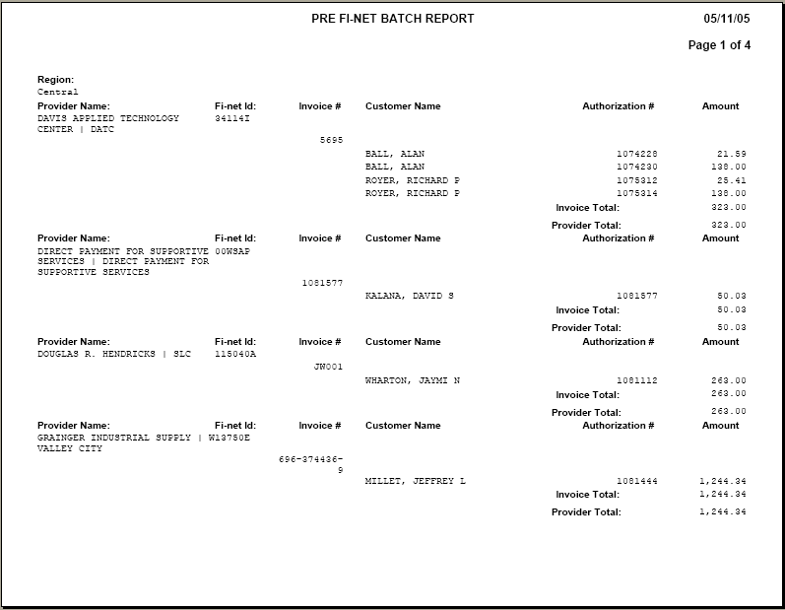
The Pre Finet Report lists the Payments that were entered into the system by the accountants but have not been sent to Finance to be paid.

The accountants use this report to make sure that all of the payments they entered that day are listed.

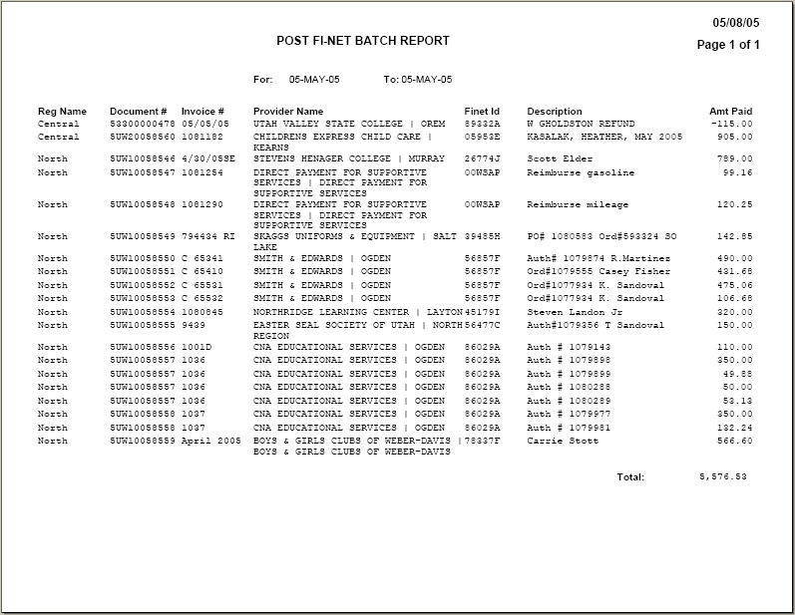
The Post Finet Report lists the Payments that were entered into the system by the accountants and have been sent to Finance to pay or have been paid.

The accountants use this report to check and see if all their payments were sent to Finance to be paid

Rapid Response

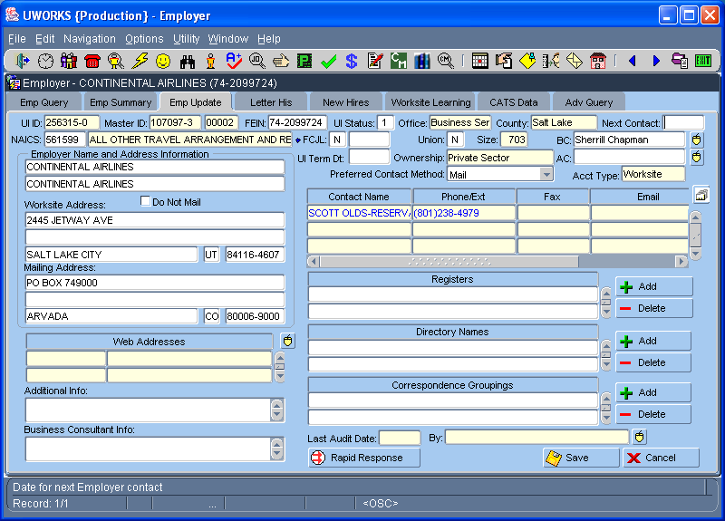
Access Rapid Response info by clicking the button on the Emp Update tab in Employer. If the employer has no Rapid Response data on their record the button will have a line through it .

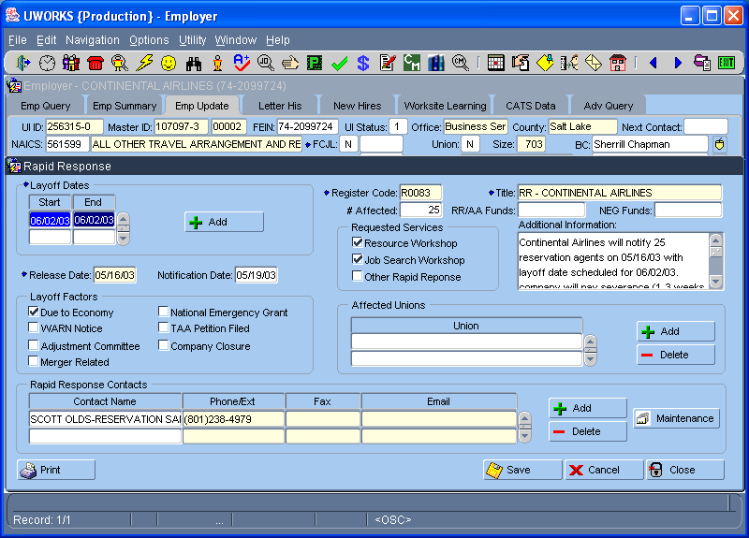
The Rapid Response screen shows information about the employer layoff. Click to get to the Rapid Response report.

Only workers with Rapid Response security access can get to this report.
Rapid Response/Con’t

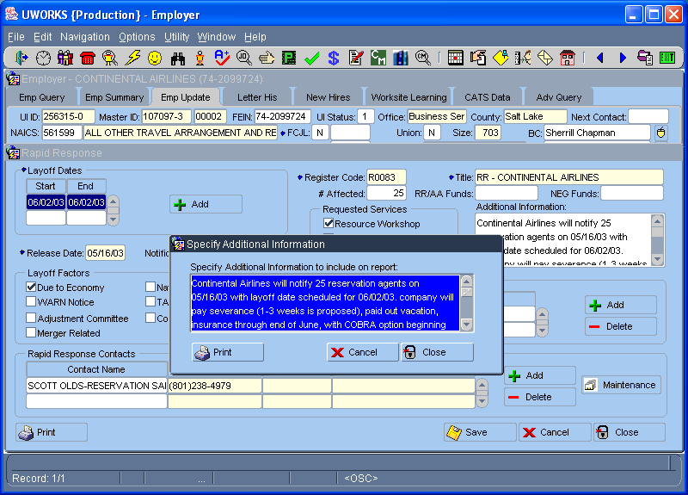
The Rapid Response worker can add information to the report by entering it on the Specify Additional Information to Include on Report pop-up screen. To print the Notification of Company Layoff report click .

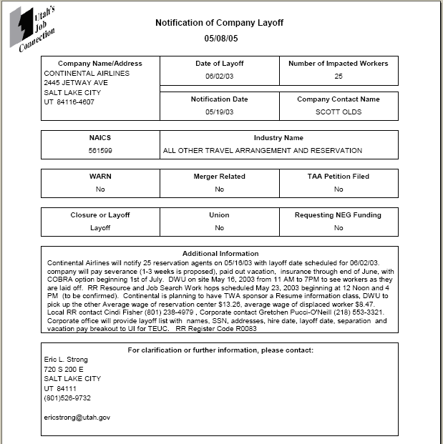
The Notification of Company Layoff report includes detailed information about the company’s layoff.
Referral Letter

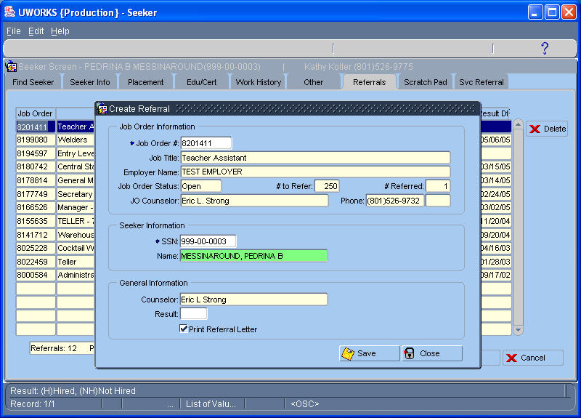
From the Job Order or Seeker screens click then to print a Referral Letter. You can also use the Referral speed button
.
The Job Order # and SSN fields must be entered. Click the Print Referral Letter check box and select .

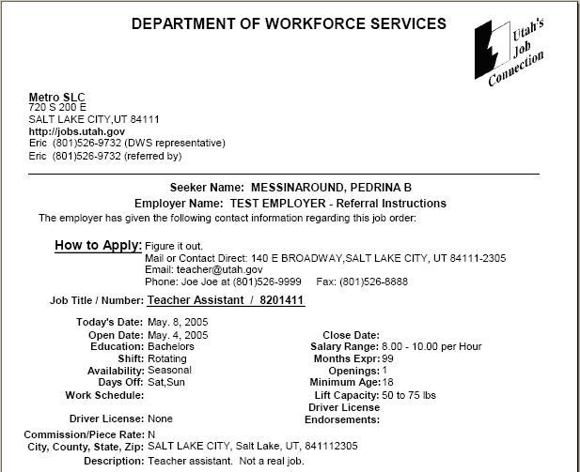
The Referral Letter verifies that the job seeker qualifies for the job order listed. The letter can be given or mailed to the job seeker. The job seeker can take the letter to the employer as verification that that they meet the job qualifications.
Registers

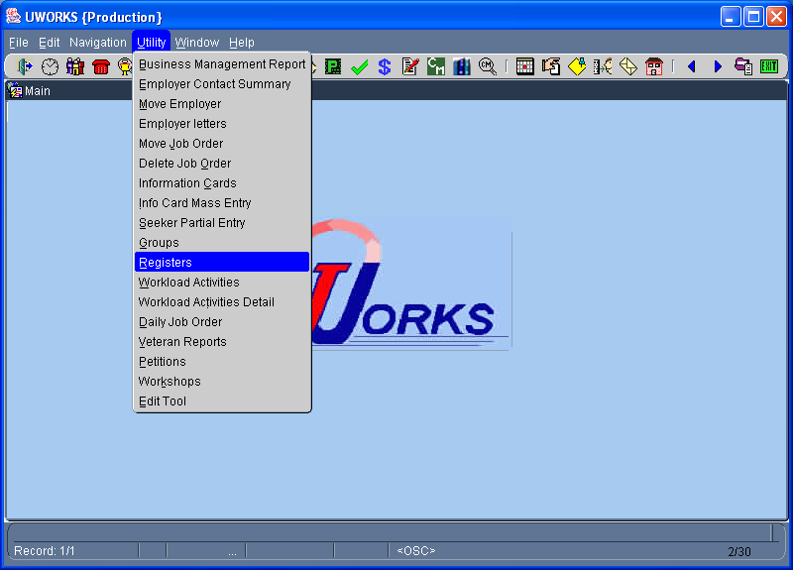
Click then to open the Registers screen.

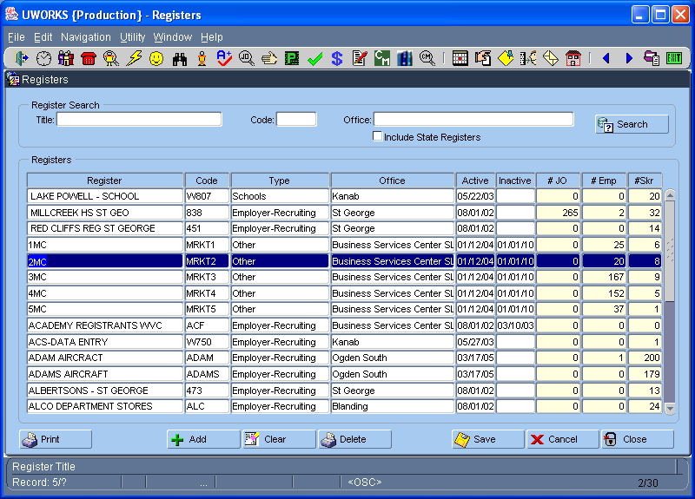
The Registers screen has a search option. Enter register title, code, and office or check the state registers and select . Highlight a register in the grid and click .
Registers/Con’t

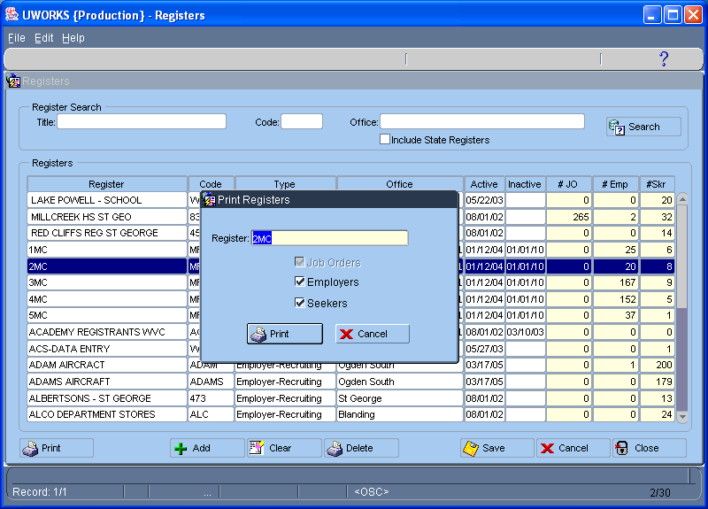
The Print Registers pop-up allows you to select the report you want. Choose your report by clicking Job Orders, Employers, and/or Seekers and selecting .
If there are no registers, like Job Orders in this example, the check box will not be available.

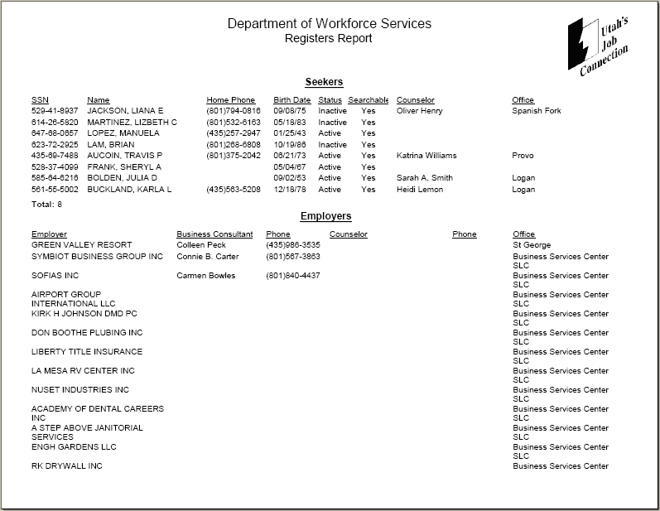
The Registers Report lists brief information about Job Orders, Seekers and Employers.

In this example the register 2MC has seekers and employers attached but no job orders.
Resume (Job Seeker)

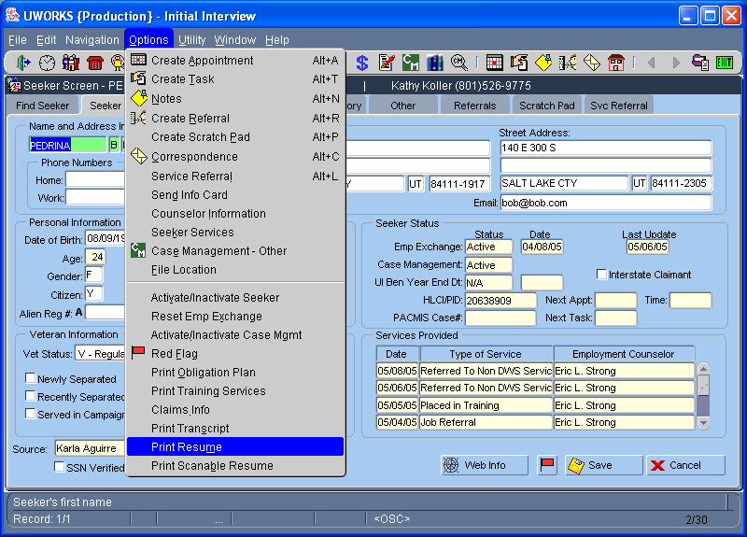
Click then from the Seeker screens to print a Resume.

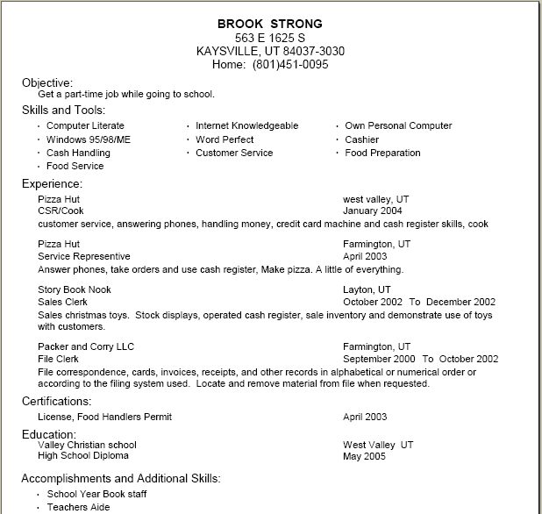
The Resume printout lists information about a seeker that would be on a normal resume. This system resume is generic and may be a good starting point for a seeker resume but most job seeker will want to create a more formal resume.
Resume (Job Seeker)/Con’t (Scanable Version)

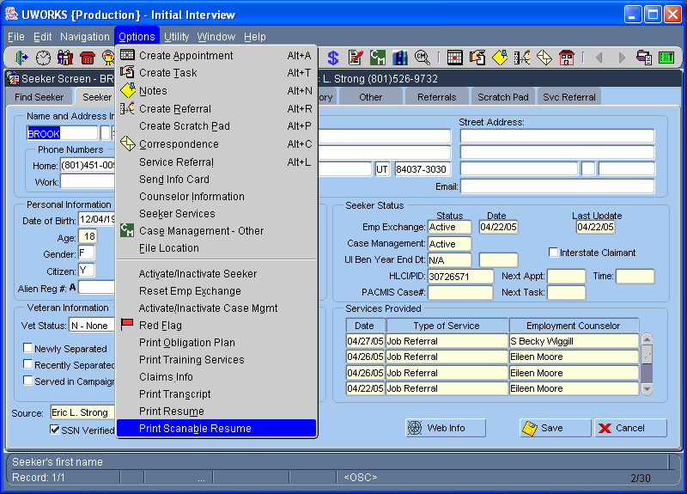
Click then from the Seeker screens to print a Scanable Resume.

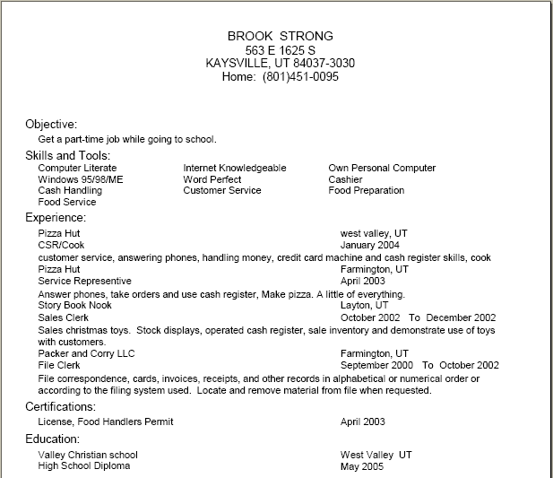
The Scanable Resume printout lists information about a seeker that would be on a normal resume. This resume is formatted so that it can be scanned without creating problems.
Schedule Query Report

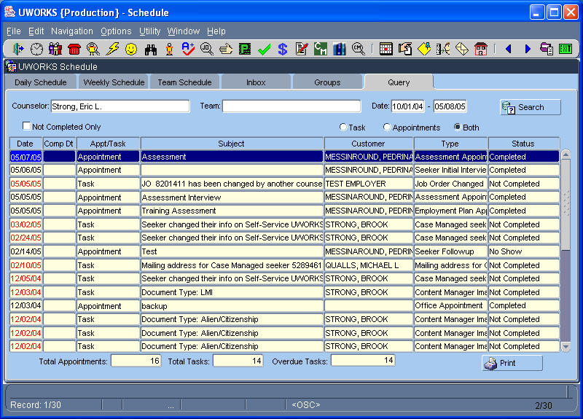
The Scheduling Query screen allows you to search for counselor’s or Team’s tasks and/or appointments. After entering you search criteria select populate the grid then select
to print the report.
Click the Daily Schedule speed button to access the Scheduler.

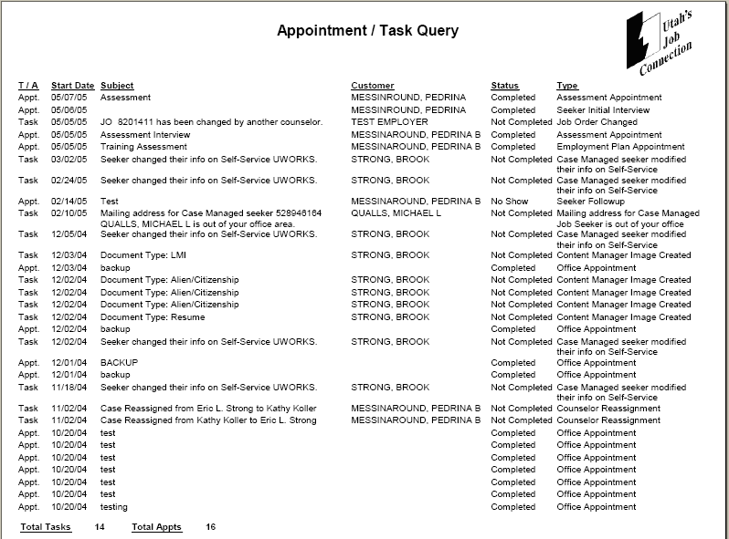
The Appointment / Task Query Report lists the tasks and appointments of a counselor.

In this example the report lists all tasks and appointments from Oct-04 to May –05 for a specific counselor.
Security Report

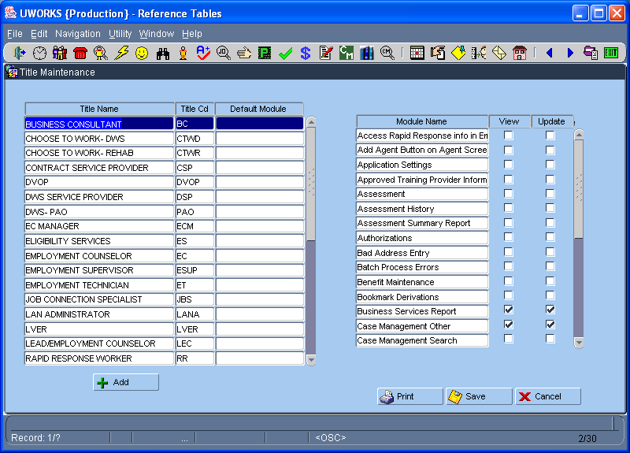
Title Maintenance is found in the Reference Tables. Security. Access is very limited. This screen is used to create User Titles and modify security system access.
To access the security report click .

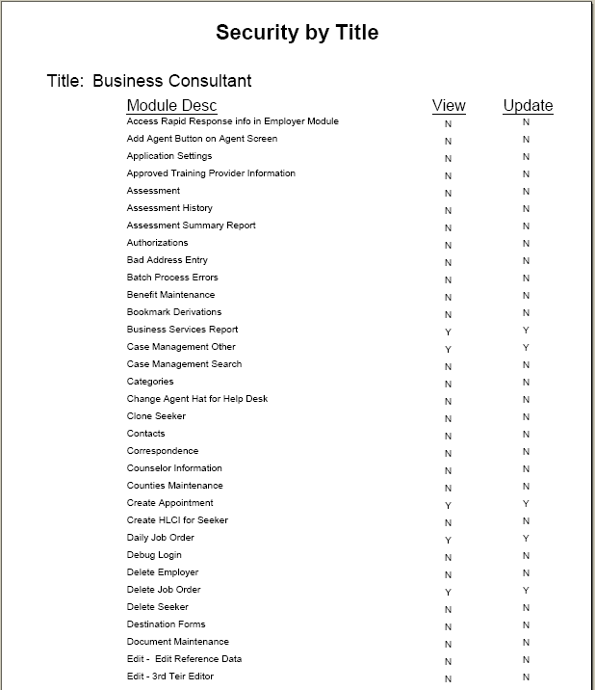
The Security by Title report lists every system title. It shows the security access modules available for that job title. This example only shows the first page of the report beginning with the Business Consultant title.
Seeker History
Click the Seeker History speed button to access Seeker History.
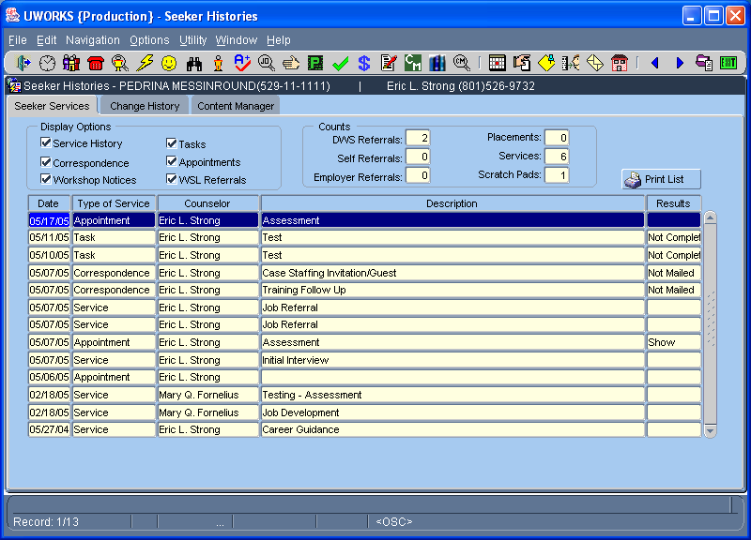
The Seeker History screen shows the Services, Correspondence, Workshop, Tasks, Appointments and WSL Referrals for the seeker. Removing the check from a box will remove that data from the grid. To print the report click

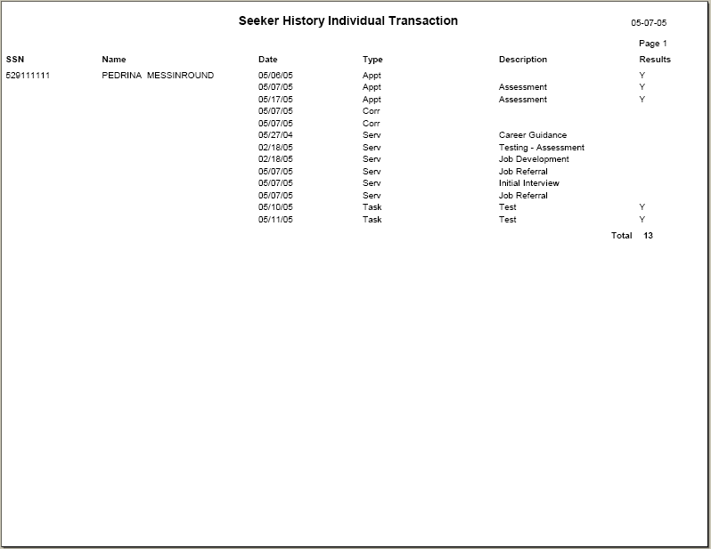
The Seeker History Individual Transaction report lists all of the services selected for that seeker.
Seeker Information Card List

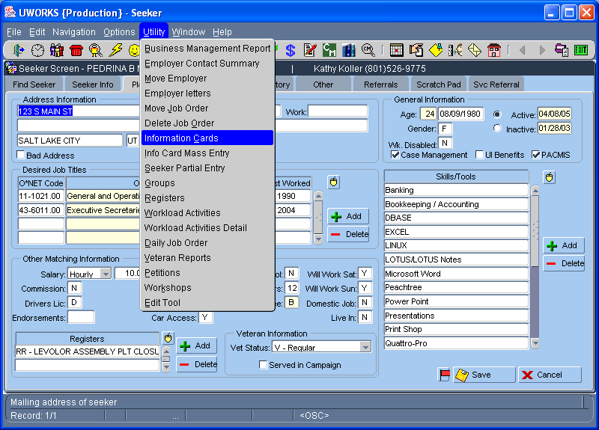
Click then to access Information Cards.

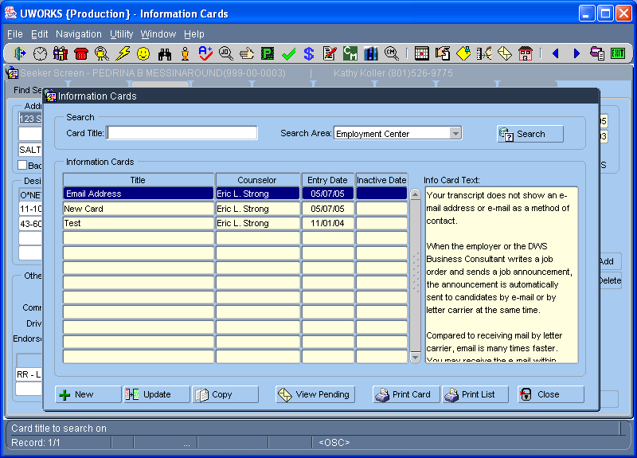
From the Information Cards screen you can print a list of Seekers that have received a specific Information Card by selecting .
Seeker Information Card List/Con’t

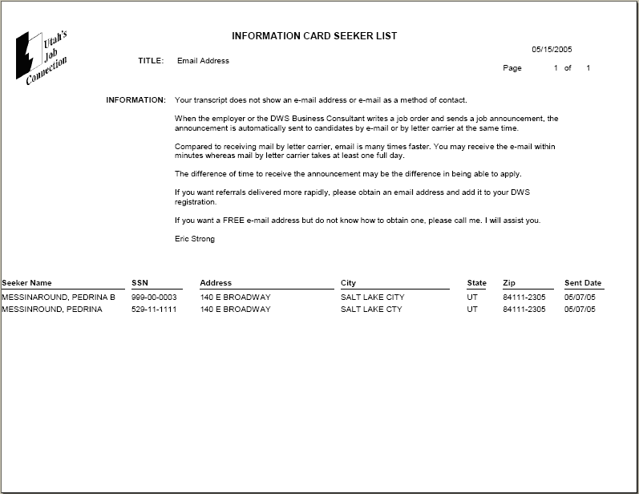
The Information Card Seeker List displays the information card text at the top of the report. At the bottom of the report all the seekers that have been sent this information card are listed.

Seeker New Hire List

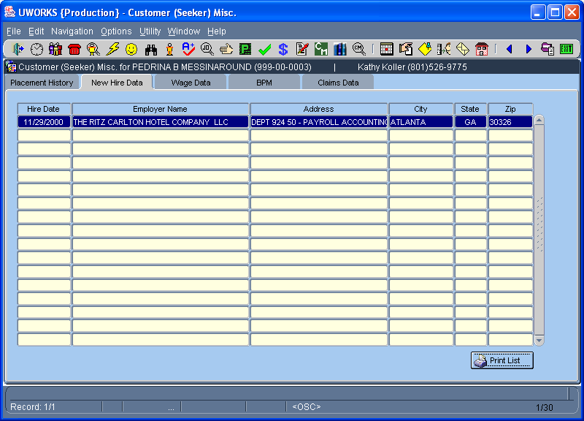
Click the Customer Misc. speed button to access the Customer Misc. screens.

Select the New Hire Data tab to get to the seeker new hire information.

Click the button to print the New Hire Report.

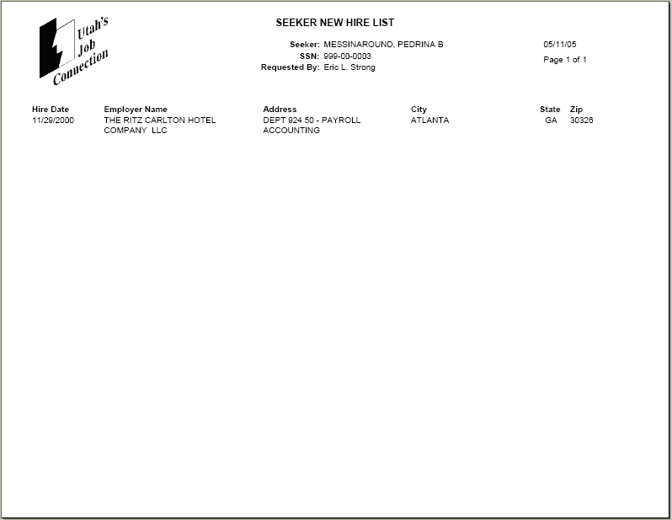
The Seeker New Hire List shows all of the employers that have reported hiring this job seeker.
In this example there is only one hire reported for this seeker.
Seeker Referral Letter

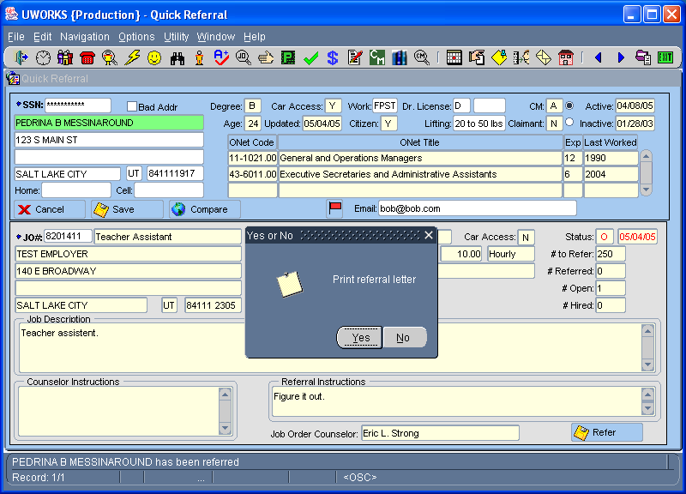
There are several ways to Print Referral Letters. The most common way to create a referral letter is using the Quick Referral screen. Once you enter the seeker SSN and job order number select which brings up the “Print Referral Letter” pop-up. Select “Yes” to print the referral letter.

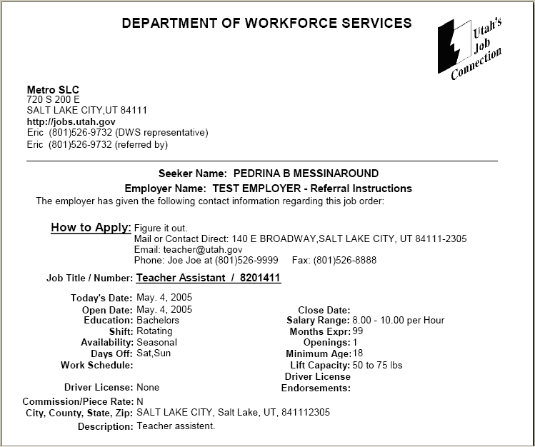
Referral Letters are usually printed out and given to the job seeker while they are in the office. The letter provides information about the job and tells the seeker how they can apply for the job. The seeker can take the letter to the employer to let them see that an employee at Workforce Service referred them to the job.
Seeker Search Results
Click the Seeker Matching speed button to access Seeker Matching screens.

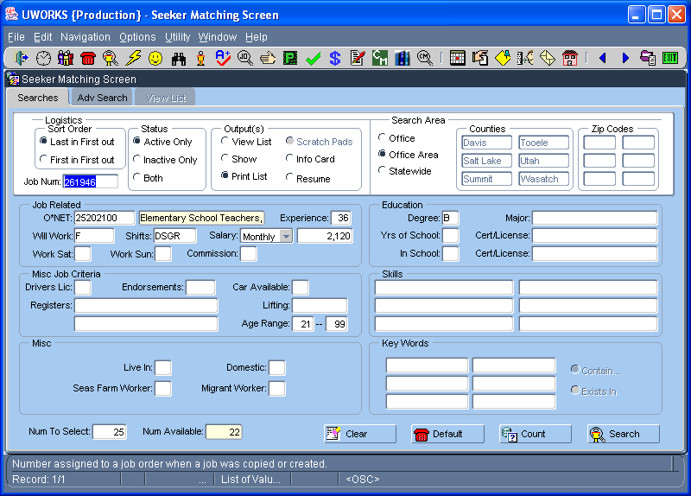
The Seeker Matching screen is a powerful search engine designed to match job seekers to criteria entered on the screen. Enter your search criteria and select to find seekers that match.

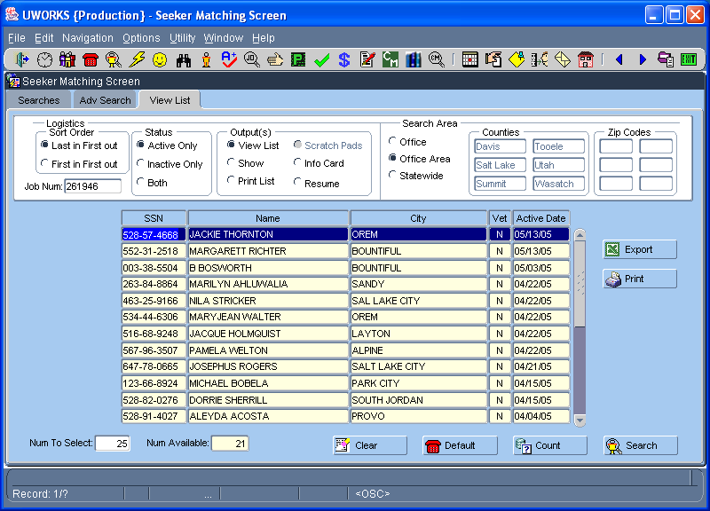
Selecting from the Searches tab takes you to the View List tab. This screen displays a list of seekers that matched the search criteria.

To print the Search Results click .
Seeker Search Results/Con’t

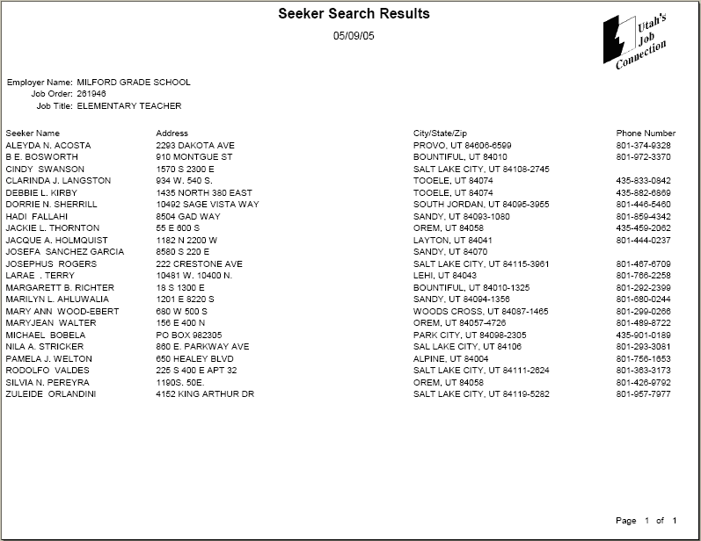
The Seeker Search Results report lists the seekers that matched the criteria you entered. The report lists the seeker name, address, and phone number.

Seeker Services
Click the Seeker Matching speed button to access Seeker Matching screens.

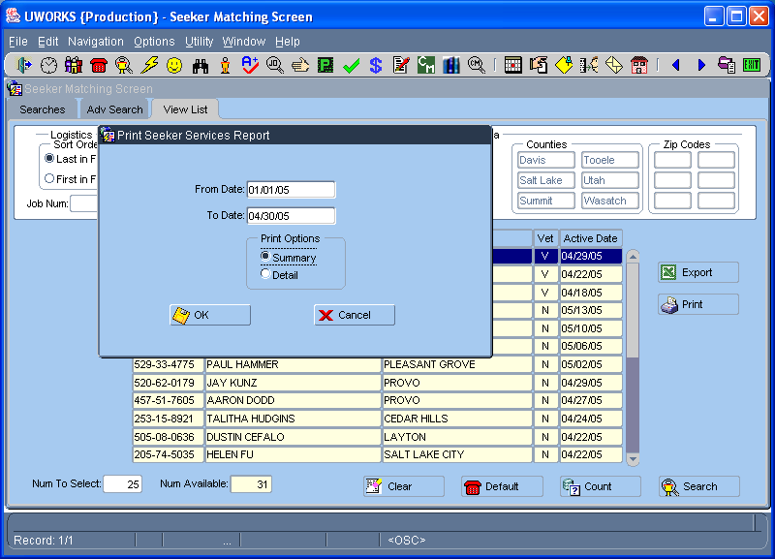
From the Seeker Matching screen do a search un-related to a job order. Next, from the View List tab click and the Print Seekers Services Report screen will pop-up. Enter dates, select Detail or Summary. To print report Click .
Seeker Services/Con’t
This page is an example of the Seeker Services Summary Report. The report lists the services and totals the number of seekers that received the service during the time period selected.
The Seeker Services Detail Report shows all services seekers received and the date the service was provided.
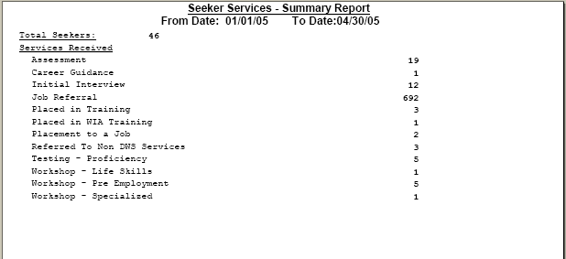

Seeker Transcript

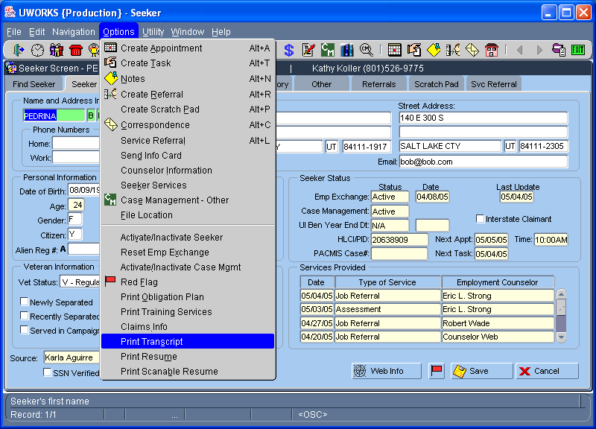
Click then to access the Seeker Transcript report.

Seeker Transcript/Con’t

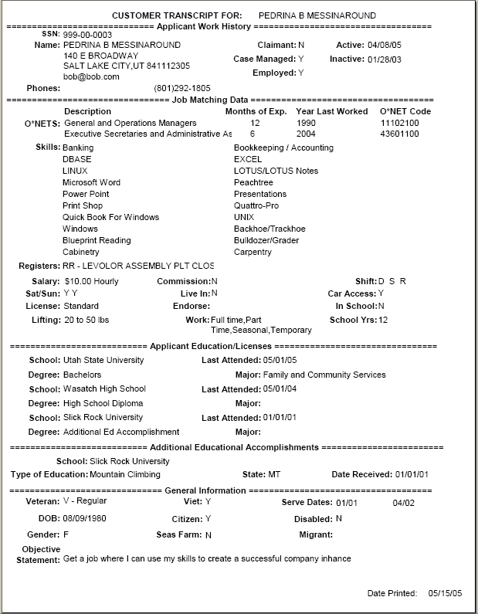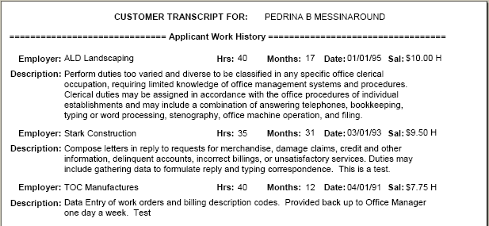
The Seeker Transcript lists detailed information from the seeker record. You could give the report to a seeker to see if their information is up to date.
Service Referral

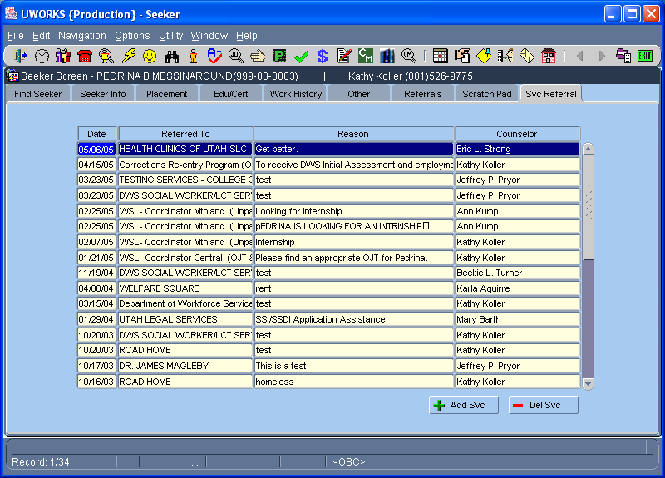
Click the Seeker Matching speed button to access Seeker Matching screens.
Select the Svc Referral tab to see the referral list.
To view the Service Referral details Double Click on the desired referral.

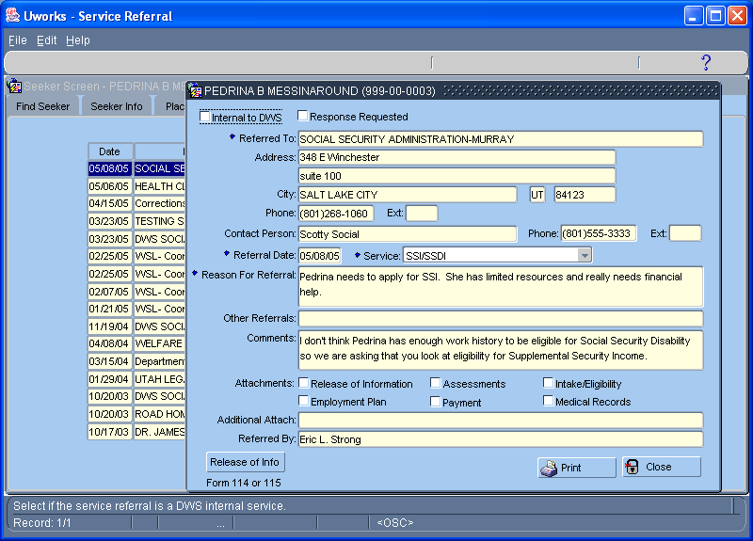
The Service Referral pop-up displays the information just as it looks when you create the referral. To print the service referral letter click on .
Service Referral/Con’t

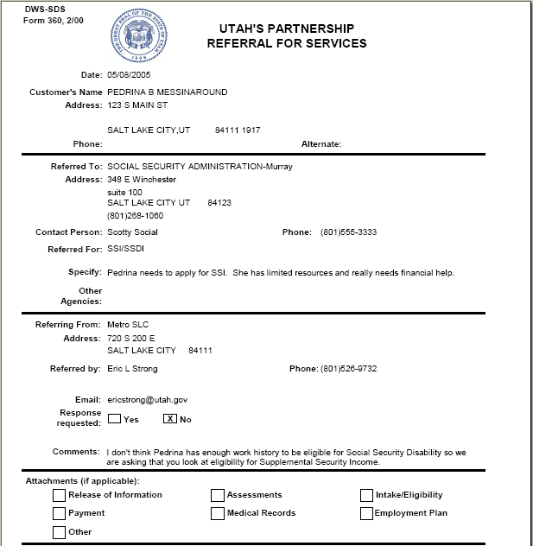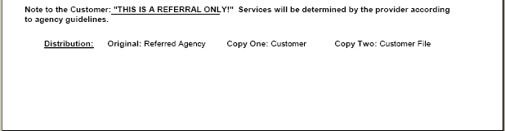
The Referral For Services report can be printed and given to the customer to take to the agency they have been referred to. The letter lists information about the customer, the referred to agency and the referring agency.

Service Request

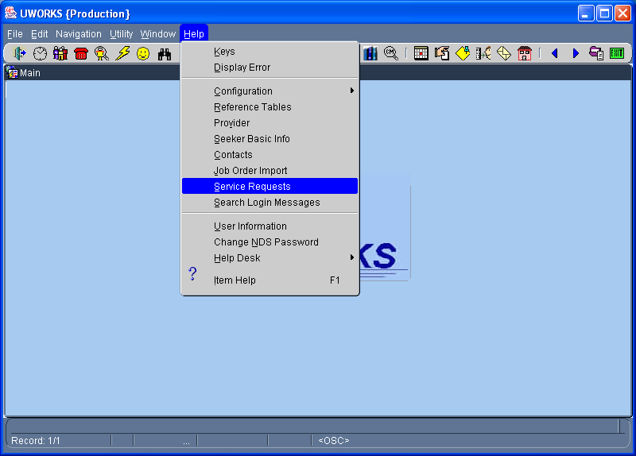
Click then to access the Service Request screen.

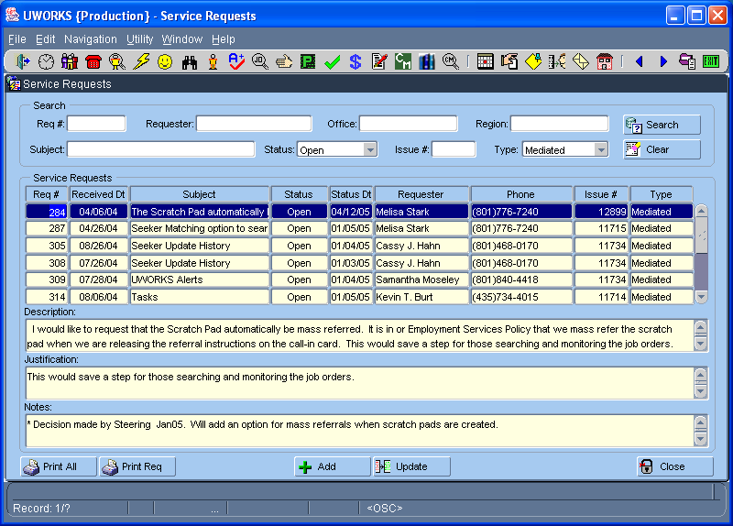
The Service Requests screen is used to add requests for system modifications and enhancements. To print a list of all requests click . To print the details for a single request highlight the desired request and select .
Service Request/Con’t

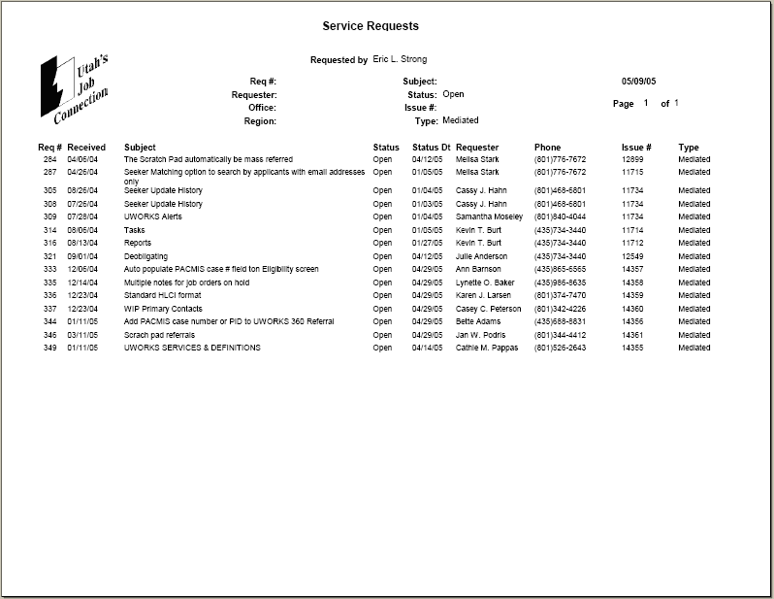
This Service Requests report lists all of the Open requests.

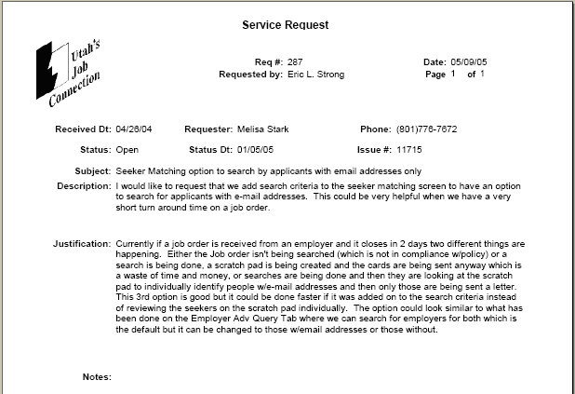
This Service Request report lists all the details for service request number 287.
Test Certificate

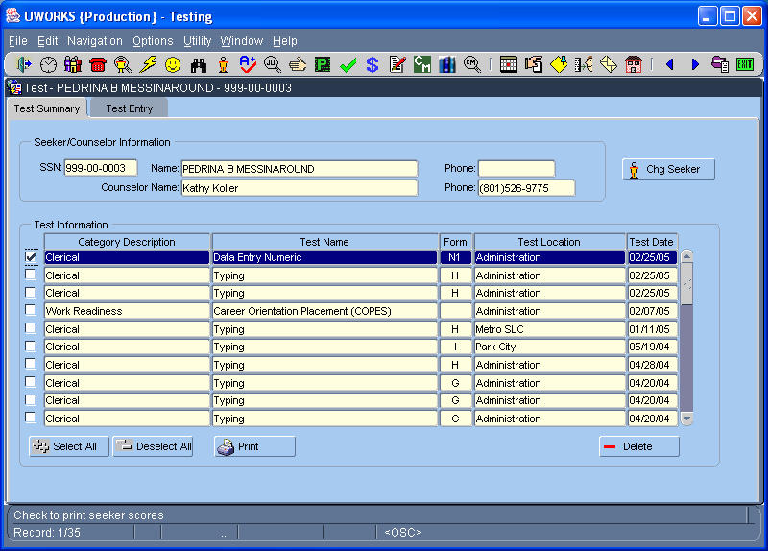
Click the Testing speed button to access the Testing screens.

The Test Summary screen lists the testing scores of the seeker. To print a testing certificate highlight the desired test and click .

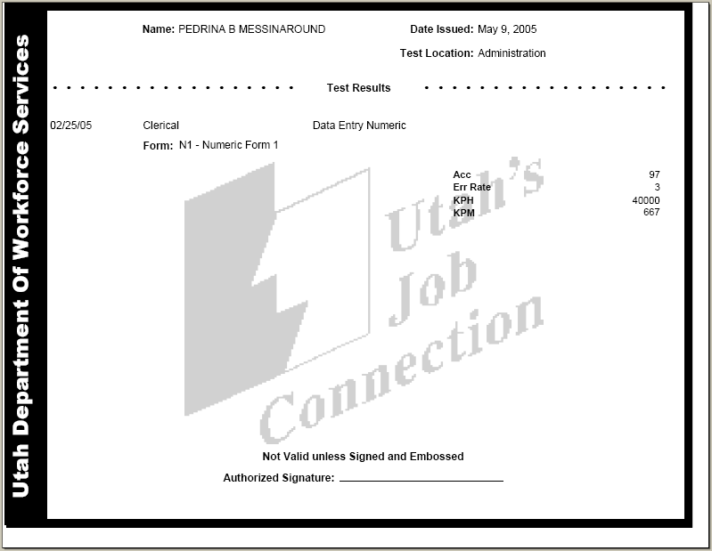
This Testing Certificate is an example of a Data Entry Numeric (ten key) test.

The seeker can use this certificate when they apply for jobs that require testing validation.
Training Waiver

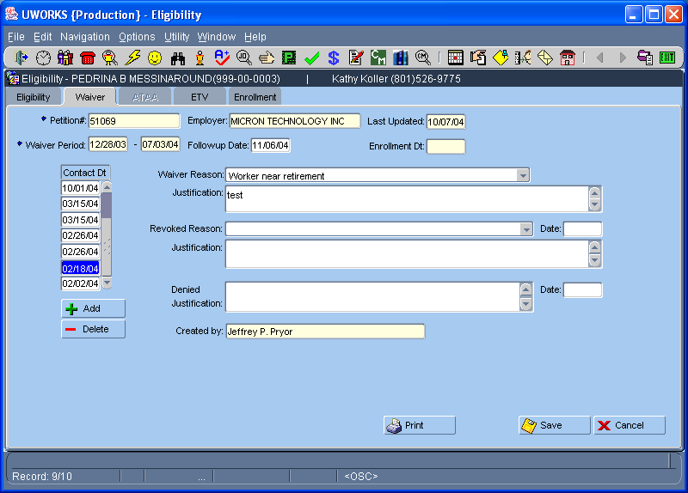
Click the Eligibility speed button to access the Eligibility screens.

Click the Waiver tab to see the waiver information.

From the Waiver tab you can print a Training Waiver Decision form by clicking .

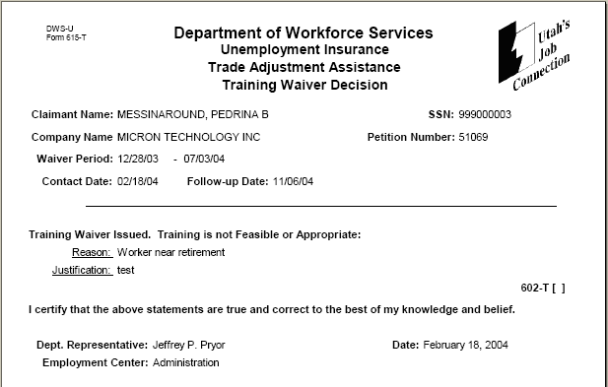
The Training Waiver Decision form shows the details about eligibility for trade waivers.
Veteran Report (Seeker)

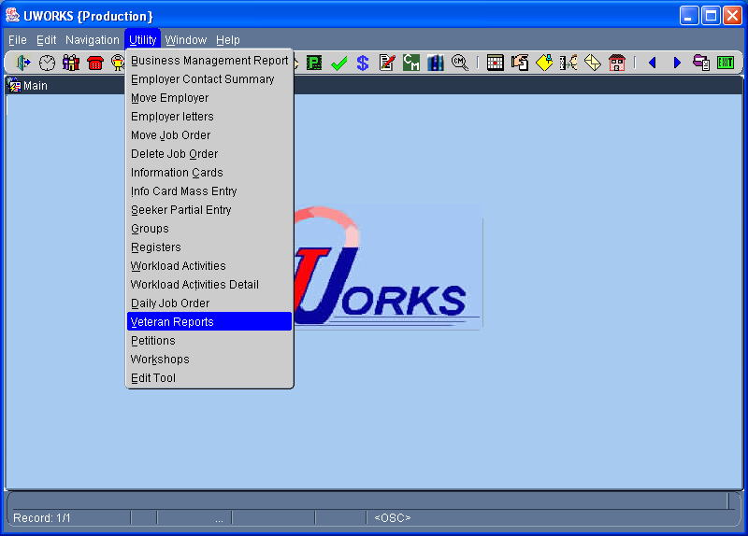
Click then to access Veteran Reports.

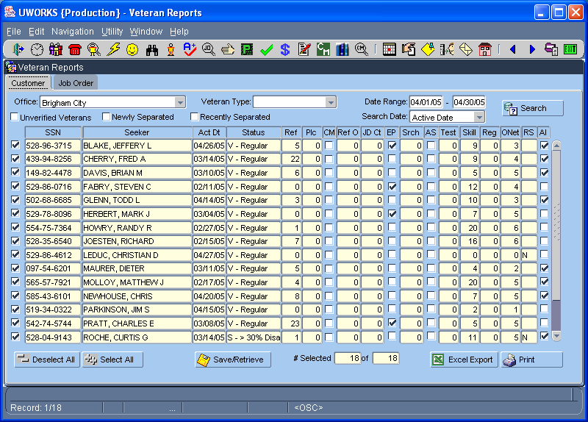
From the Veteran Reports Customer tab you can enter query information and then select to populate the grid.

To create a Veteran Customer Report click .
Veteran Report/Con’t (Seeker)

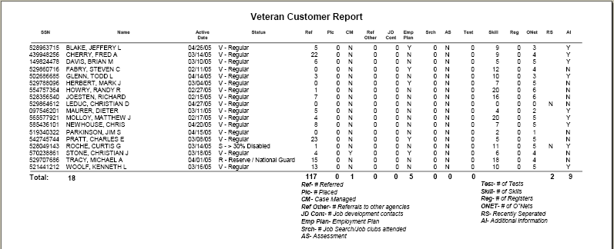
The Veteran Customer Report lists information about veterans. Most of the information is related to job matching, job placements and generally how well veterans are being served.

Veteran Report (Job Order)

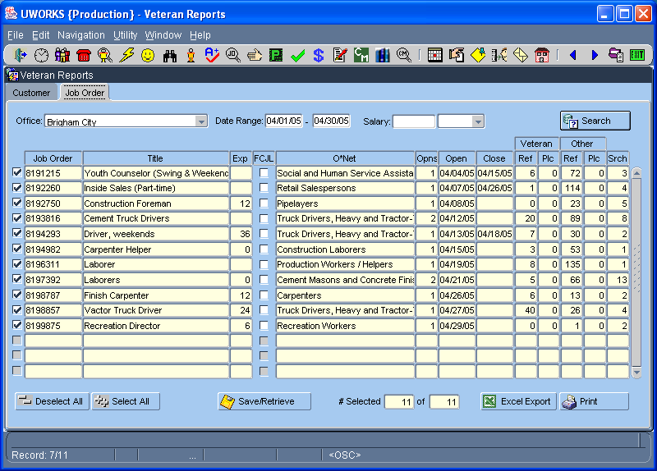
From the Veteran Reports Job Order tab you can enter query information and then select to populate the grid.

To create a Veteran Job Order Report click .

Veteran Report/Con’t (Job Order)

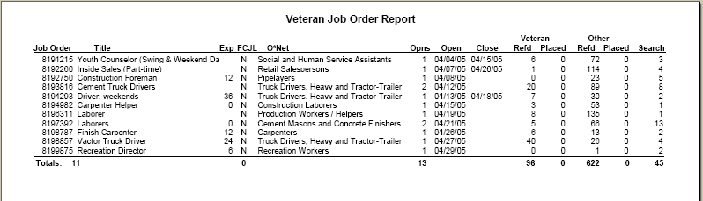
The Veteran Job Order Report lists information about veterans relating to job orders. It lists how many veterans were referred and placed for each job order.


Wage Data List

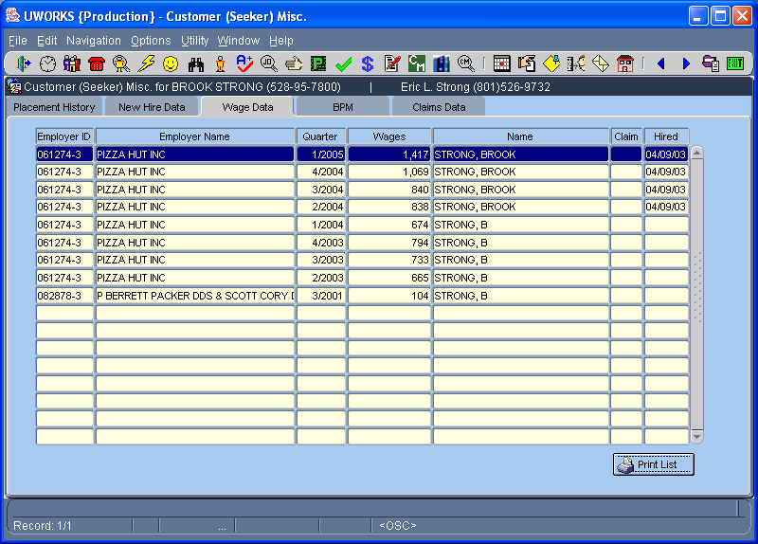
Click the Customer Misc. speed button to access the Customer Misc. screens.

Click the Wage Data tab to see wage information for this seeker.

To print a report of the wage data information click .
Wage Data List/Con’t

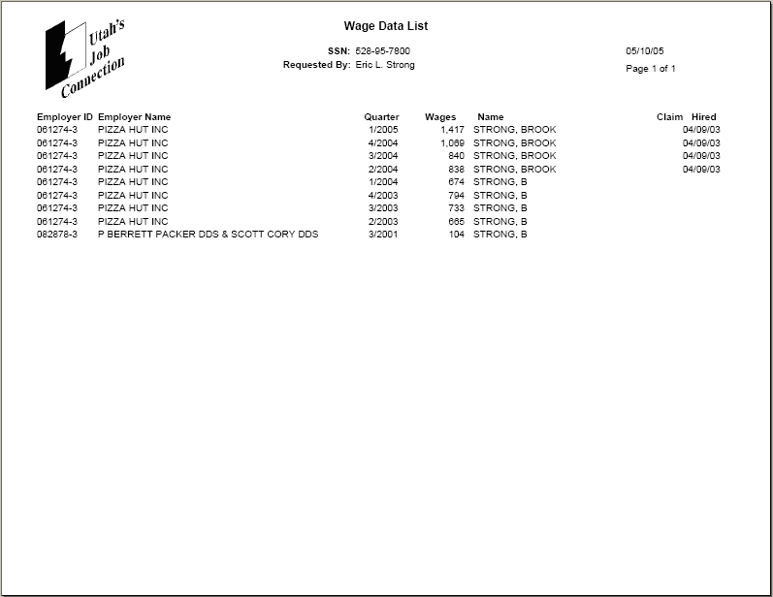
The Wage Data List displays the wage information for the seeker selected.

Weekly Schedule

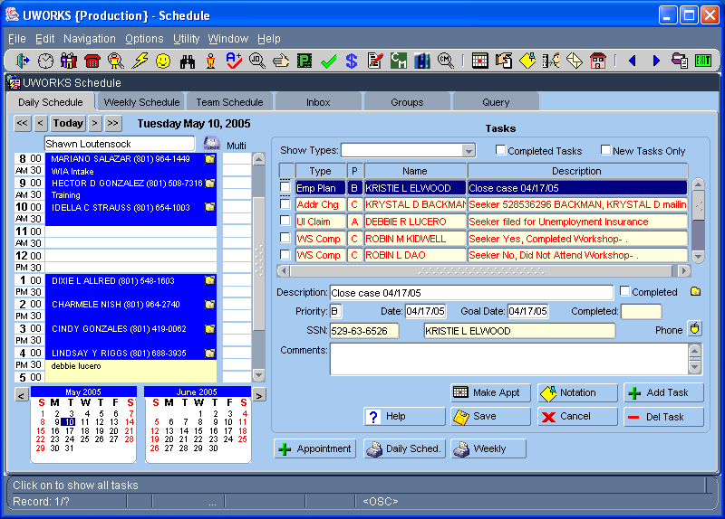
Click the Daily Schedule speed button to access the Scheduling screens.

To print a workers weekly schedule click .
Weekly Schedule/Con’t

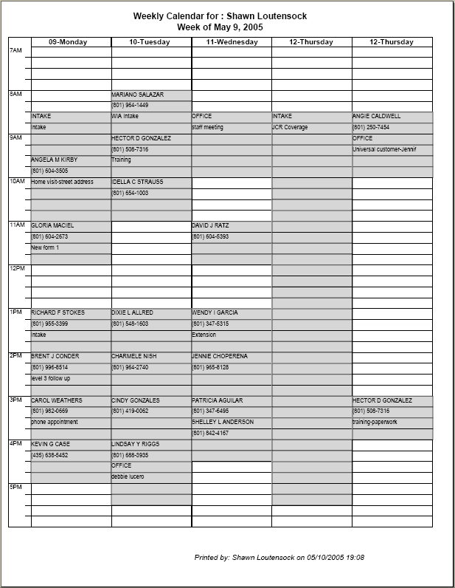
The Weekly Schedule lists all the appointments an Employment Counselor has scheduled for an entire week.

Workload Activity

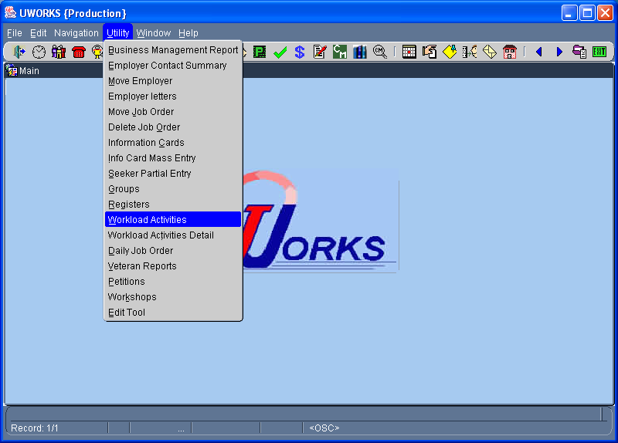
Click then to access Workload Activities Reports.

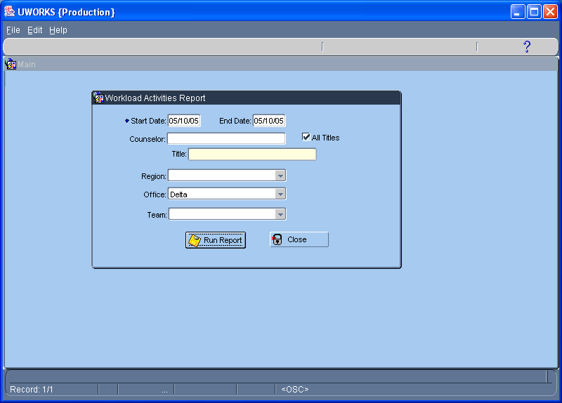
The Workload Activities Report can be created using different time periods. The report can be created for a Counselor, Region, Office, or Team. Enter the information and select .
Workload Activity/Con’t

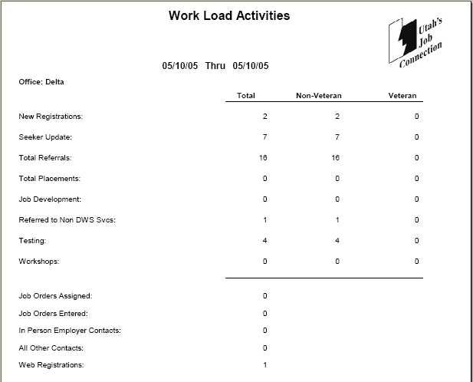
This page shows an example of a Work Load Activities report for the Delta office on May 10, 2005.

The report details the workload for this office relating to their employment activities.

Workload Activity Detail

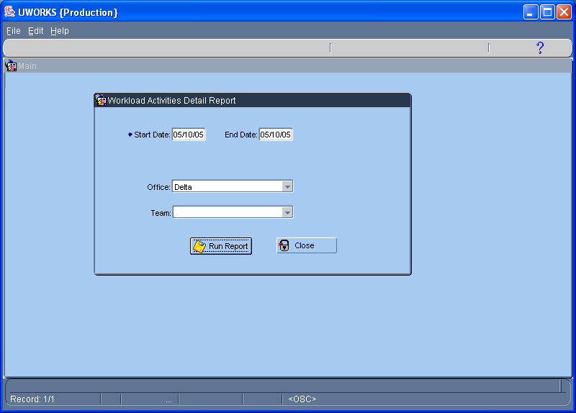
To access the Workload Activities Detail Report select then

The Workload Activities Detail Report can be created using different time periods. The report can be created for an Office or Team. Enter the information and select .
Workload Activity Detail/Con’t

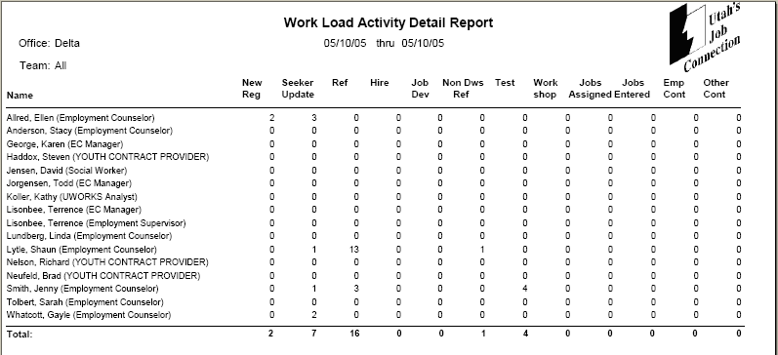
This page shows an example of a Work Load Activities Detail Report for the Delta office on May 10, 2005.

The report shows the workload for this office related to employment activities. The details are listed at the worker level and totaled for the office.

Workshop List

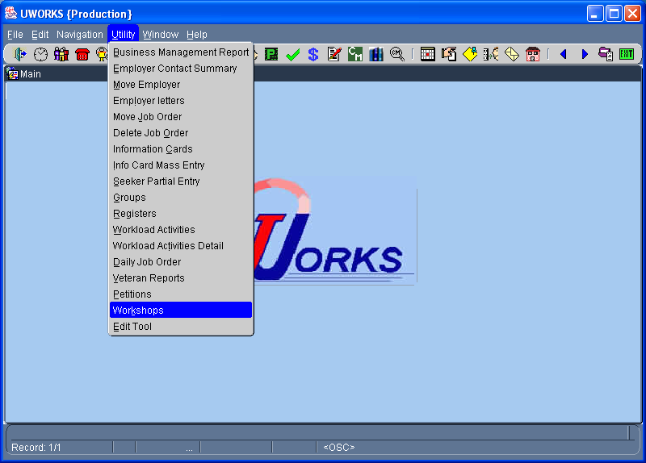
Click then to access Workshop screens.

Workshop List/Con’t

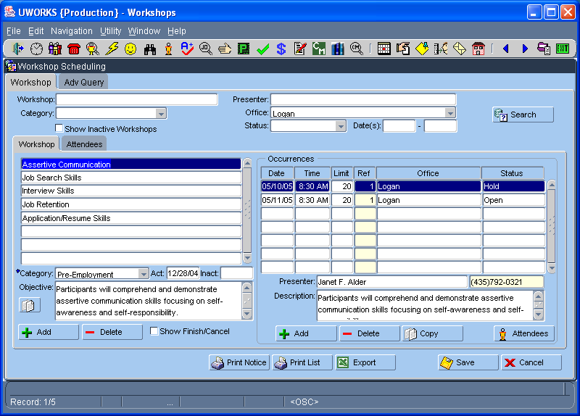
The Workshop Scheduling screens are used to create workshops and schedule seekers to attend the workshops.

From the Workshop tab you can print two different reports the report and the report.

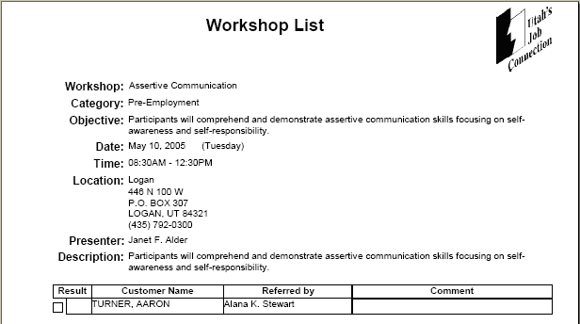
The Workshop List report displays details about the workshop and lists all of the job seekers that were or have been scheduled for the workshop.

Workshop Notice

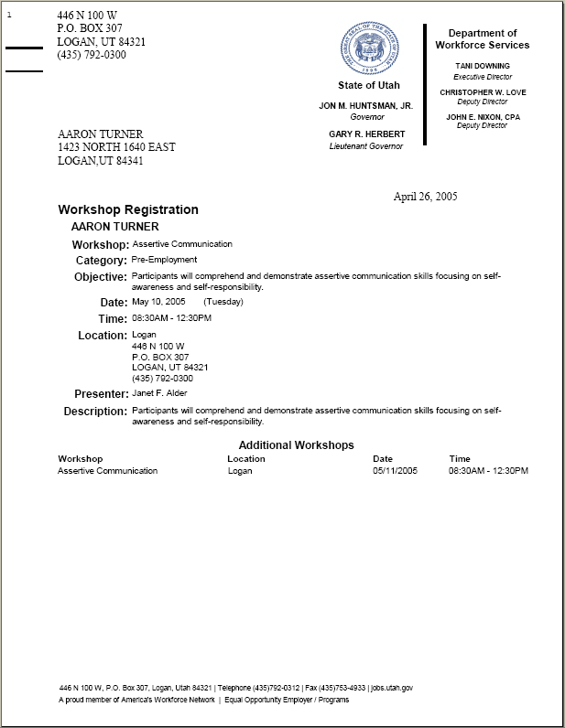
The Workshop List Notice is a letter that can be sent to a seeker. The letter gives details about the workshop. It lets the seeker know what day, time and place to attend the workshop.

Worksite Learning Referral

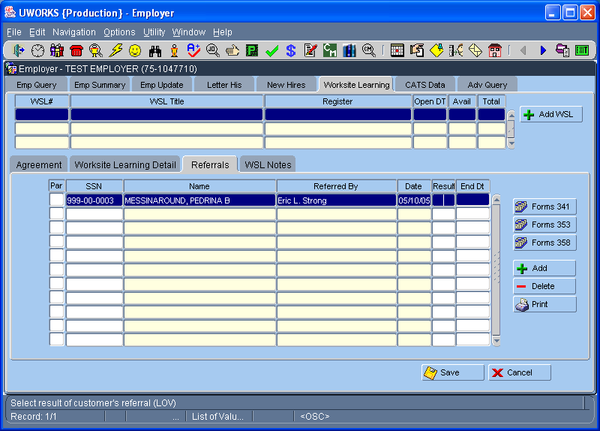
Click Employer speed button to access Employer.
From the Worksite Learning tab you can select the Referrals tab to assign a job seeker to an employer worksite.

To print a Worksite Learning Referral select .

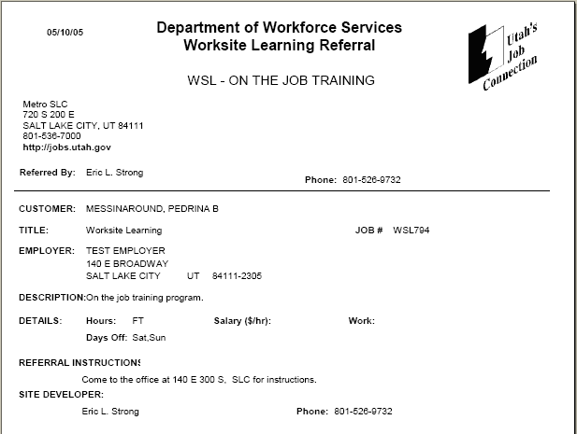
This page is an example of the Worksite Learning Referral report. This report shows the worksite job details.

